**PRACTICAL 1**

**Aim: Implementation of Data partitioning through Hash, Range and List Partitioning.**

Writeup: Data partitioning is a technique used to divide a large set of data into smaller, more manageable parts, or "partitions." This makes it easier to distribute the data across multiple servers, ensuring faster access, better performance, and easier management. There are several ways to partition data, each with its own method and use case. Three common types of data partitioning are Hash Partitioning, Range Partitioning, and List Partitioning.

1.Hash Partitioning

Hash partitioning splits data based on a hash function. A hash function takes the data (like a key or a column value) and computes a fixed-size output, called a hash value. The data is then placed in a partition based on the hash value.

•The hash function assigns a numerical value to each data element.

•This value determines which partition the data should go into.

•For example, if you have 3 partitions, the hash function might divide the data into partitions 1, 2, or 3 based on the hash value.

Example: Suppose you're partitioning data based on the "user_id" column and you have 4 partitions.

•A hash function will calculate the hash value of the "user_id" and assign it to one of the four partitions.

•If hash(user_id) % 4 == 0, the data goes to Partition 0; if hash(user_id) % 4 == 1, it goes to Partition 1, and so on.

Advantages:

•The distribution is usually even, which helps avoid skewed partitions.

•It’s good for situations where you don’t need to maintain a specific order of data. Disadvantages:

•Hash partitioning can be difficult to reverse. You cannot easily predict in which partition a given record will land just by looking at the data.

•Adding or removing partitions can be complex, as it may require rehashing existing data.

2.Range Partitioning

Range partitioning divides data into partitions based on a specified range of values. For example, you might partition data by date or by age range.

•You define specific ranges for a column, and the data is grouped into those ranges.

For example, if you’re partitioning by the "age" of people, you might have partitions for:

•Ages 0-20 in Partition 1,

•Ages 21-40 in Partition 2,

•Ages 41-60 in Partition 3, and so on.

Example: If you have a "sales_date" column and you're partitioning by the year:

•Partition 1 could hold data from 2020,

•Partition 2 could hold data from 2021,

•Partition 3 could hold data from 2022, etc. Advantages:

•Useful for time-based data, like partitioning by year, quarter, or month.

•Easy to understand and manage, as data is organized by a natural range. Disadvantages:

•If the data isn’t evenly distributed, some partitions may have much more data than others (this is known as "skew").

•Adding new ranges may require reorganizing data if the range definitions change

3.List Partitioning

List partitioning divides data into partitions based on specific, predefined lists of values. Instead of dividing by ranges (like in Range Partitioning), the data is grouped based on certain categories.

•You define a list of values for each partition.

•Each data item is assigned to a partition based on whether its value matches one of the values in the predefined list.

Example: If you're partitioning by "region," you might define:

•Partition 1 for North America,

•Partition 2 for Europe,

•Partition 3 for Asia,

•Partition 4 for Africa, etc. Advantages:

•Easy to understand and manage, especially when the categories are well-defined.

•Great for cases where you have clear categories, such as geographical locations or product types.

Disadvantages:

•If the categories are too broad or don’t have a natural division, partitions may be uneven.

•If new categories are added or existing ones change, you might have to reorganize data

**Code:**

1. Create the student Table with Range Partitioning:

Design a table named student with the following columns:

s_id (integer) – student ID

s_name (varchar of 20 characters) – student name

dob (date) – date of birth

Partition this table based on the year of birth (dob) using range partitions:

p0: Includes students born before 1990.

p1: Includes students born between 1990 and 1994.

p2: Includes students born between 1995 and 1999.

create table student(s_id int, s_name varchar(20), dob date)partition by range(year(dob))(partition p0 values less than (1990),partition p1 values less than(1995),partition p2 values less than (2000));

insert into student values(2,'ajay','1998-10-20'),(3,'sumit','1989-9-14'),(4,'vijay','1988-04-21'),(5,'joshna','1999-04-24'),(6,'ankita','1994-04-23');

**Table Creation:**

**Query:**

CREATE TABLE student (

s_id INT,

s_name VARCHAR2(20),

dob DATE

)

PARTITION BY RANGE (dob) (

PARTITION p0 VALUES LESS THAN (TO_DATE('01-Jan-1990','DD-MON-YYYY')),

PARTITION p1 VALUES LESS THAN (TO_DATE('01-Jan-1995','DD-MON-YYYY')),

PARTITION p2 VALUES LESS THAN (TO_DATE('01-Jan-2000','DD-MON-YYYY'))

);

**Output:**

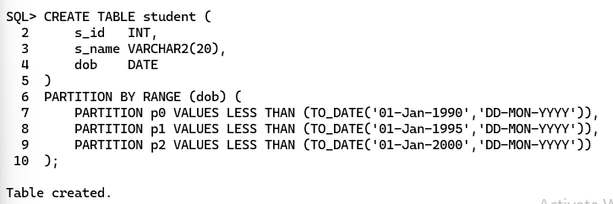

**Inserting values into table:**

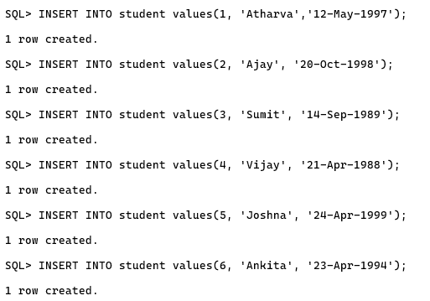

**Display Table:**

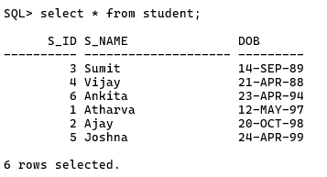

2. Design a table named stores with the following columns:

shop_id (integer) – store shop ID

s_name (varchar of 20 characters) – store name

st_number (integer) – store contact number

email_id (varchar of 40 characters) – store email

store_id (integer) – unique store identifier

Partition this table based on the store_id using list partitions:

peast: Includes store IDs 104, 106, and 109.

pwest: Includes store IDs 103, 105, and 107.

pnorth: Includes store IDs 101, 102, and 108.

psouth: Includes store IDs 110, 111, and 112.

**Table Creation:**

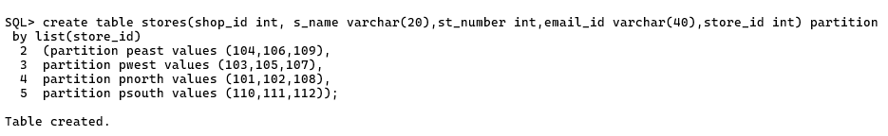

**Inserting values in table:**

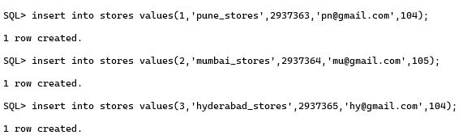

**Display Table:**

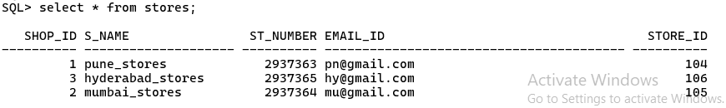

3. Fire the following Queries:

Solution:

1. Retrieve all records from the student table that belong to partition p1.

select * from student partition(p1);

2. Write a query to count the number of rows in each partition of the student table. The result should show partition_name and table_rows for each partition.

select partition_name,table_rows from information_schema.partitions where table_name='student';

Output:

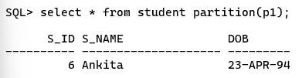

**Practical 2**

**Aim: Implementation of Analytical queries like Roll_UP, CUBE, First, Last, Rank AND Dense Rank using oracle.**

Writeup: Analytical Queries in Oracle: ROLLUP, CUBE, FIRST, LAST, RANK, and DENSE_RANK Oracle provides a suite of powerful analytical functions to perform advanced data analysis in SQL.

Among them, ROLLUP, CUBE, FIRST, LAST, RANK, and DENSE_RANK are commonly used to generate summaries, rankings, and provide insights into datasets. Here's an overview and implementation of these functions:

1.ROLLUP

The ROLLUP operator is used for generating summary data by grouping the result set in a hierarchical manner. It performs aggregation at multiple levels of a hierarchy, rolling up the intermediate summaries to a grand total.

2.CUBE:

The CUBE operator extends ROLLUP by generating subtotals for all combinations of the specified grouping columns. It is useful for performing multidimensional aggregation and allows the calculation of all possible groupings.

3.FIRST and LAST:

The FIRST and LAST functions return the first and last values in a specific ordering of a column within a group.

4.RANK:

The RANK function assigns a rank to each row in the result set, with ties receiving the same rank. However, it leaves gaps in the ranking if there are ties (e.g., if two rows are ranked 1, the next row will be ranked 3).

5.DENSE_RANK:

The DENSE_RANK function is similar to RANK, but it does not leave gaps in the ranking when there are ties. For example, if two rows have the same rank, the next row will be ranked immediately after (i.e., no gaps).

Conclusion

These analytical functions in Oracle are essential tools for business intelligence and data analysis. They allow for flexible aggregation, ranking, and windowing operations, providing deep insights into data across multiple dimensions.

--for formatting purpose only

-- set lines 256

set trim out on set tab off

**Query:**

**Create a Partitioned Table (for ROLLUP and CUBE):**

**Query:**

CREATE TABLE partitioned_employees (

employee_id NUMBER,

ename VARCHAR2(50),

department VARCHAR2(50),

job VARCHAR2(50),

salary NUMBER,

hire_date DATE

)

PARTITION BY RANGE (hire_date) (

PARTITION emp_hiredate_jan2020 VALUES LESS THAN (TO_DATE('2020-02-01', 'YYYY-MM-DD')),

PARTITION emp_hiredate_feb2020 VALUES LESS THAN (TO_DATE('2020-03-01', 'YYYY-MM-DD')),

PARTITION emp_hiredate_mar2020 VALUES LESS THAN (TO_DATE('2020-04-01', 'YYYY-MM-DD')),

-- Add more partitions as needed

PARTITION emp_hiredate_default VALUES LESS THAN (MAXVALUE)

);

**Output:**

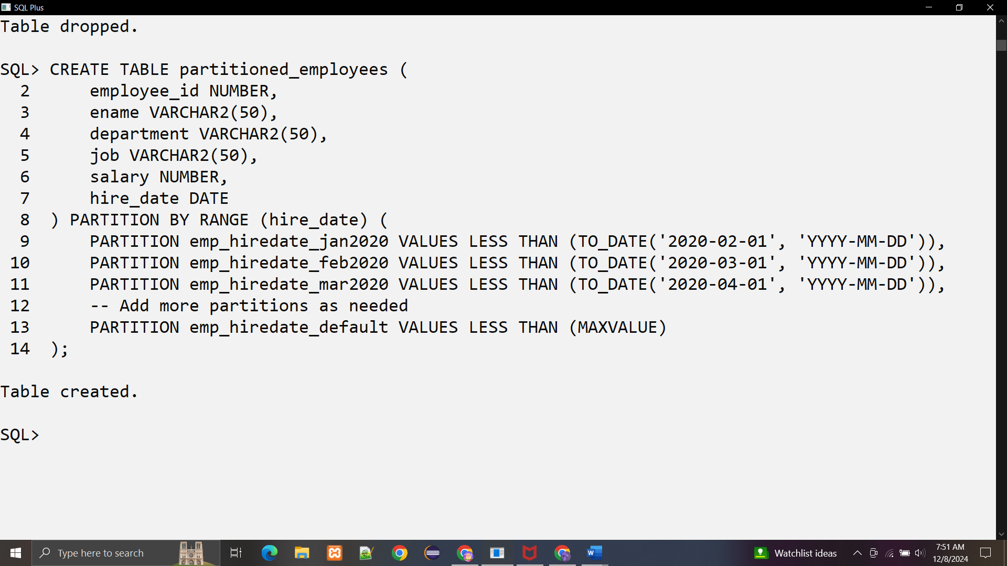

INSERT INTO partitioned_employees VALUES (201, 'Robert King', 'HR', 'Manager', 5000, TO_DATE('2020-01-15', 'YYYY-MM-DD'));

INSERT INTO partitioned_employees VALUES (202, 'Olivia Clark', 'Finance', 'Analyst', 4500, TO_DATE('2020-02-10', 'YYYY-MM-DD'));

INSERT INTO partitioned_employees VALUES (203, 'Ethan Harris', 'IT', 'Developer', 6000, TO_DATE('2020-03-20', 'YYYY-MM-DD'));

INSERT INTO partitioned_employees VALUES (204, 'Sophia Turner', 'Marketing', 'Executive', 4800, TO_DATE('2020-01-25', 'YYYY-MM-DD'));

INSERT INTO partitioned_employees VALUES (205, 'William Scott', 'Sales', 'Lead', 5200, TO_DATE('2020-02-05', 'YYYY-MM-DD'));

INSERT INTO partitioned_employees VALUES (206, 'Isabella Adams', 'HR', 'Assistant', 3500, TO_DATE('2020-03-15', 'YYYY-MM-DD'));

INSERT INTO partitioned_employees VALUES (207, 'Lucas Carter', 'IT', 'Admin', 5600, TO_DATE('2020-01-05', 'YYYY-MM-DD'));

INSERT INTO partitioned_employees VALUES (208, 'Mia Robinson', 'Finance', 'Manager', 7000, TO_DATE('2020-04-10', 'YYYY-MM-DD'));

INSERT INTO partitioned_employees VALUES (209, 'Henry Evans', 'Sales', 'Executive', 4900, TO_DATE('2020-02-28', 'YYYY-MM-DD'));

INSERT INTO partitioned_employees VALUES (210, 'Ava Mitchell', 'Marketing', 'Lead', 5300, TO_DATE('2020-03-25', 'YYYY-MM-DD'));

CREATE TABLE partitioned_employees_rank (

employee_id NUMBER,

ename VARCHAR2(50),

department VARCHAR2(50),

job VARCHAR2(50),

salary NUMBER,

hire_date DATE

)

PARTITION BY LIST (department) (

PARTITION emp_it VALUES ('IT'),

PARTITION emp_hr VALUES ('HR'),

PARTITION emp_sales VALUES ('Sales'),

-- Add more partitions as needed

PARTITION emp_other VALUES (DEFAULT)

);

**Output:**

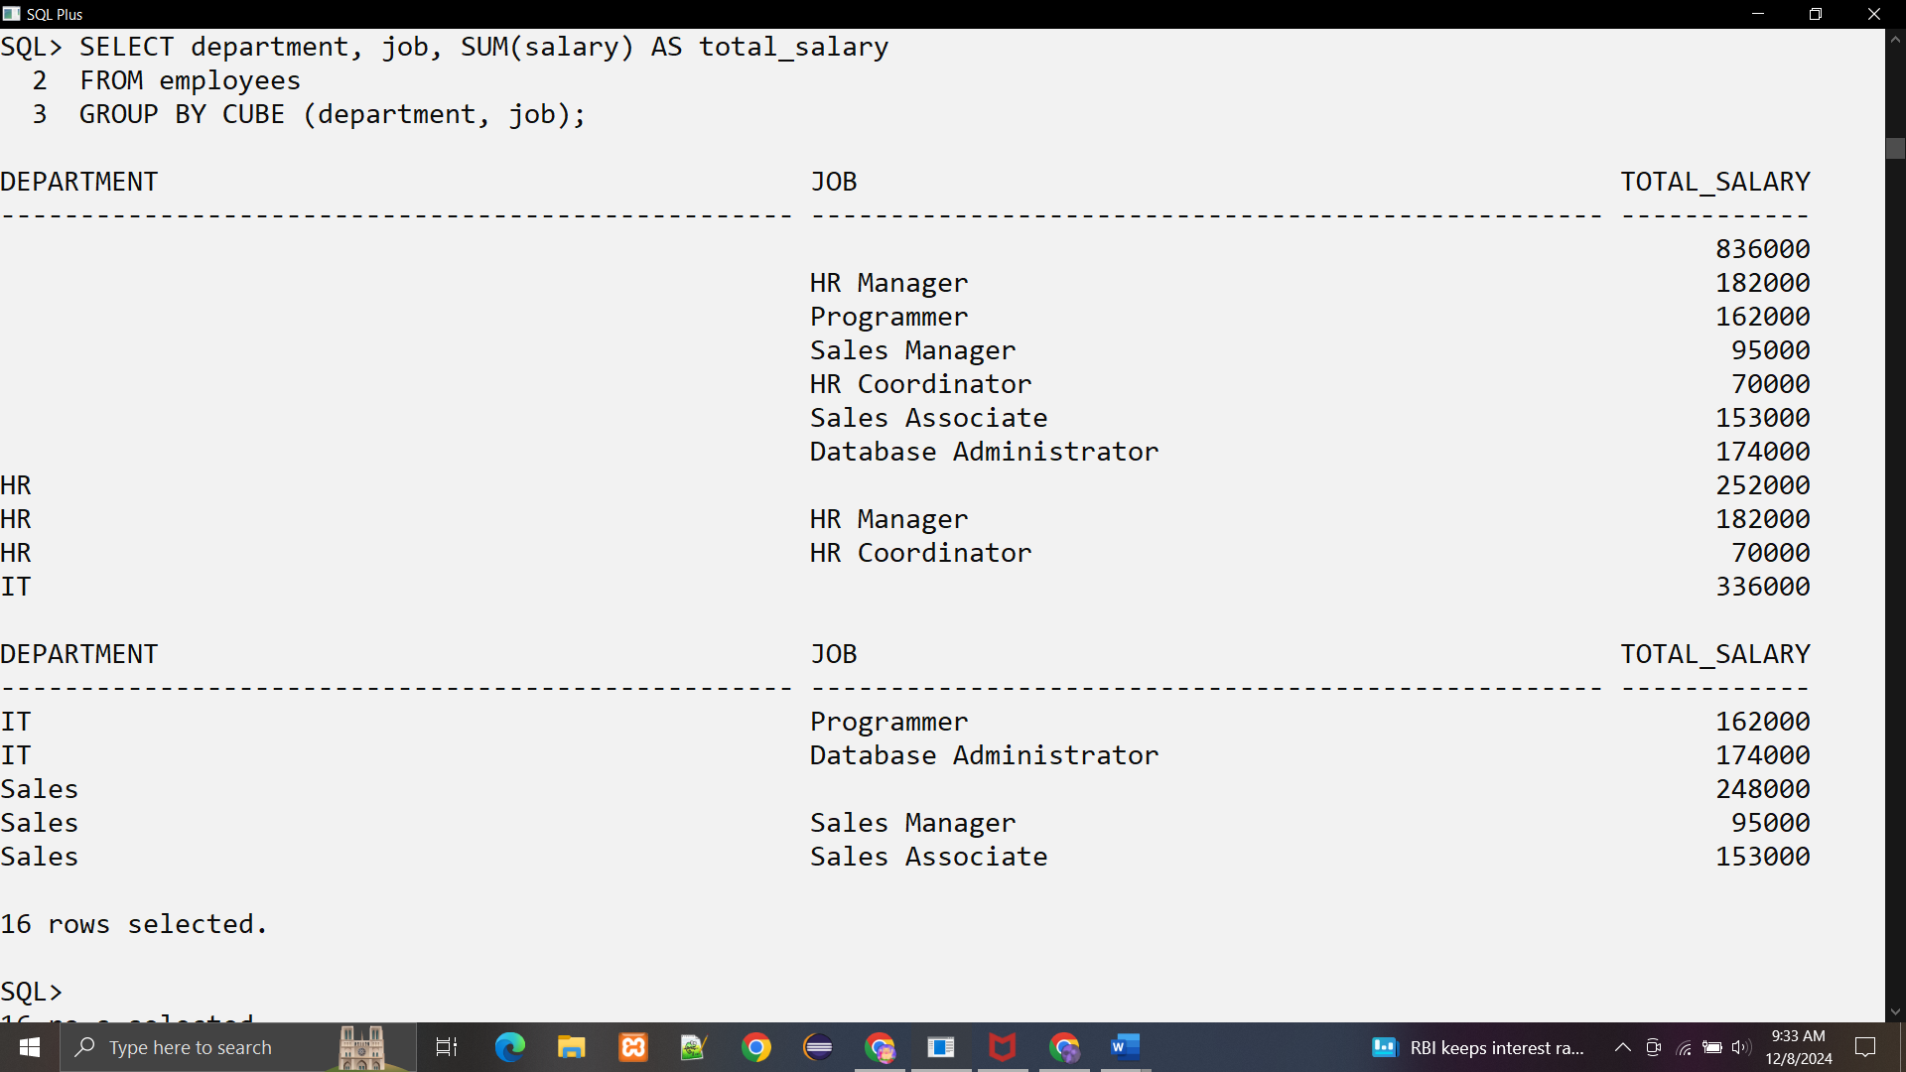

**Practical 3**

**Aim: Implementation of ORDBMS concepts like ADT (Abstract Data Types), Object table and Inheritance**

**Theory:**

**1. Abstract Data Types (ADT)**

**What is ADT?**

ADT is a custom data structure that encapsulates data attributes and behaviors (methods) into a single entity, resembling a class in object-oriented programming. It provides a reusable and structured way to represent real-world entities.

**How to Implement in Oracle**

**Step 1:** Define an ADT using the CREATE TYPE command.

Example:

CREATE TYPE EmployeeType AS OBJECT (

EMPLOYEE_ID NUMBER,

ENAME VARCHAR2(50),

DEPARTMENT VARCHAR2(50),

JOB VARCHAR2(50),

SALARY NUMBER,

MEMBER FUNCTION AnnualSalary RETURN NUMBER

);

* EMPLOYEE_ID, ENAME, etc., are attributes.
* MEMBER FUNCTION AnnualSalary is a method (behavior).

**Step 2:** Define the behavior (method) in the ADT body.

CREATE TYPE BODY EmployeeType AS

MEMBER FUNCTION AnnualSalary RETURN NUMBER IS

BEGIN

RETURN SALARY * 12;

END;

END;

* The body implements the functionality defined in the ADT.

**2. Object Tables**

**What are Object Tables?**

Object Tables store rows where each row is an object instance of a defined ADT. They bring a direct mapping of objects into the database, enabling a natural representation of data.

**How to Implement in Oracle**

**Step 1:** Create an object table based on the ADT.

Example:

CREATE TABLE Employees OF EmployeeType;

**Step 2:** Insert data into the object table.

INSERT INTO Employees VALUES (EmployeeType(101, 'John Doe', 'HR', 'Manager', 75000));

INSERT INTO Employees VALUES (EmployeeType(102, 'Jane Smith', 'IT', 'Developer', 65000));

**Step 3:** Query the object table.

SELECT VALUE(e) FROM Employees e;

* VALUE(e) fetches the entire object stored in each row.

**Step 4:** Use object methods in queries.

SELECT e.ENAME, e.AnnualSalary() AS ANNUAL_SALARY

FROM Employees e;

**3. Inheritance**

**What is Inheritance?**

Inheritance allows creating a new ADT (subtype) based on an existing ADT (supertype). The subtype inherits attributes and methods from the supertype and can add or override them.

**How to Implement in Oracle**

**Step 1:** Define a subtype using UNDER.

Example:

CREATE TYPE ManagerType UNDER EmployeeType (

TEAM_SIZE NUMBER,

OVERRIDE MEMBER FUNCTION AnnualSalary RETURN NUMBER

);

* UNDER specifies that ManagerType inherits from EmployeeType.
* TEAM_SIZE is an additional attribute in the subtype.
* OVERRIDE allows redefining the AnnualSalary method.

**Step 2:** Implement the overridden method.

CREATE TYPE BODY ManagerType AS

OVERRIDE MEMBER FUNCTION AnnualSalary RETURN NUMBER IS

BEGIN

RETURN (SALARY * 12) + (TEAM_SIZE * 1000);

END;

END;

**Step 3:** Create an object table for the subtype.

CREATE TABLE Managers OF ManagerType;

**Step 4:** Insert and query data in the subtype table.

Insert Data:

INSERT INTO Managers VALUES (ManagerType(201, 'Alice Johnson', 'HR', 'Manager', 85000, 5));

Query Data:

SELECT m.ENAME, m.AnnualSalary() AS ANNUAL_SALARY FROM Managers m;

**Key Benefits of These Concepts**

1. **Reusability**: ADTs and inheritance allow defining reusable structures and methods.
2. **Encapsulation**: ADTs bundle data and behavior together, improving clarity and maintainability.
3. **Polymorphism**: Subtypes can override methods and be queried alongside supertypes.

**Code:**

**Q1. Creating tables with ADT and References for customer, purchase order ,stock, lineitems table.**

1. **Create tables:**

CREATE TABLE Customer (

CustNo NUMBER NOT NULL,

CustName VARCHAR2(200) NOT NULL,

Street VARCHAR2(200) NOT NULL,

City VARCHAR2(200) NOT NULL,

State CHAR(2) NOT NULL,

Zip VARCHAR2(20) NOT NULL,

Phone1 VARCHAR2(20),

Phone2 VARCHAR2(20),

Phone3 VARCHAR2(20),

PRIMARY KEY (CustNo));

**Output:**

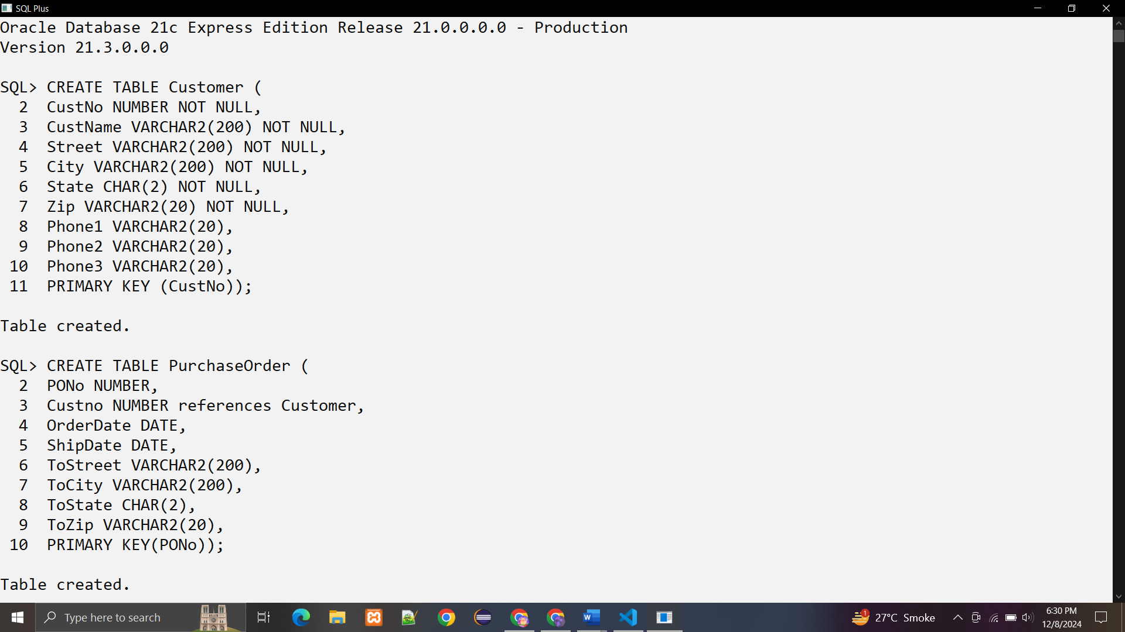

CREATE TABLE PurchaseOrder (

PONo NUMBER,

Custno NUMBER references Customer,

OrderDate DATE,

ShipDate DATE,

ToStreet VARCHAR2(200),

ToCity VARCHAR2(200),

ToState CHAR(2),

ToZip VARCHAR2(20),

PRIMARY KEY(PONo));

**Output:**



CREATE TABLE Stock (

StockNo NUMBER PRIMARY KEY,

Price NUMBER,

TaxRate NUMBER);

**Output:**

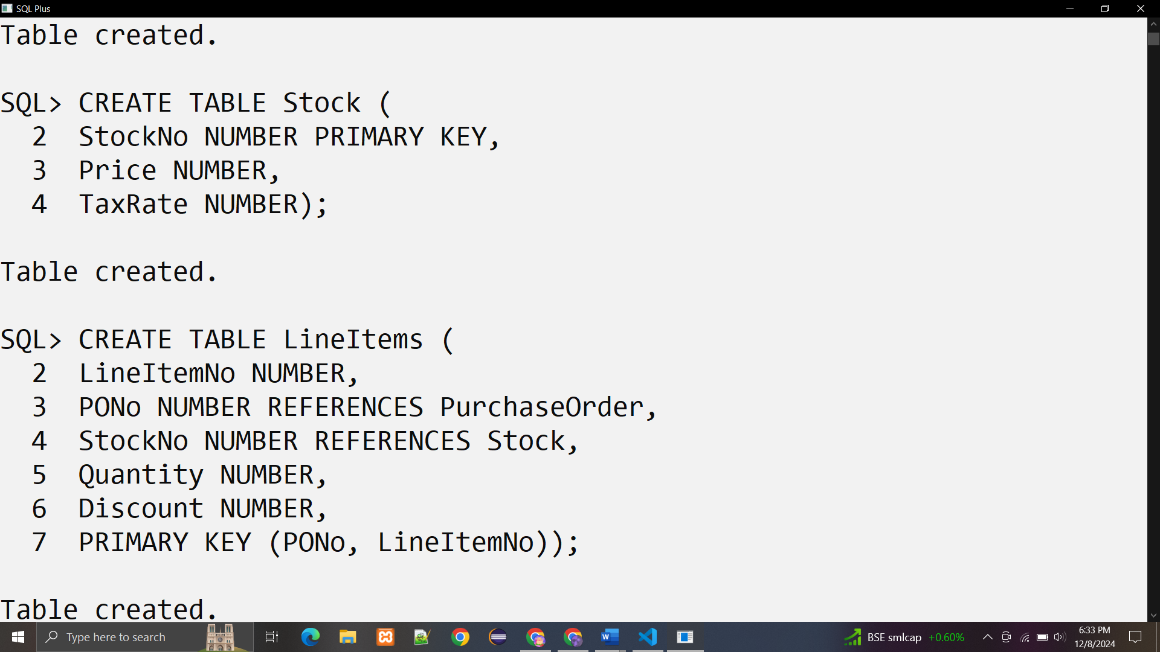

CREATE TABLE LineItems (

LineItemNo NUMBER,

PONo NUMBER REFERENCES PurchaseOrder,

StockNo NUMBER REFERENCES Stock,

Quantity NUMBER,

Discount NUMBER,

PRIMARY KEY (PONo, LineItemNo));



1. **Inserting data into tables with ADT and references**

**1)Insert data into Stock Table:**

INSERT INTO Stock VALUES(1004, 6750.00, 2);

INSERT INTO Stock VALUES(1011, 4500.23, 2);

INSERT INTO Stock VALUES(1534, 2234.00, 2);

INSERT INTO Stock VALUES(1535, 3456.23, 2);

**Output:**

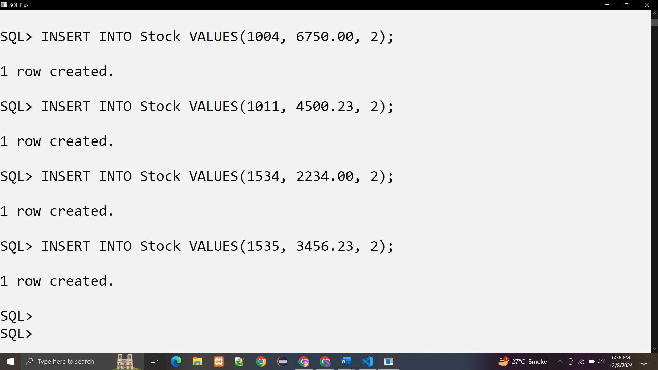

**2)Insert data into Customer Table:**

INSERT INTO Customer VALUES (1, 'Jean Nance', '2 Avocet Drive','Redwood Shores', 'CA', '95054','415-555-1212', NULL, NULL);

INSERT INTO Customer VALUES (2, 'John Nike', '323 College Drive','Edison', 'NJ', '08820','609-555-1212', '201-555-1212', NULL);

**Output:**

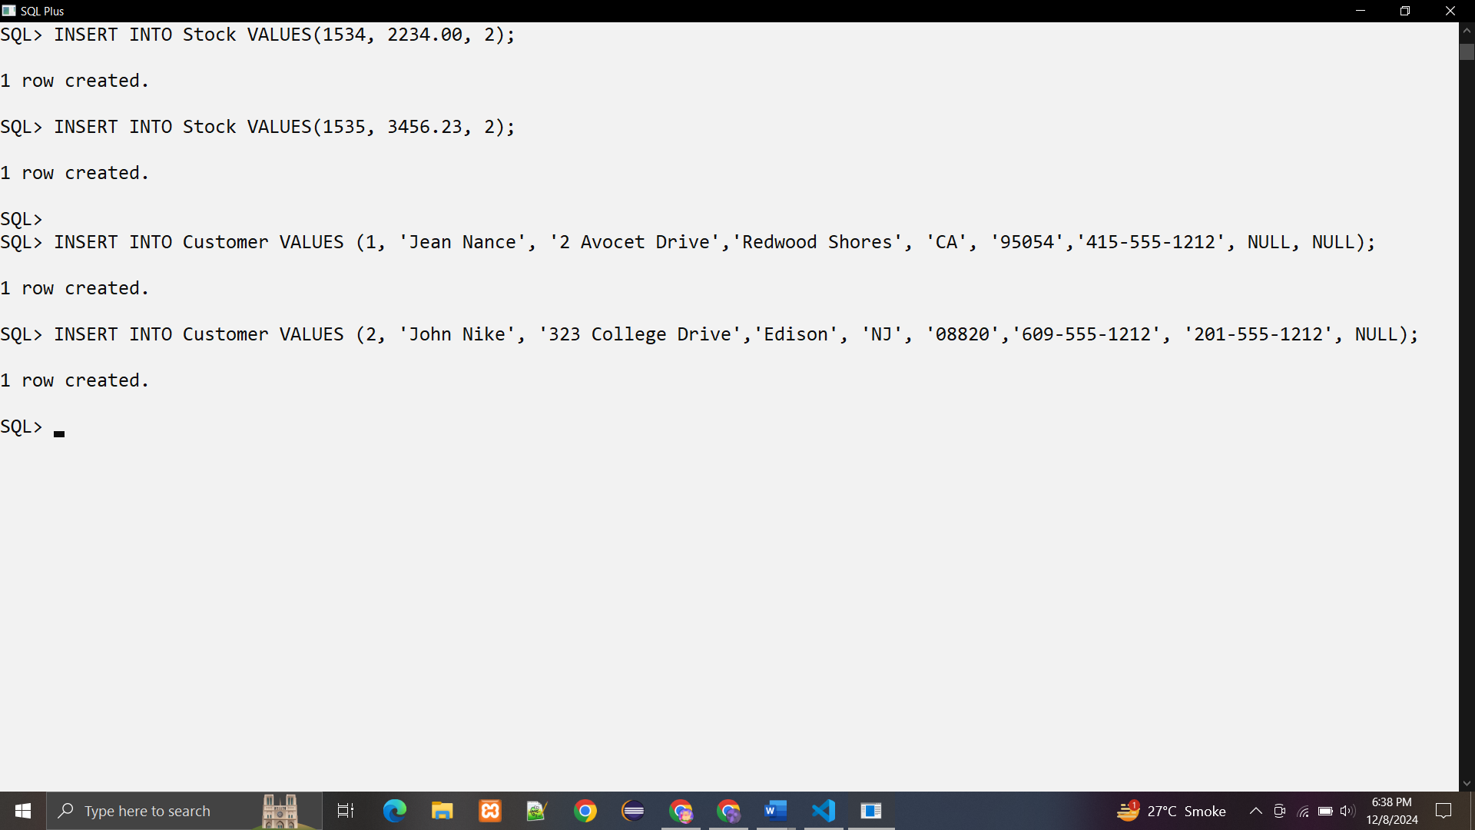

**3) Insert data into PurchaseOrder** **Table:**

INSERT INTO PurchaseOrder VALUES (1001, 1, SYSDATE, '10-MAY-1997',NULL, NULL, NULL, NULL);

INSERT INTO PurchaseOrder VALUES (2001, 2, SYSDATE, '20-MAY-1997','55 Madison Ave', 'Madison', 'WI', '53715');

**Output:**

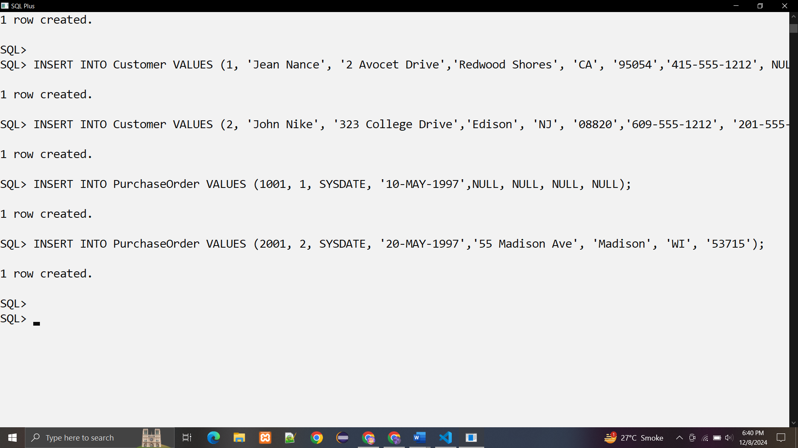

**3) Insert data into LineItems** **Table:**

INSERT INTO LineItems VALUES(01, 1001, 1534, 12, 0);

INSERT INTO LineItems VALUES(02, 1001, 1535, 10, 10);

INSERT INTO LineItems VALUES(01, 2001, 1004, 1, 0);

INSERT INTO LineItems VALUES(02, 2001, 1011, 2, 1);

INSERT INTO LineItems VALUES(01, 2001, 1534, 2, 1);

**Output:**

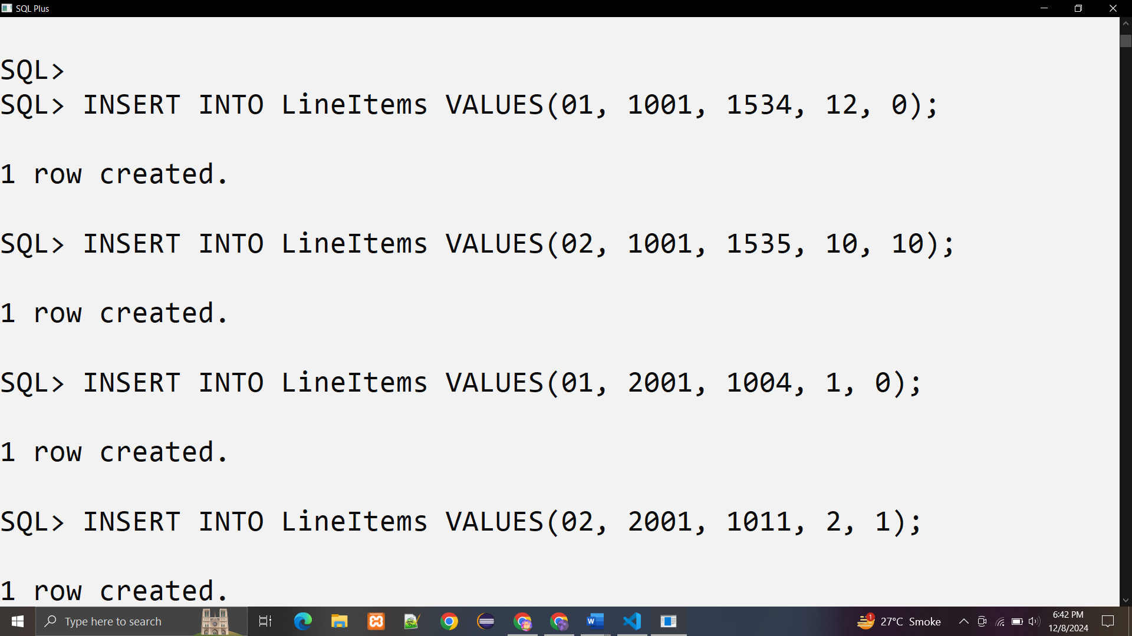

1. **simple query on table:**

**1. Get the Total Value of Purchase Orders**

**Query:**

SELECT P.PONo, SUM(S.Price * L.Quantity)

FROM PurchaseOrder P,

LineItems L,

Stock S

WHERE P.PONo = L.PONo

AND L.StockNo = S.StockNo

GROUP BY P.PONo;

**Output:**

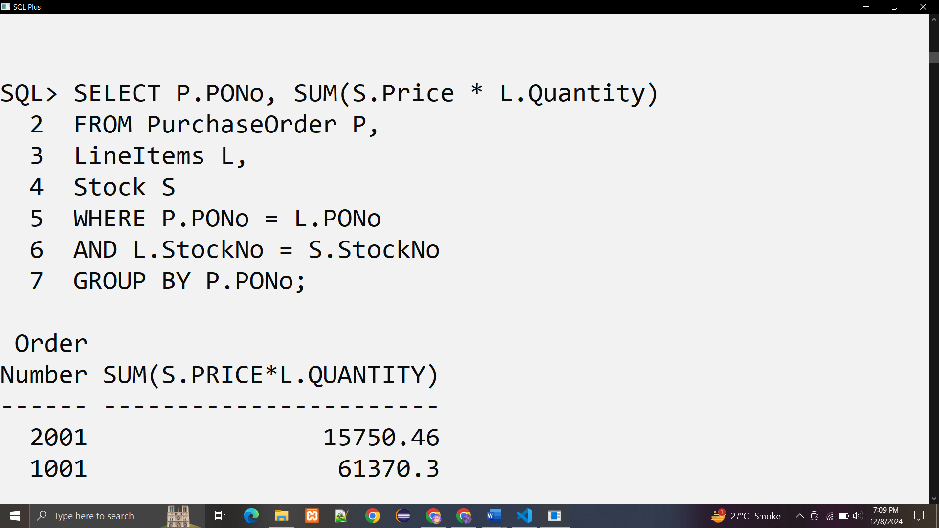

**2.Get the Purchase Order and Line Item Data for Stock Item 1004**

**Query:**

SELECT P.PONo, P.CustNo,

L.StockNo, L.LineItemNo, L.Quantity, L.Discount

FROM PurchaseOrder P,LineItems L

WHERE P.PONo = L.PONo

AND L.StockNo = 1004;

**Output:**

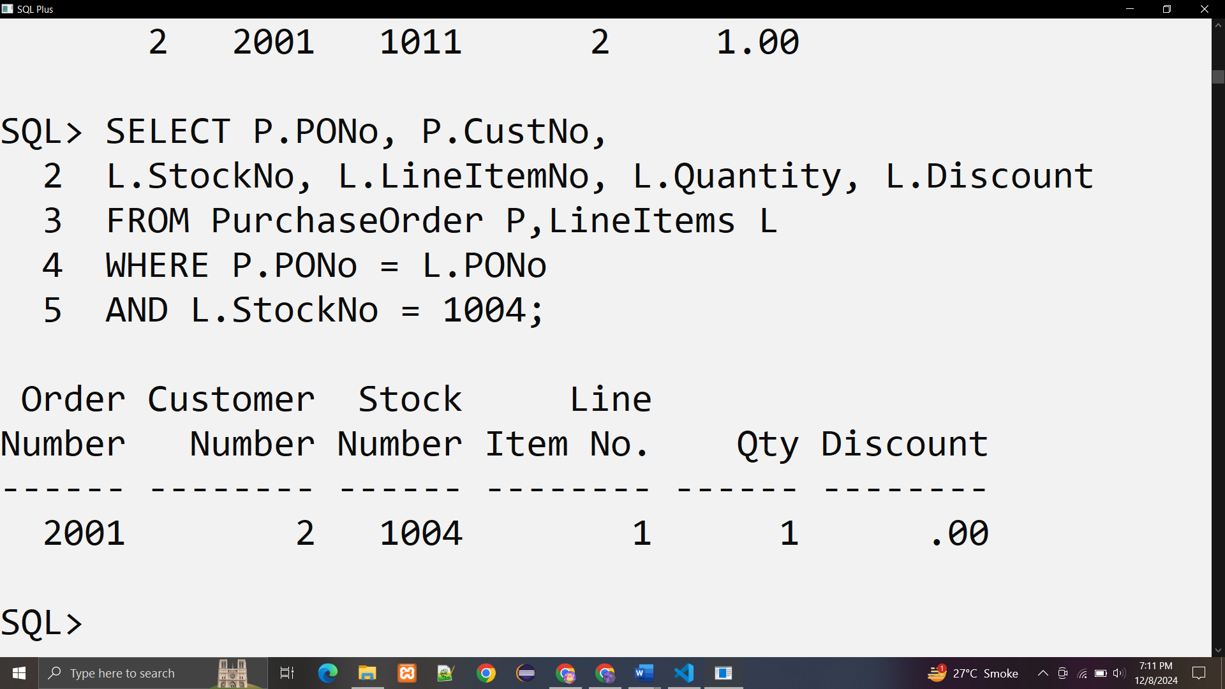

**4. Updating Data Under the Relational Model. The application can execute statements like these to update the data:**

**Query:**

UPDATE LineItems SET Quantity = 20 WHERE PONo = 1001 AND StockNo = 1534;

**Output:**

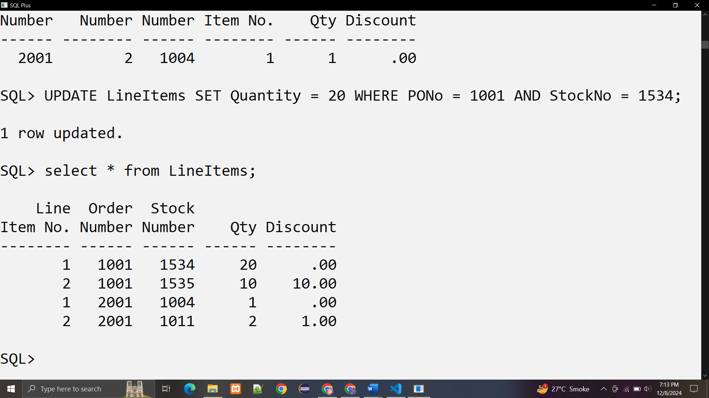

**5. Deleting Data Under the Relational Model:**

**Query:**

DELETE FROM LineItems WHERE PONo = 1001;

DELETE FROM PurchaseOrder WHERE PONo = 1001;

**Before deletion:**



**After Deletion:**

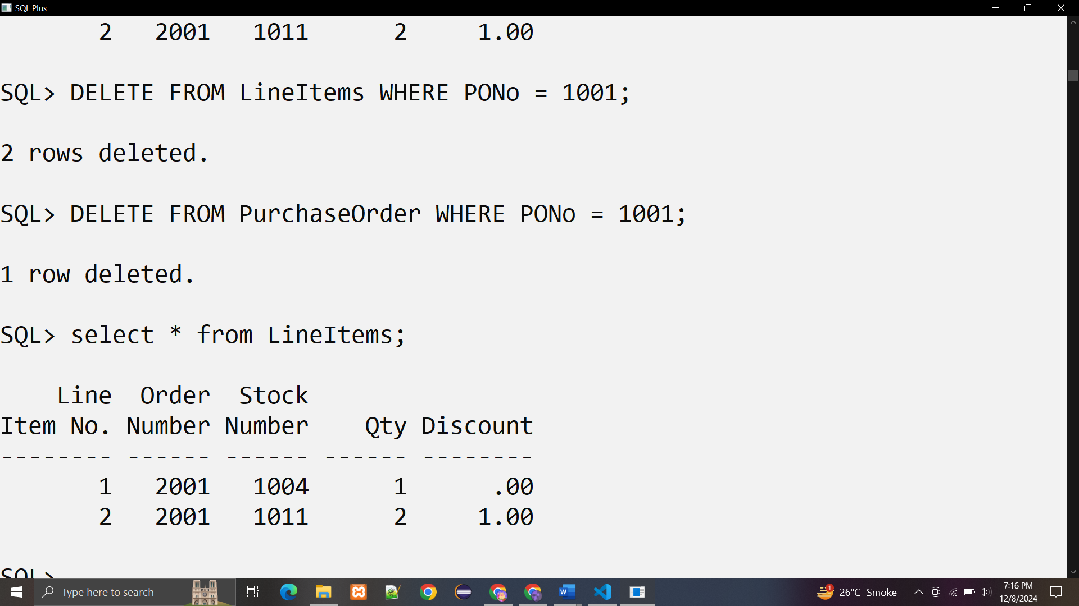

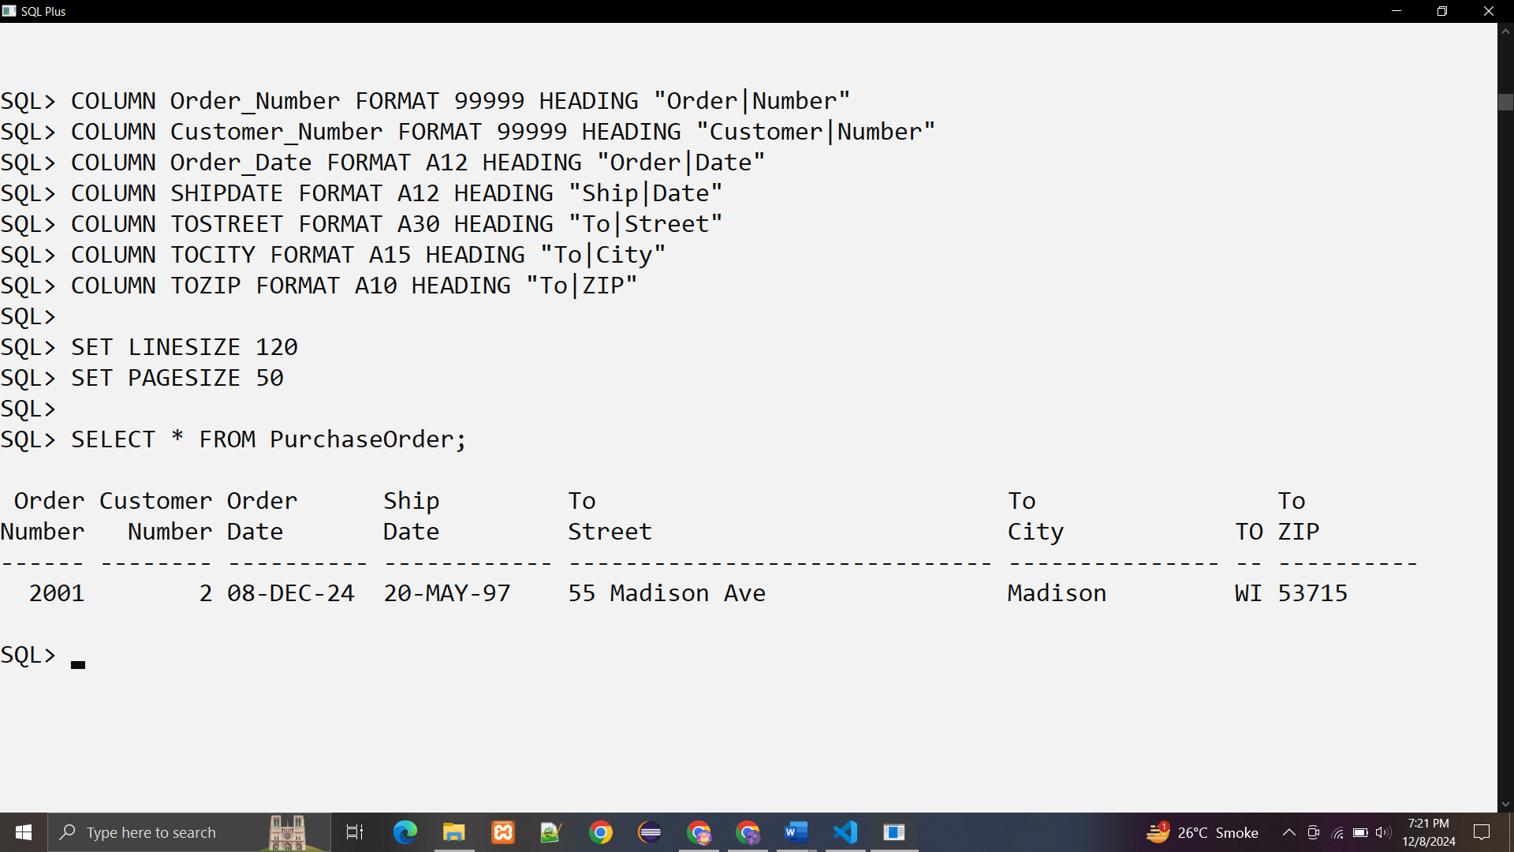

**Q2. Create an ADT Credit_type for purchase_amt, credit_grade(A,B,C)**

**Create a table Customer_Rating with attributes Cust_id, Name, and Credits**

**1. Display name of all customers.**

**2. Display the credit_grade of the customer whose purchase amount is greater than**

**25000**

**3. Display all customers with ‘C’ credit_grade**

**4. Display only the Name of customers with ‘A’ and ‘B’ Credit_grade**

**solution :**

**Create the ADT Credit_type:**

CREATE TYPE Credit_type AS OBJECT (

purchase_amt NUMBER,

credit_grade CHAR(1)

);

**Output:**

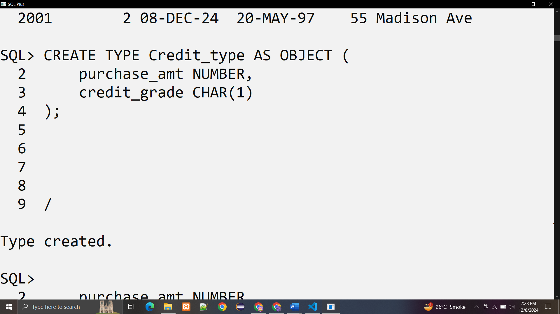

**2)Create the table Customer_Rating**

CREATE TABLE Customer_Rating (

Cust_id NUMBER PRIMARY KEY,

Name VARCHAR2(50),

Credits Credit_type

);

**Output:**

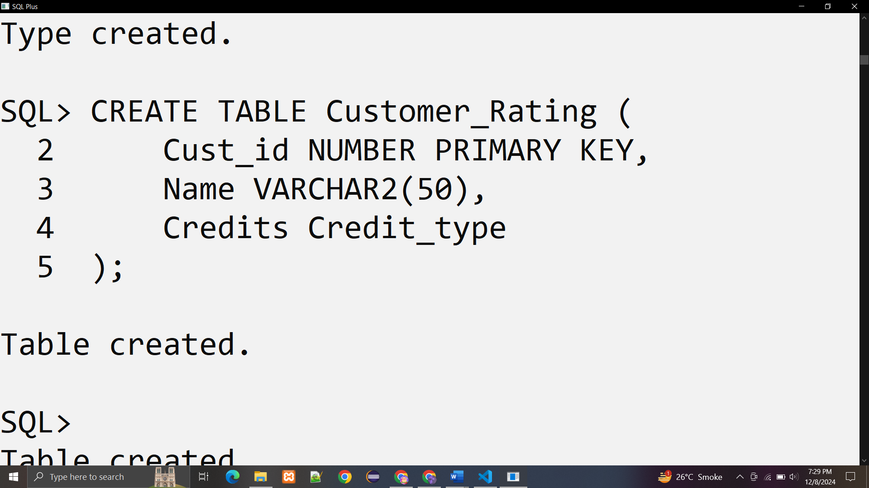

**sample data**

INSERT INTO Customer_Rating VALUES (1, 'vijay', Credit_type(30000, 'A'));

INSERT INTO Customer_Rating VALUES (2, 'ajay', Credit_type(20000, 'B'));

INSERT INTO Customer_Rating VALUES (3, 'muskaan', Credit_type(27000, 'C'));

INSERT INTO Customer_Rating VALUES (4, 'neel', Credit_type(18000, 'A'));

**Output:**

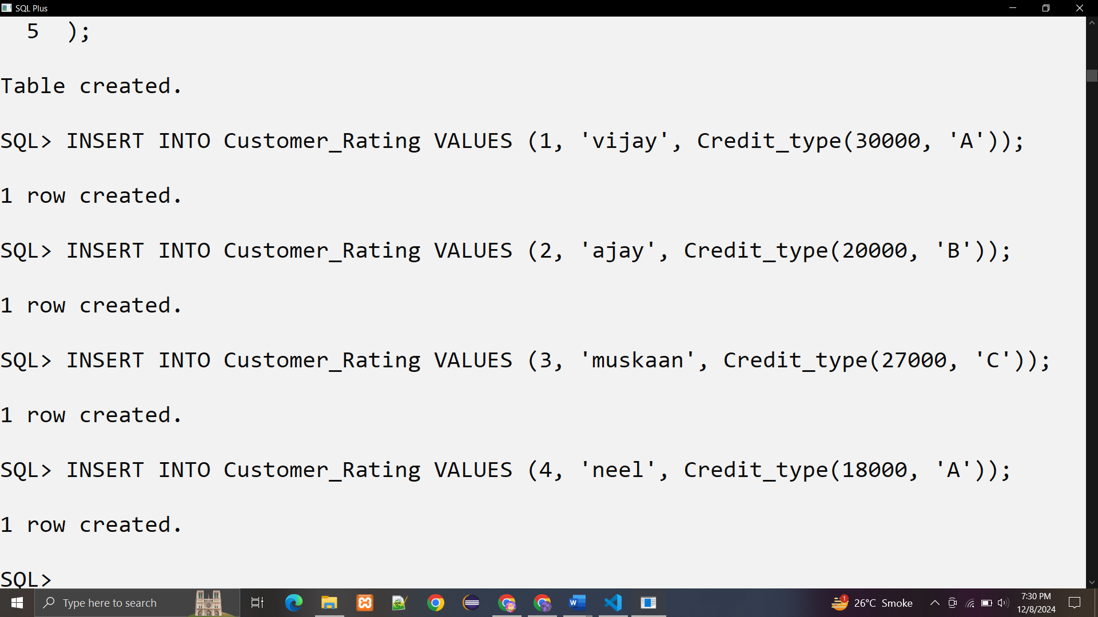

**Q.Display name of all customers:**

**Query:**

SELECT Name FROM Customer_Rating;

**Output**:

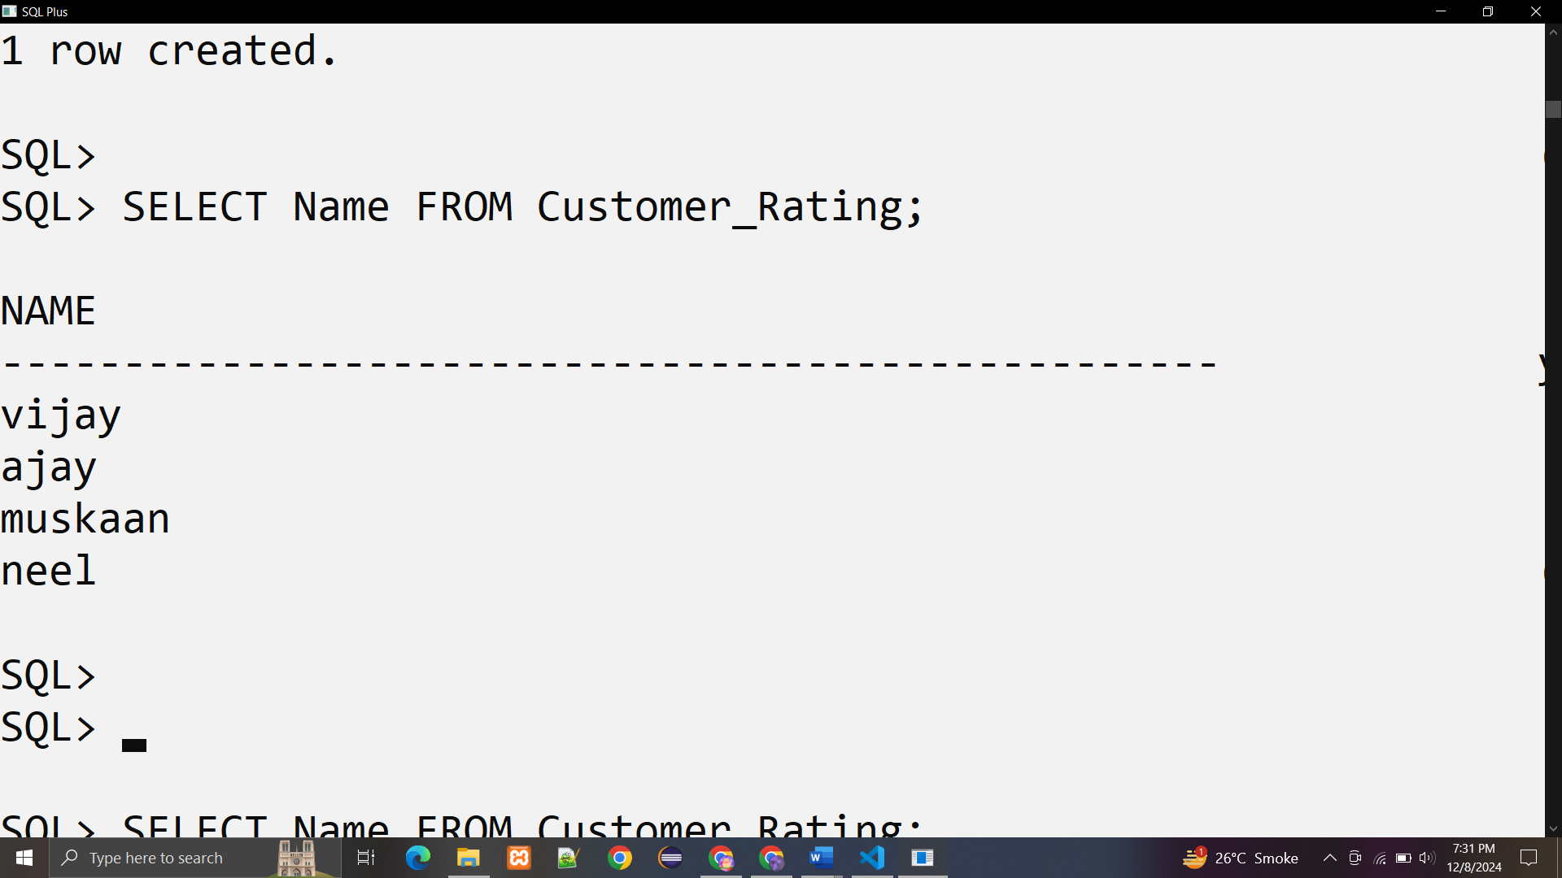

**Q.Display all customers with ‘C’ credit_grade**

SELECT * FROM Customer_Rating c WHERE c.Credits.credit_grade = 'C';

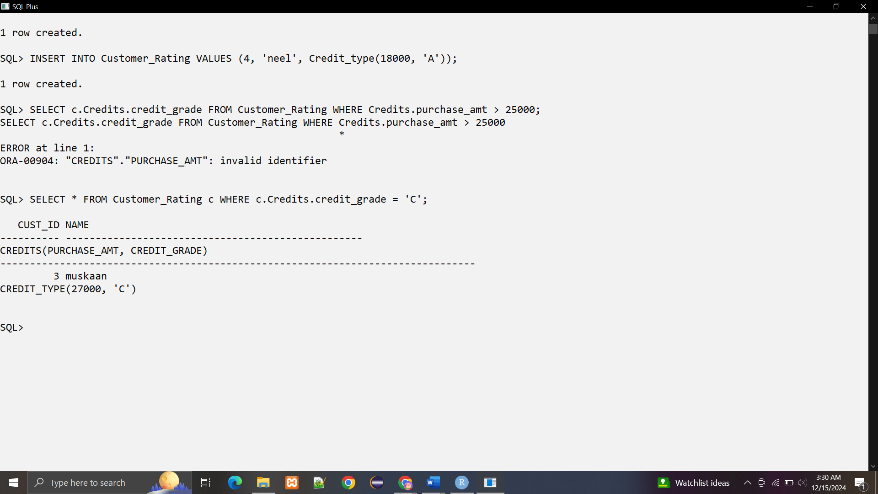

**Output:**

**Q.Display only the Name of customers with ‘A’ and ‘B’ Credit_grade**

SELECT Name FROM Customer_Rating c WHERE c.Credits.credit_grade IN ('A', 'B');

**Output:**

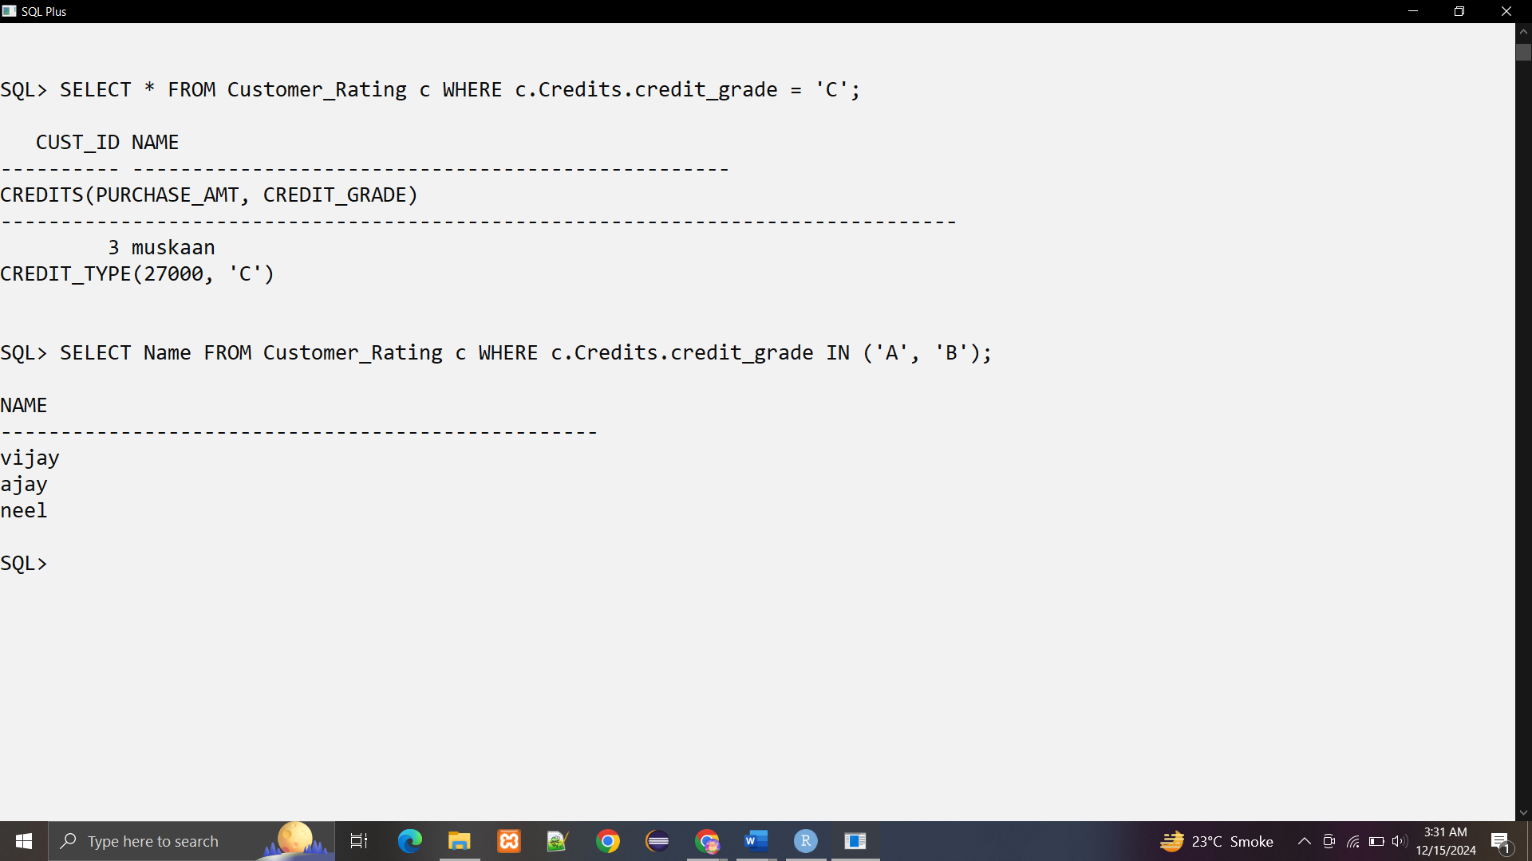

**Practical 4**

**Aim:** **Implementation of ETL transformation with Pentaho .**

**Theory:**

A Pentaho transformation is a sequence of steps that transform and manipulate data. It can be used to extract data from various sources, transform the data, and load it into a target system.

* **Step 1: Connect to MySQL Database**
  + **MySQL Connection Step:** This step connects to the MySQL database using the provided connection details.
  + **Database Table:** Select the table from which you want to extract data.
* **Step 2: Filter and Select Data**
  + **Filter Step:** This step filters the data based on specific conditions.
  + **Select Values Step:** This step selects the required columns from the filtered data.
* **Step 3: Transform Data**
  + **Transform Step:** This step transforms the data as required. For example, you can use this step to convert date formats or perform calculations.
* **Step 4: Export Data to Excel**
  + **Excel Output Step:** This step exports the transformed data to an Excel file.
  + **Excel File Name:** Specify the name and location of the Excel file.
  + **Sheet Name:** Specify the name of the sheet in the Excel file.
* **ETL Transformation with Pentaho**

ETL (Extract, Transform, Load) is a process of extracting data from various sources, transforming it according to business requirements, and loading it into a target system. Pentaho provides a range of transformation steps that can be used to implement ETL processes.

* + **Transformation Steps**
    1. **Copy Data**
       - Source: Table/Excel/Oracle
       - Target: Table/Excel/Oracle
       - Example: Copy data from a MySQL table to an Excel file.
    2. **Sequence**
       - Used to generate a sequence of numbers or dates.
       - Example: Generate a sequence of numbers starting from 1 to 100.
    3. **Calculator**
       - Used to perform mathematical operations on data.
       - Example: Calculate the sum of two columns.
    4. **Concatenation**
       - Used to concatenate two or more fields.
       - Example: Concatenate two columns, "First Name" and "Last Name", into a single column "Full Name".
    5. **Split**
       - Used to split a single field into multiple fields.
       - Example: Split a field "Address" into separate fields "Street", "City", and "State".
    6. **Number Range**
       - Used to perform range-based operations on numbers.
       - Example: Filter rows where the value is between 1 and 100.
    7. **String Operations**
       - Used to perform string-based operations, such as trimming or converting to uppercase.
       - Example: Trim leading and trailing spaces from a column.
    8. **Sorting**
       - Used to sort data in ascending or descending order.
       - Example: Sort data by a specific column in ascending order.
* **Merge Join Transformation**

The Merge Join transformation is used to combine data from two tables based on a common key.

•Example: Combine data from two tables, "orders" and "customers", based on the "customer_id" column.

* **Data Validations**

Data validations are used to ensure that the data meets certain conditions before it is loaded into the target system.

•Example: Validate that the "price" column is greater than 0 before loading it into the target table.

* **Benefits of ETL Transformation with Pentaho**

• Easy Data Integration: Pentaho provides an easy-to-use interface for integrating data from various sources.

• Flexible Data Transformation: Pentaho provides a wide range of transformation steps that can be used to manipulate data as required.

• Improved Data Quality: ETL transformation helps to ensure that data is accurate and consistent across systems.

By using Pentaho's ETL transformation capabilities, you can implement complex data transformations and ensure that your data is accurate, consistent, and up-to-date.

**1. create a pentaho transformation to get data from mysql and push required data into an excel file**

**Create table customer:**

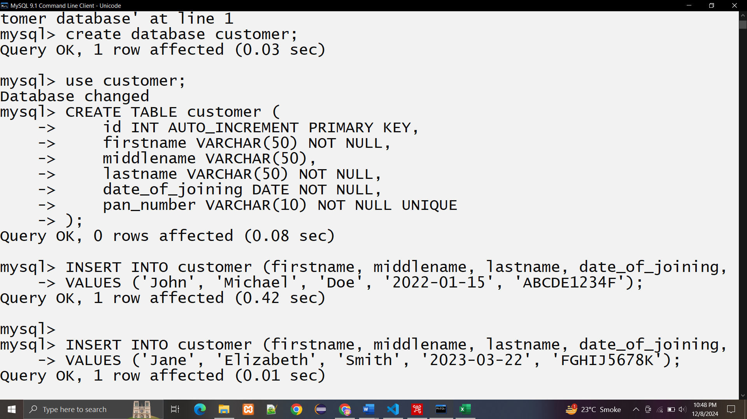

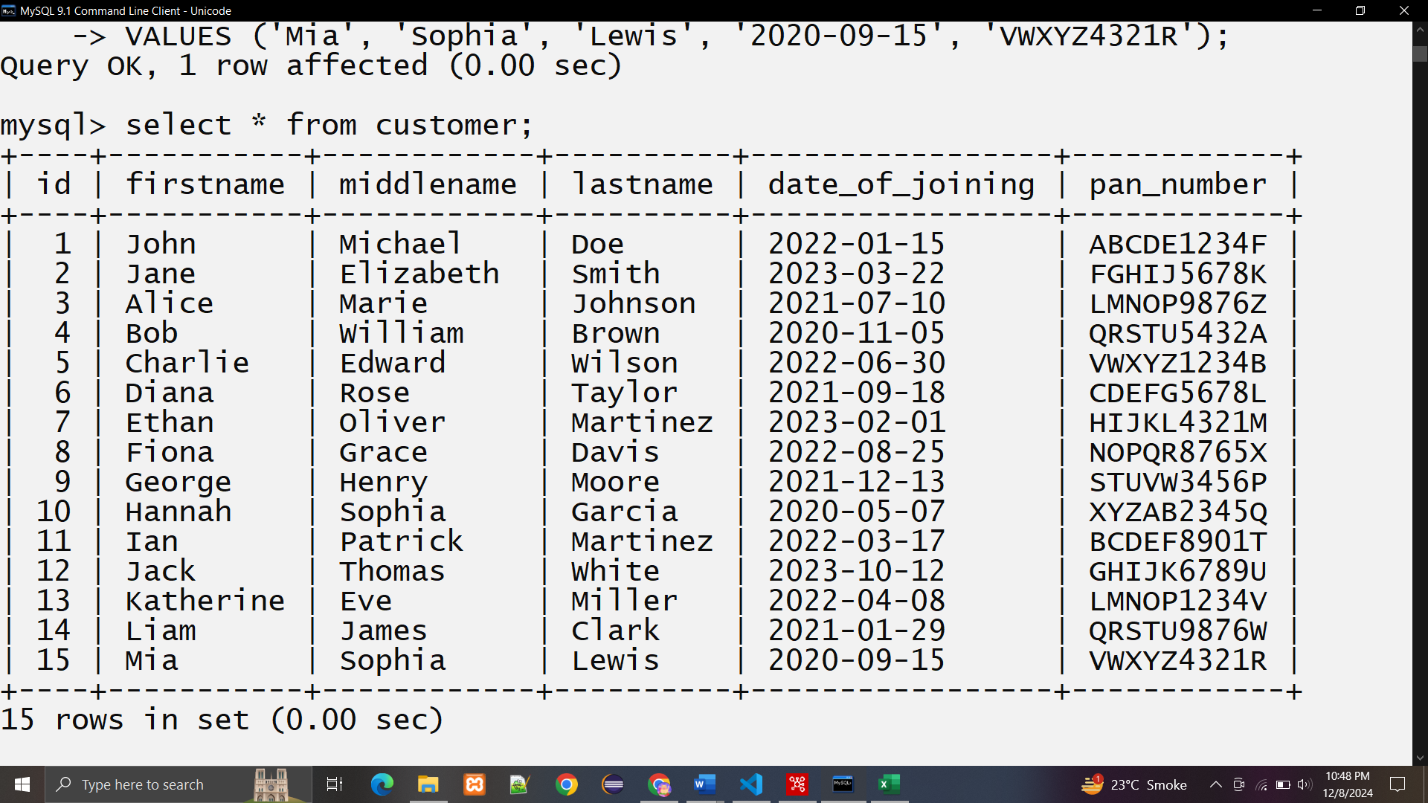

**Establish connection with the database:**

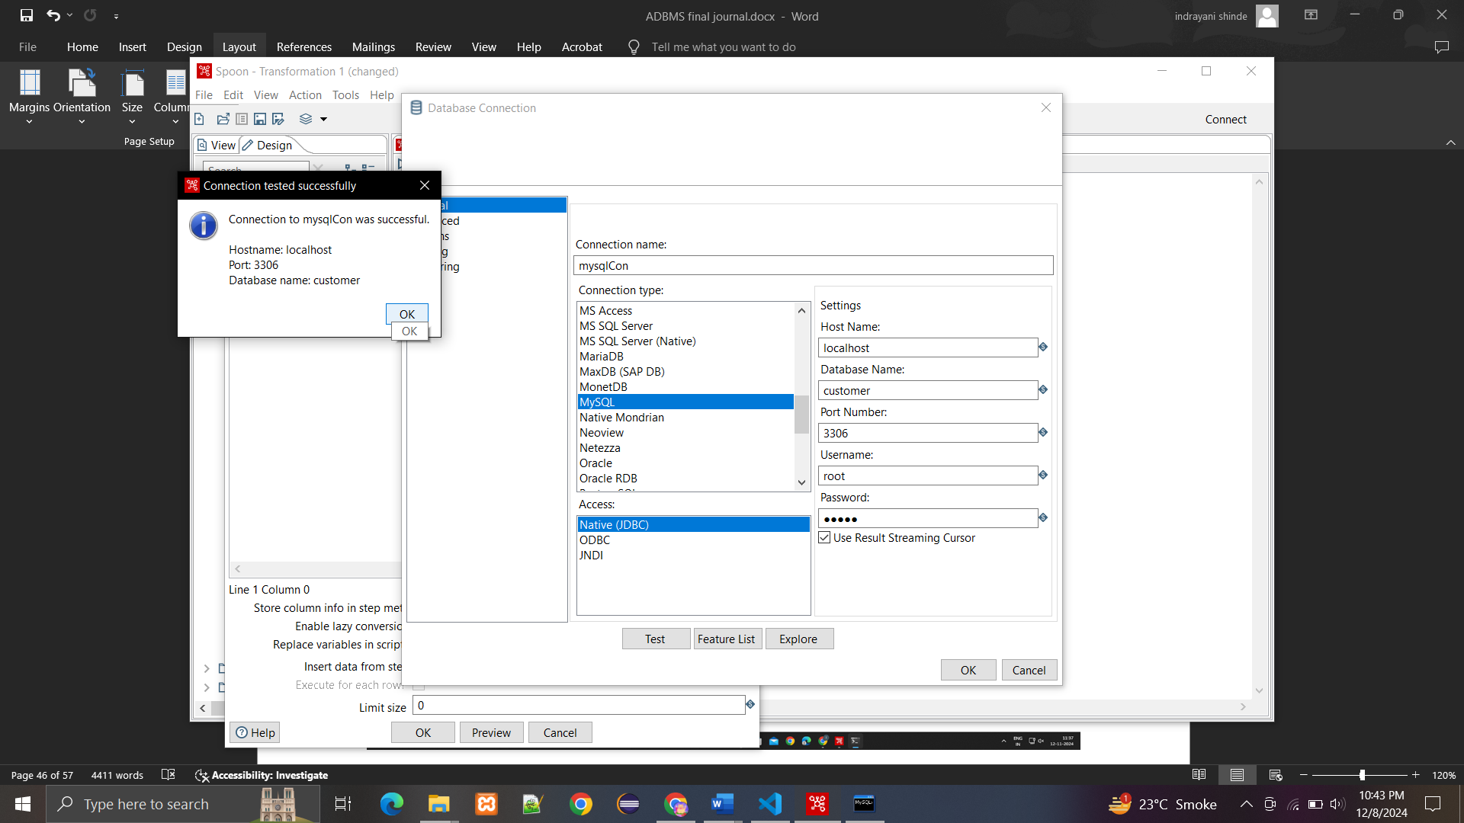

**Transformation:**

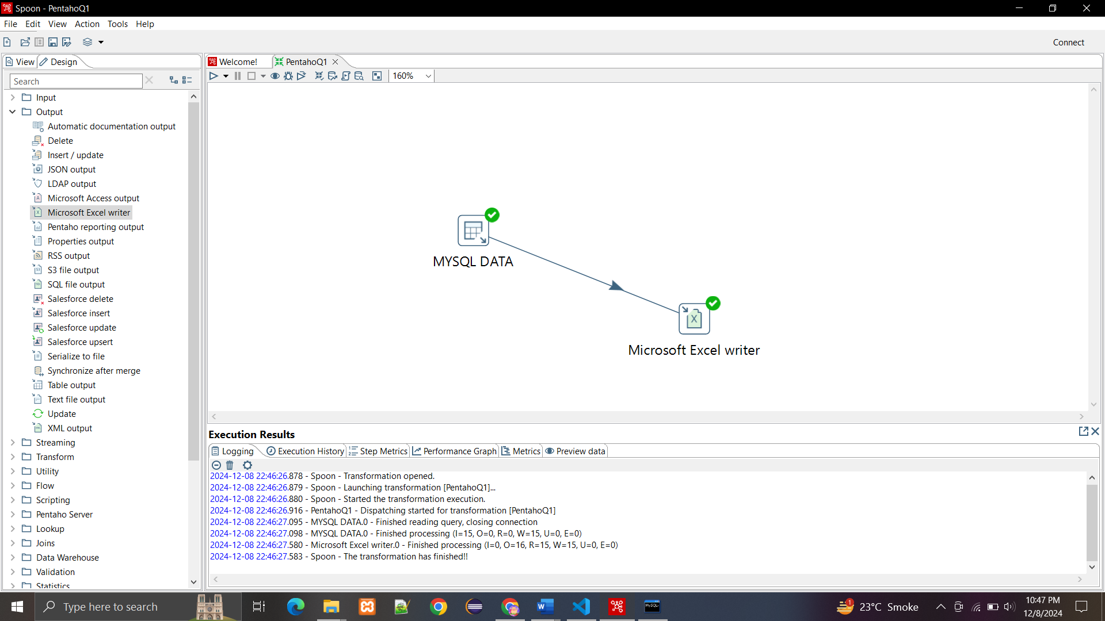

**Data flushed to excel:**

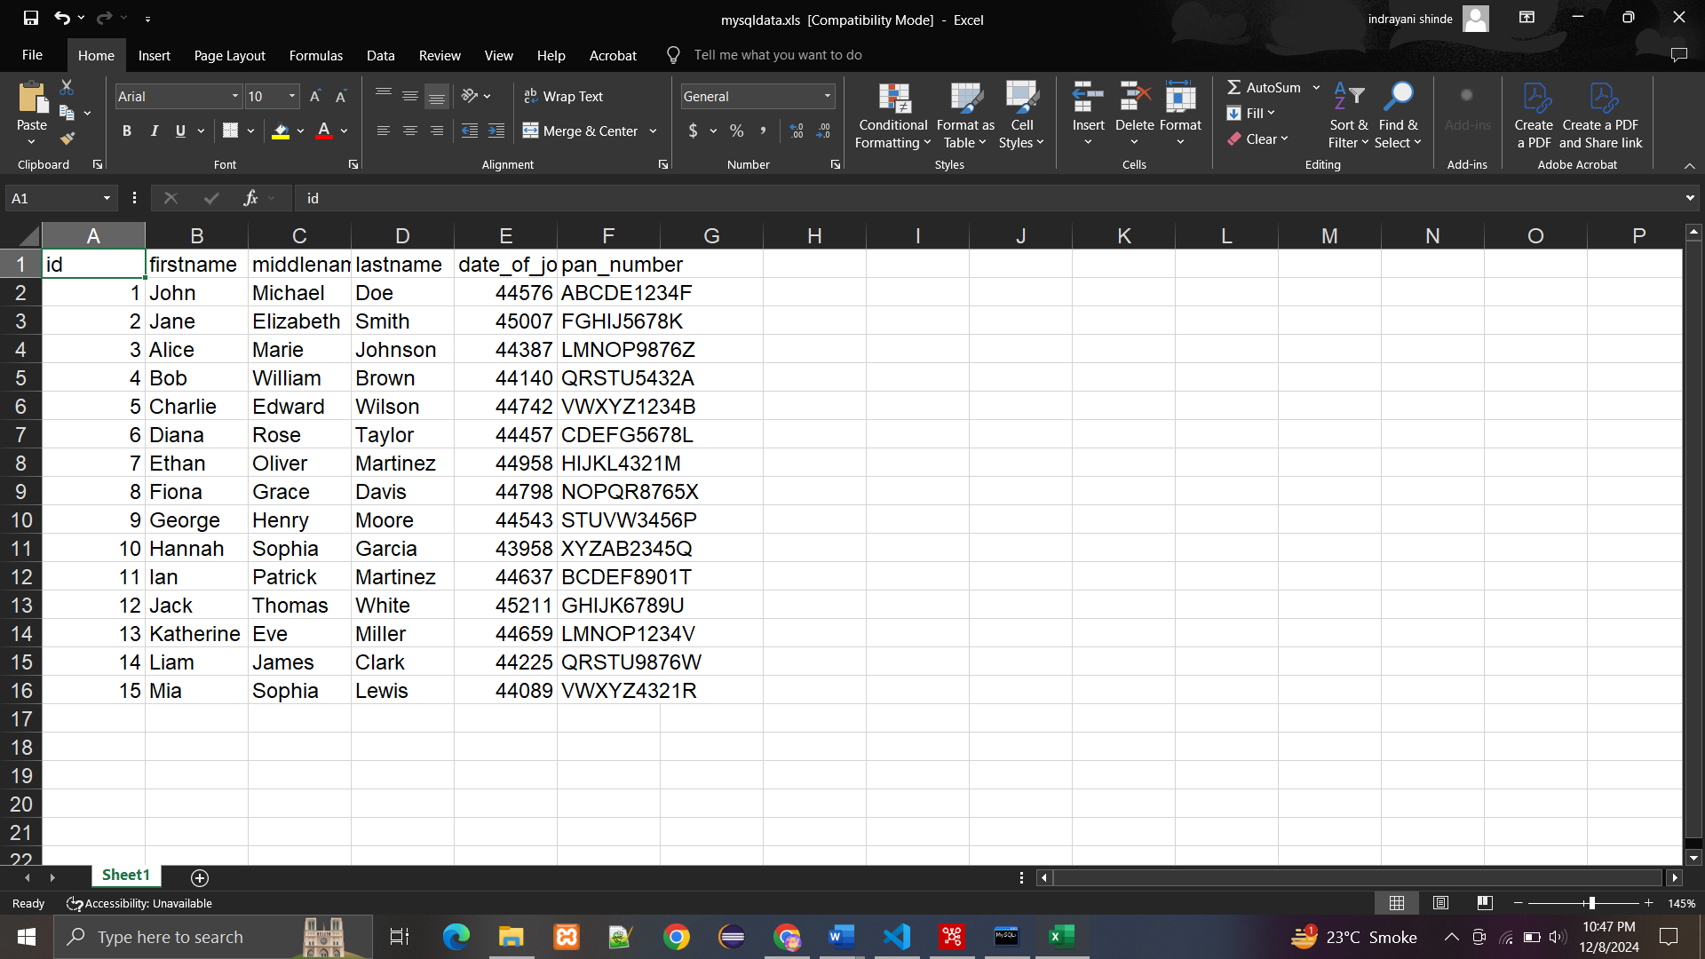

**2. Create a pentaho transformation to get required data from excel file and push it into mysql**

**Excel data :**

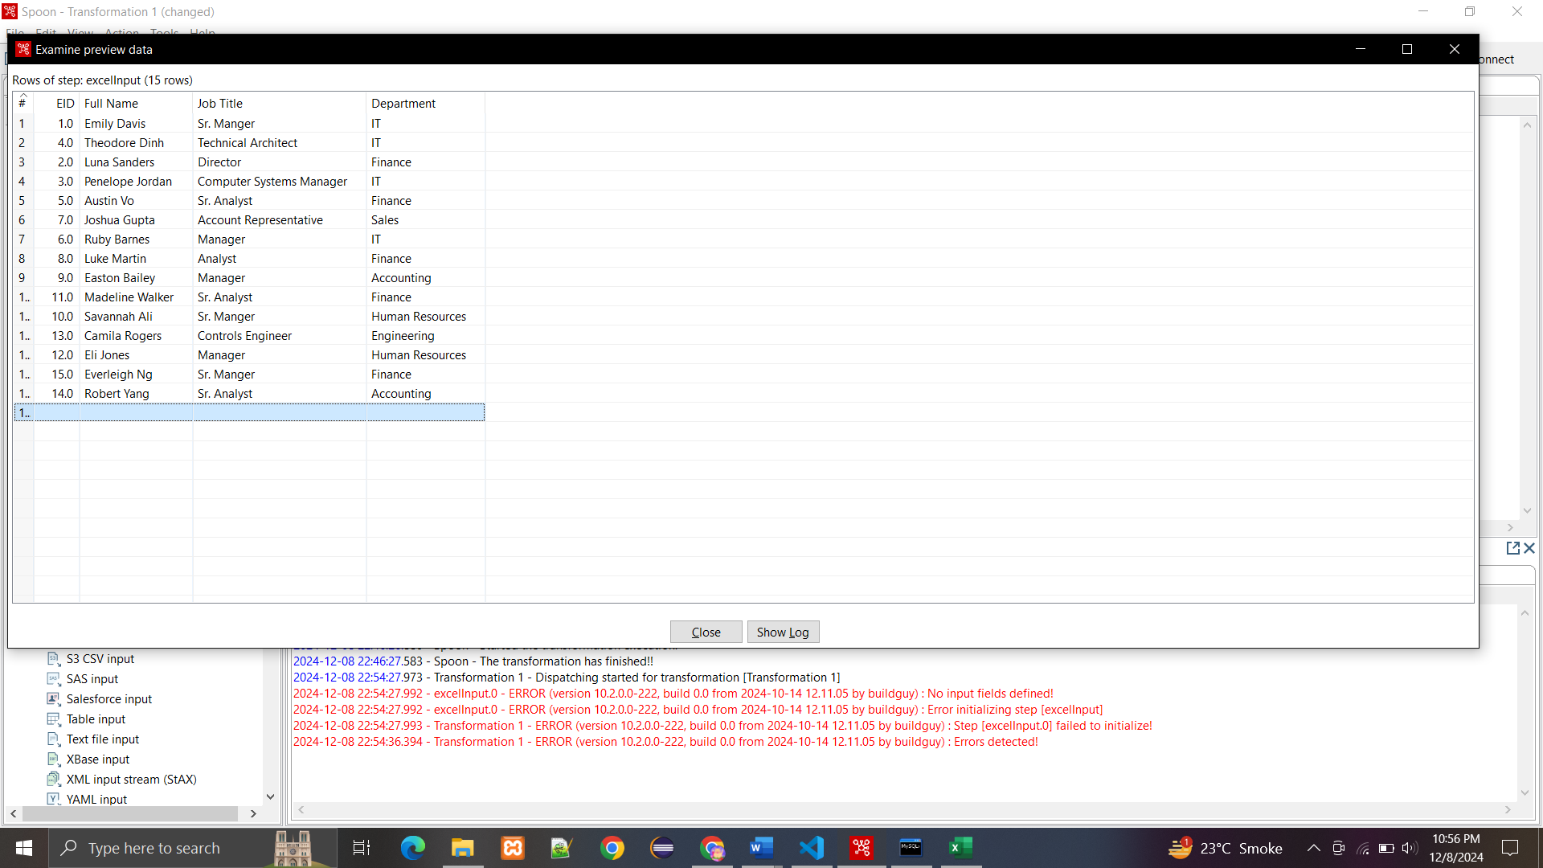

**Establishing database connection:**

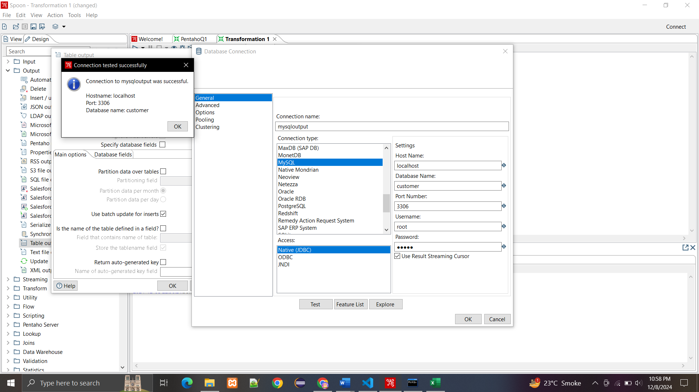

**Transformation:**

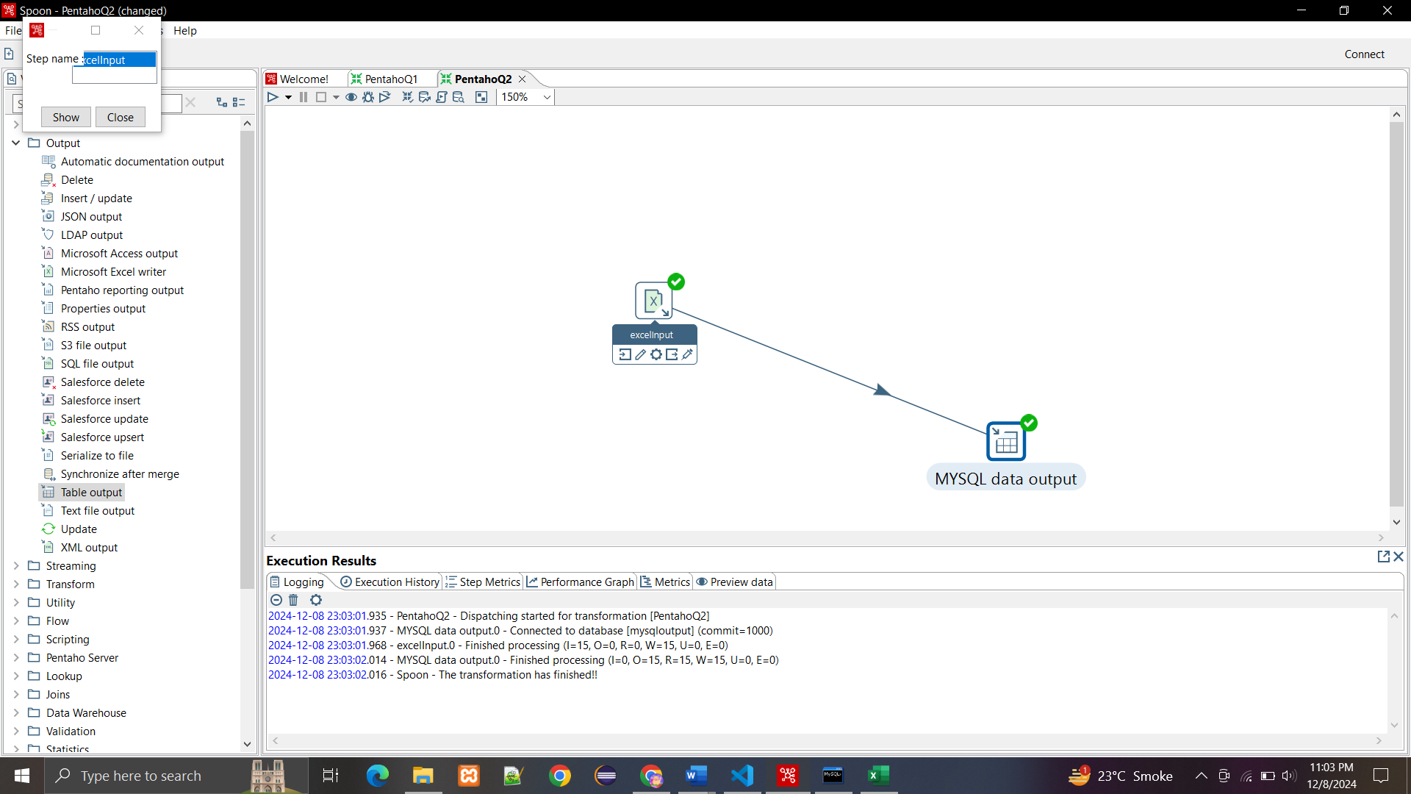

**Flushed data to the database:**

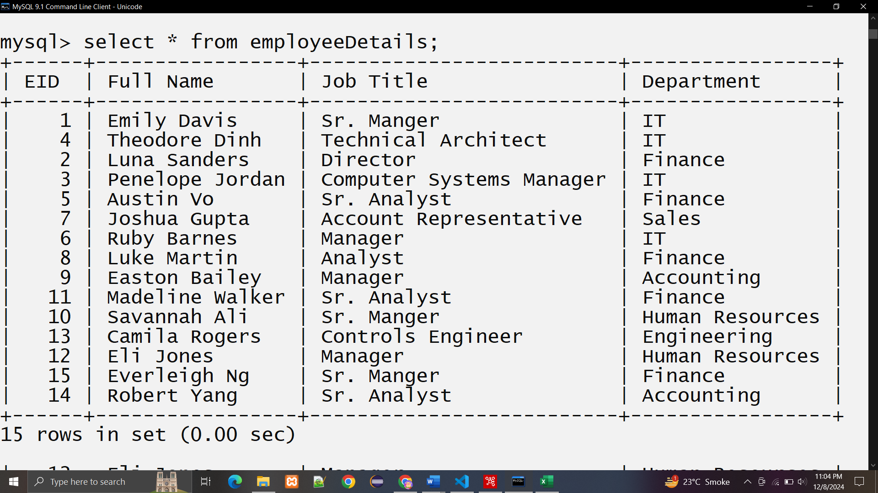

1. **Create a pentaho tranformation to get data from mysql table add serial no to the data using pentaho sequences and push data into a excel.**

**Connection Established to the database:**

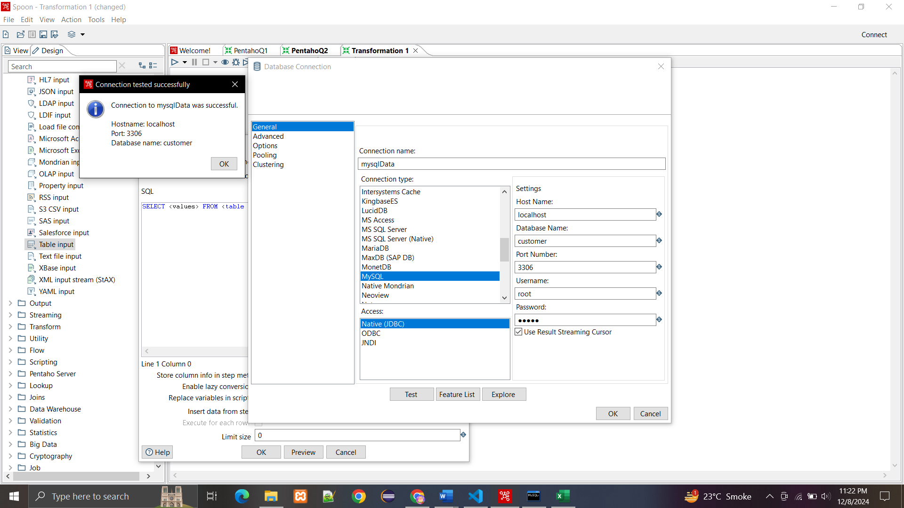

**Data from database:**

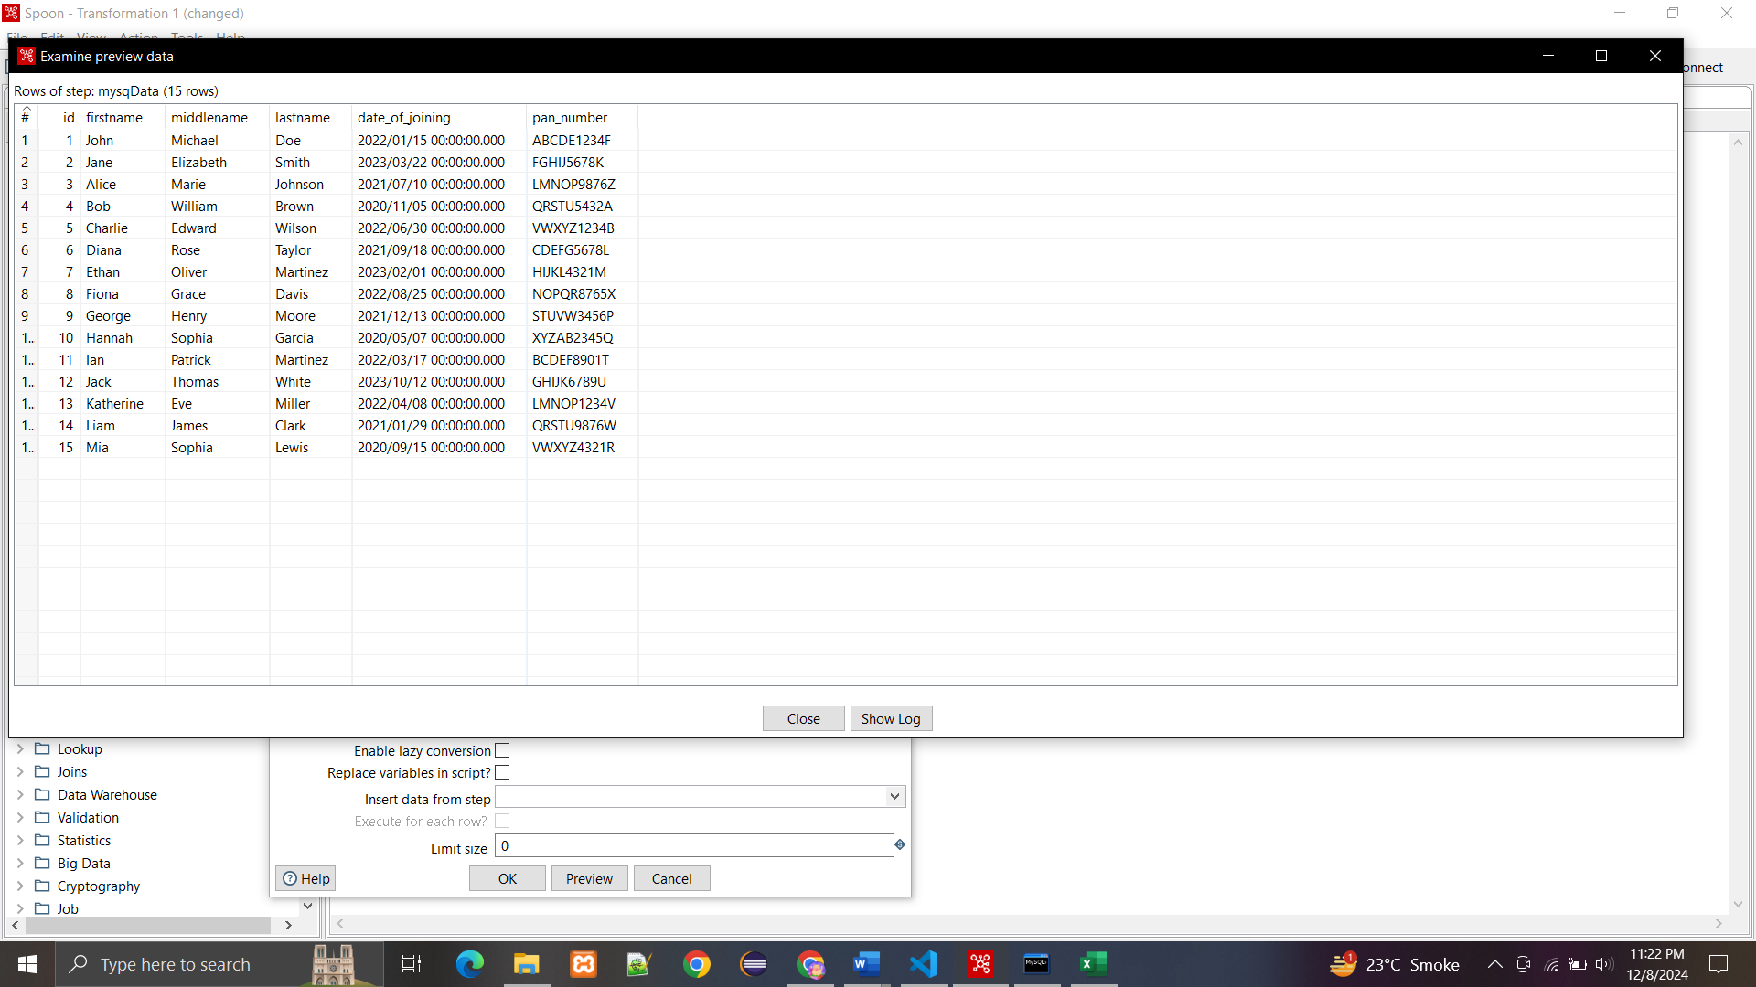

**Flushed into the excel:**

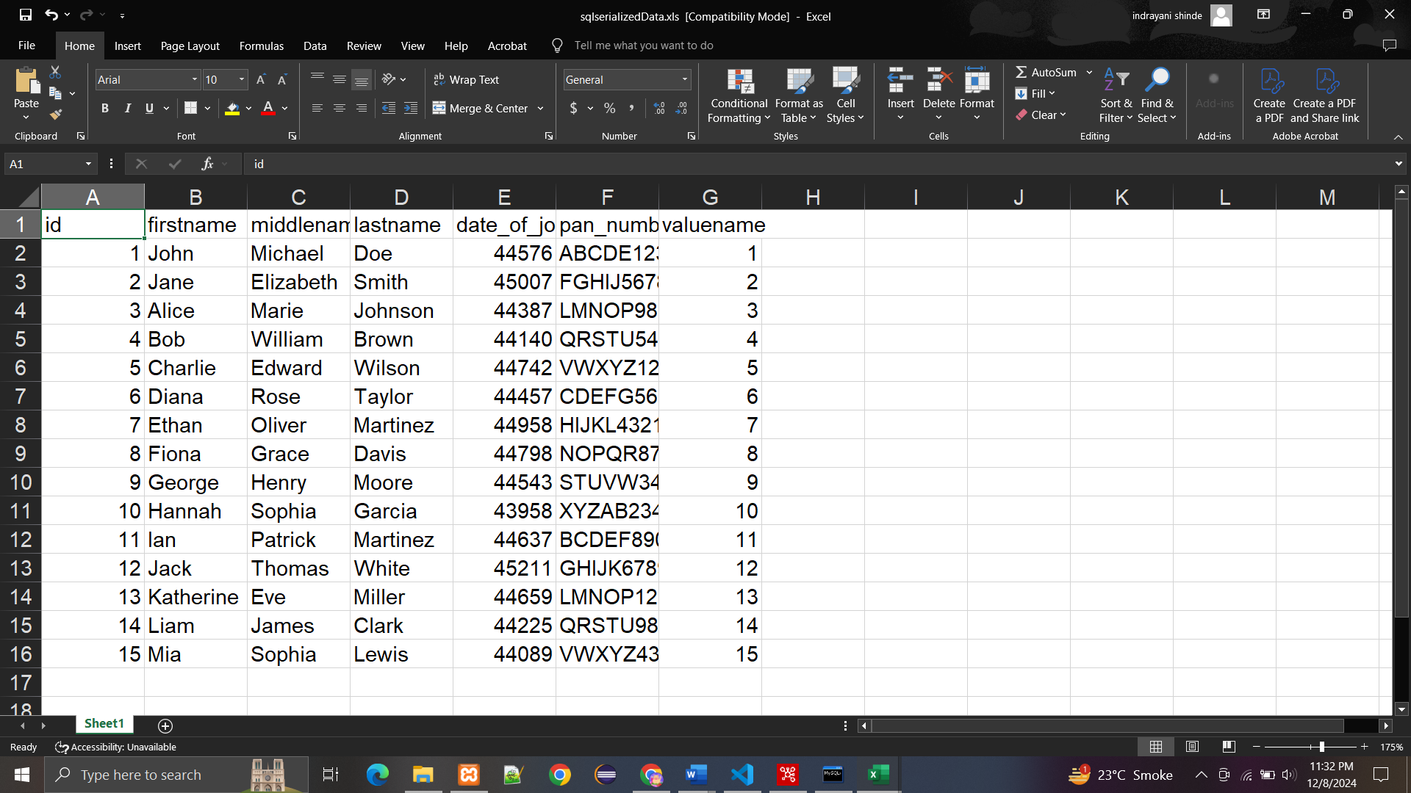

**4. Create a pentaho tranformation to get data from mysql table named as employee have the following columns (emp_id,full name and job_id). Split the full name of the employee using pentaho split tranformation and store the data into a new table in mysql name as emp1 having the following columns (emp_id,fname,mname,lname and job_id).**

**SQL Queries:**

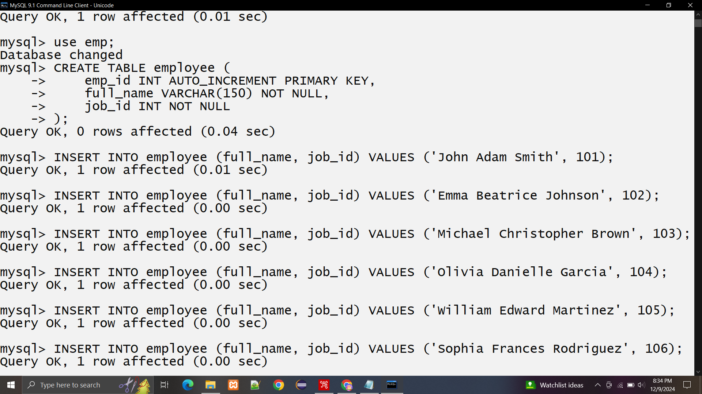

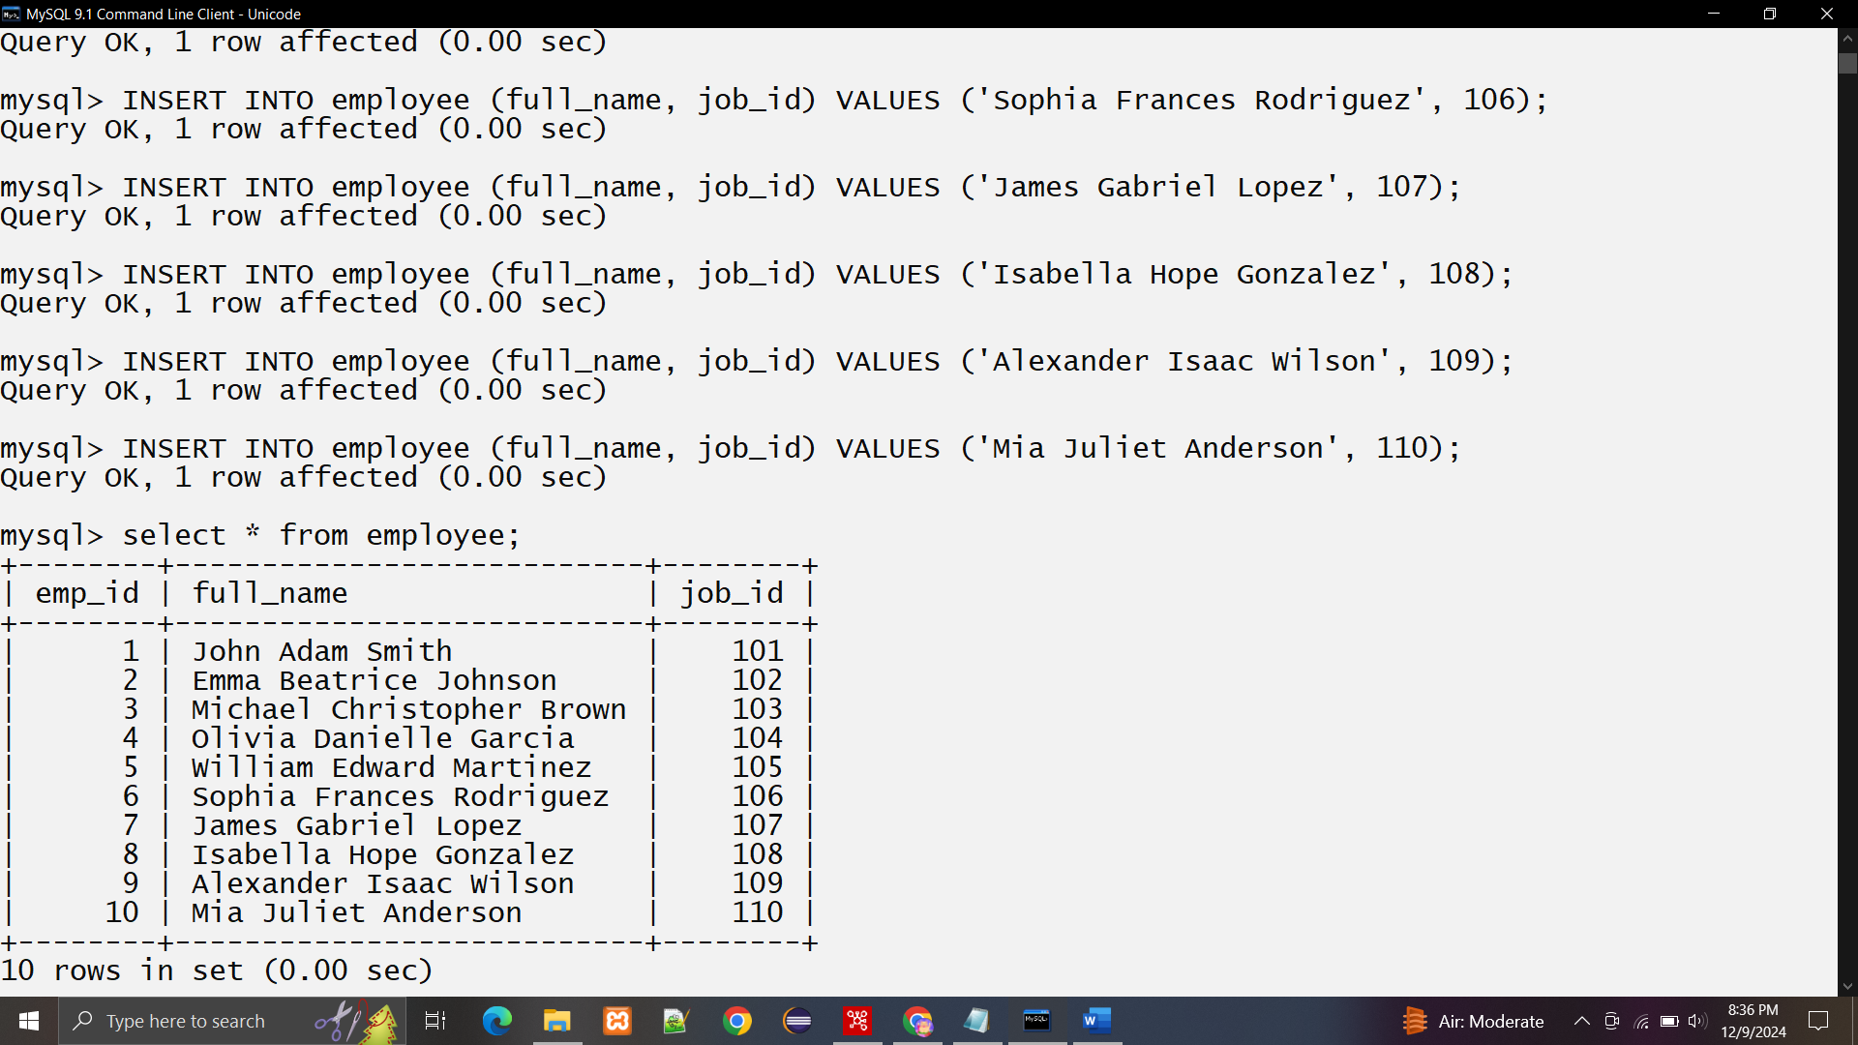

**Database connection established:**

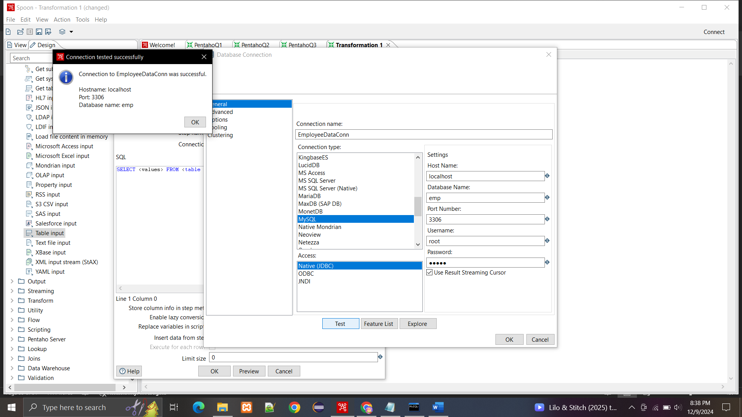

**Splitting the fullname field into firstname, middlename, lastname .**

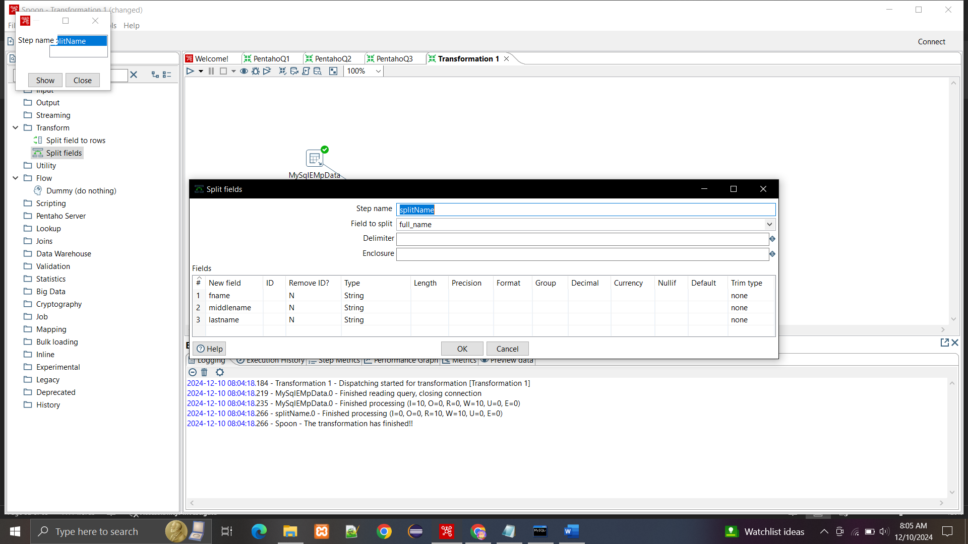

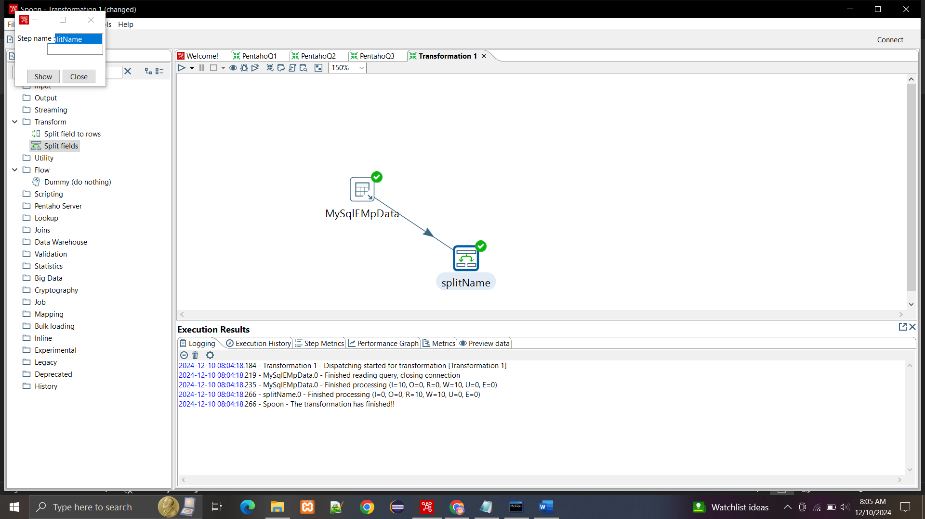

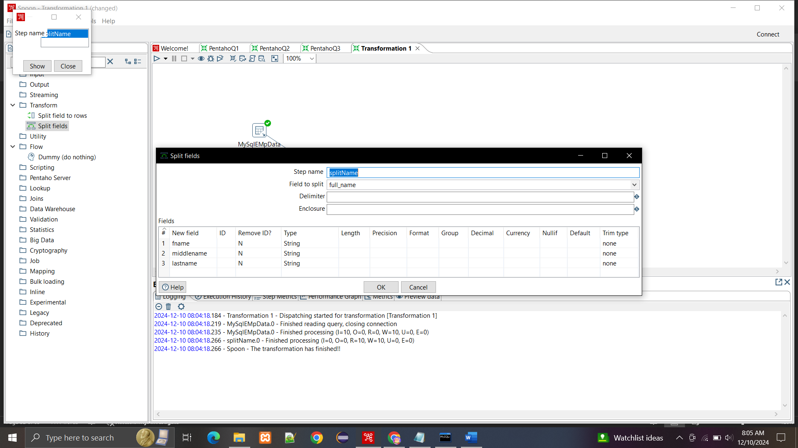

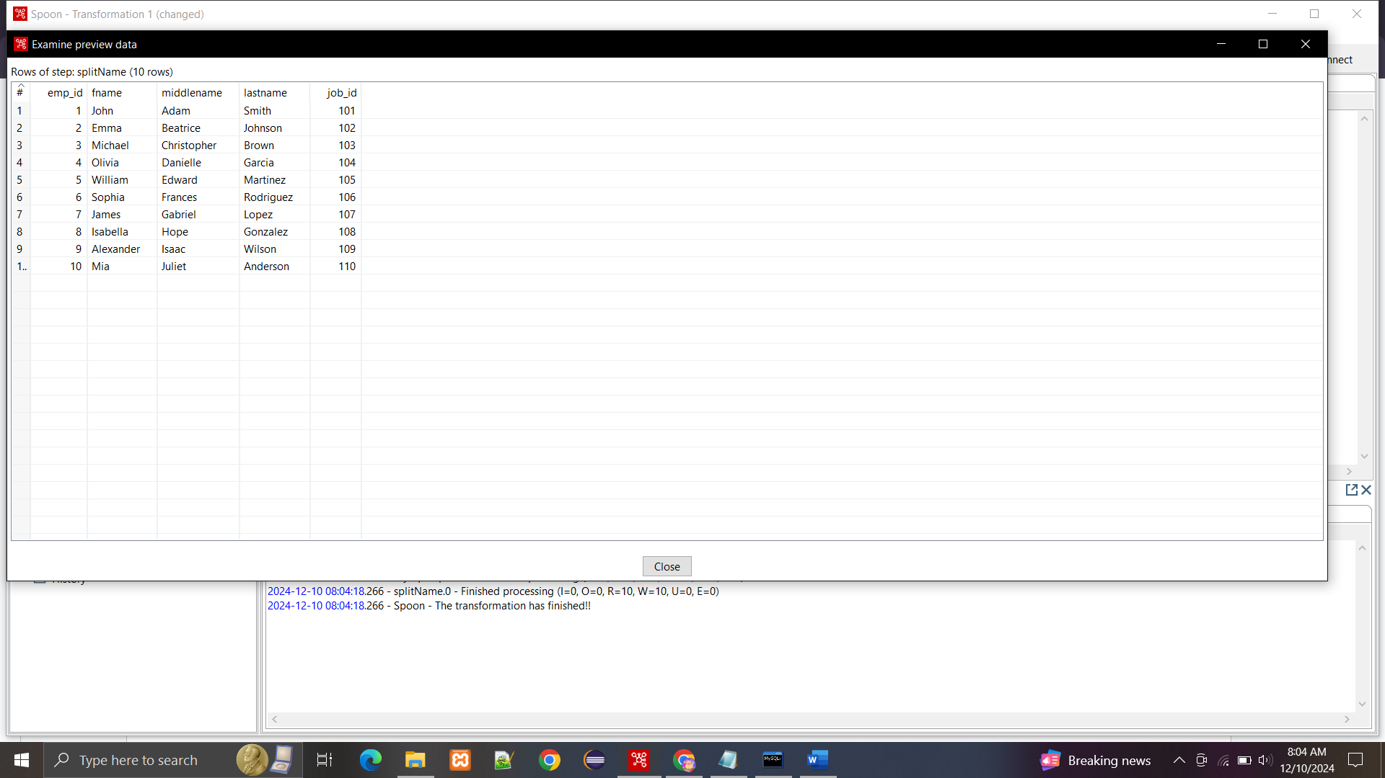

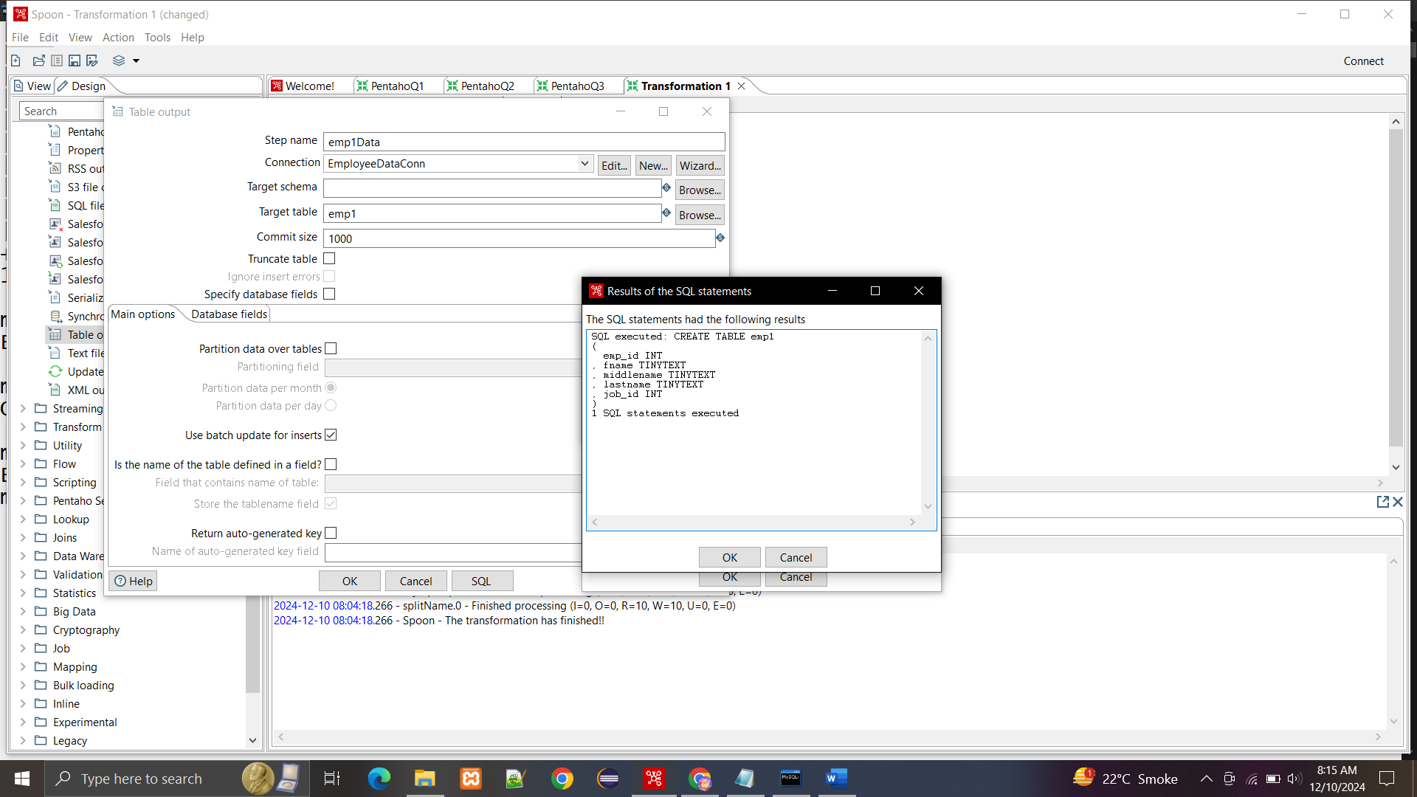

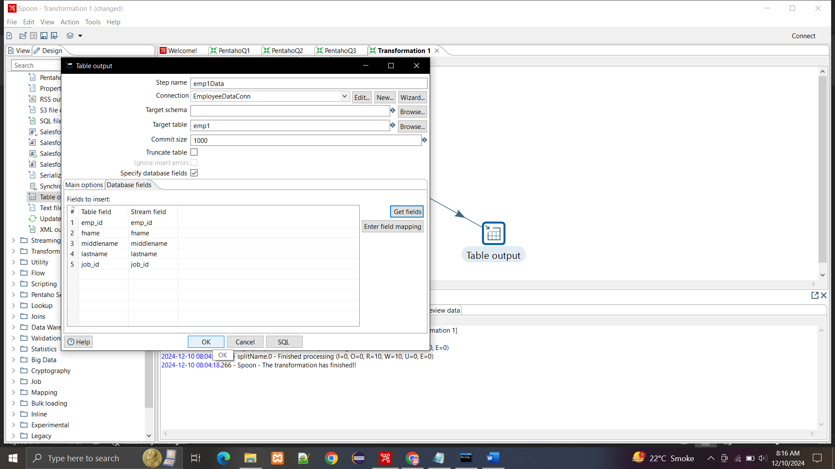

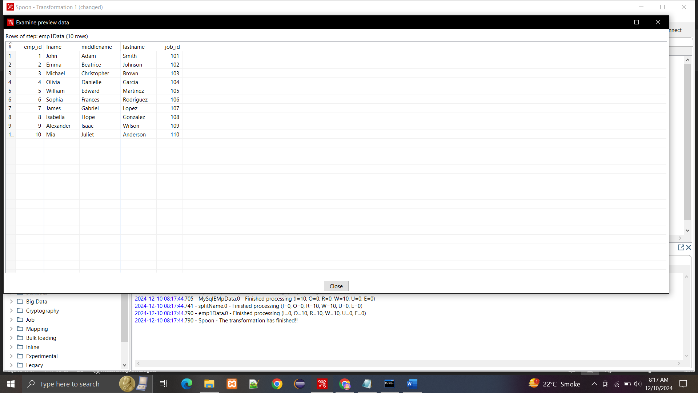

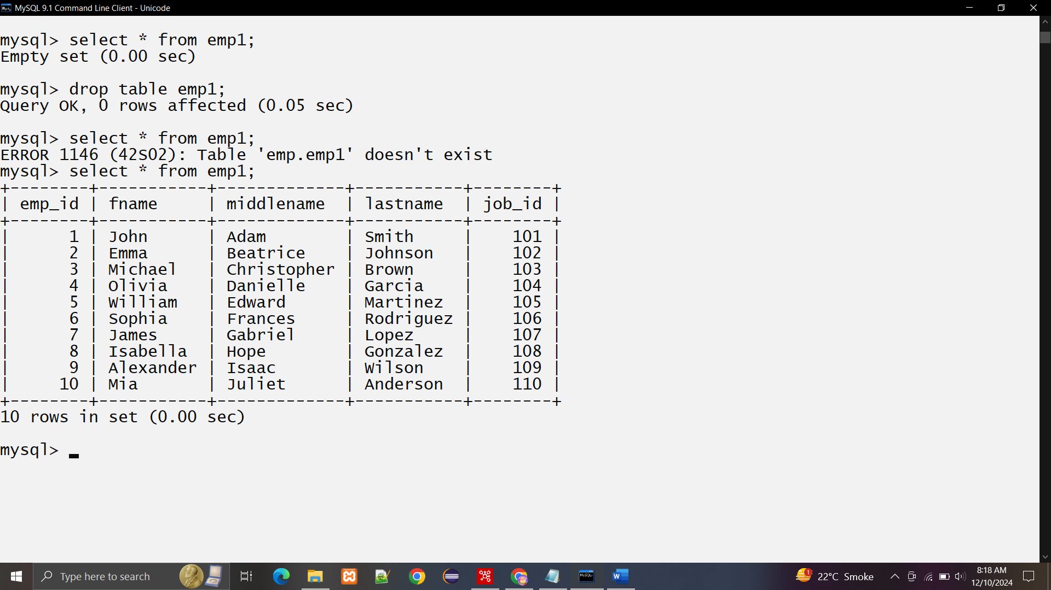

**5. create a two excel files with following columns**

**(a) data 1: EID, Full Name, Job, Title, Department.**

**data 2:EID,Business,Unit, Gender, Ethnicity,Age.**

**EID in data 1 points to EID in data 2 . Make sure to have atleast 10 to 15 rows in the file. sort the data using sort tranformation of pentaho.**

**(b) Merge join the sorted in pentaho and remove repeated rows and save the data in mysql table.**

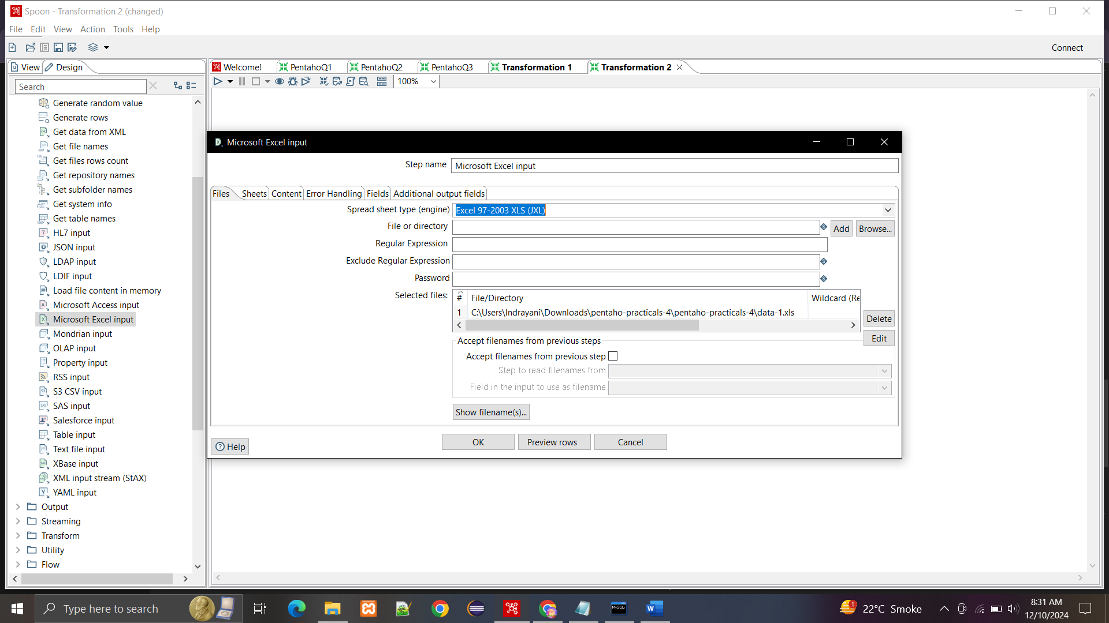

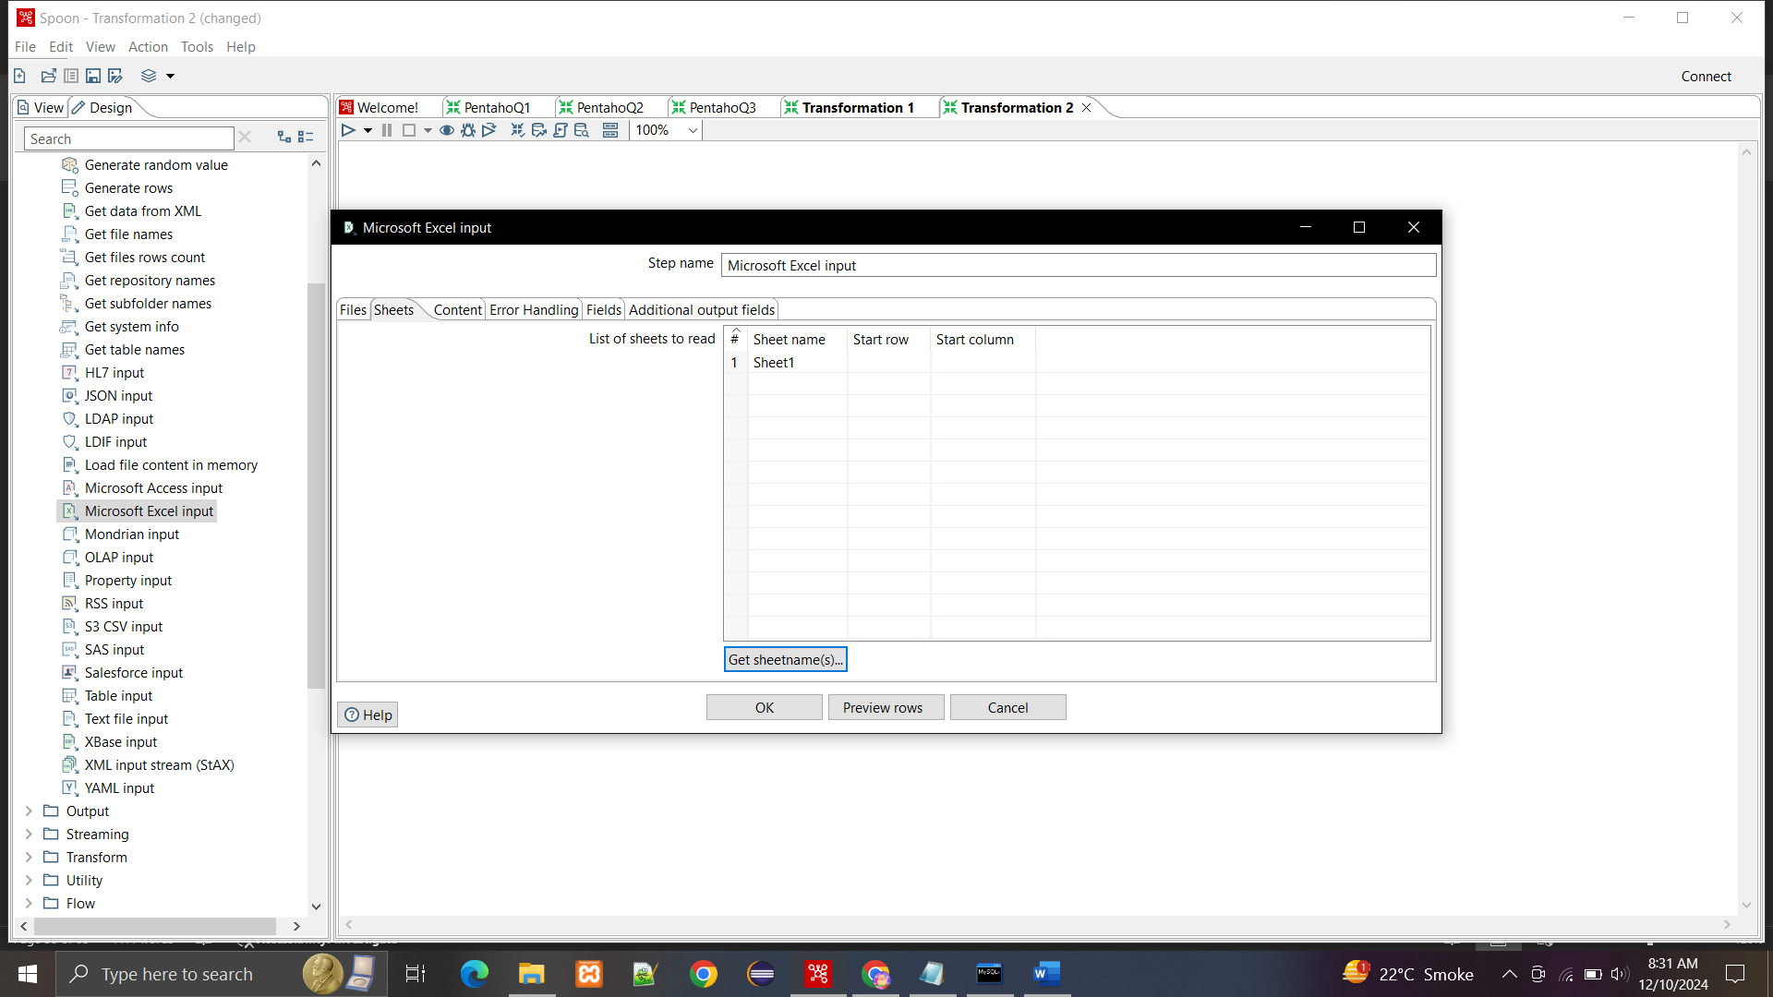

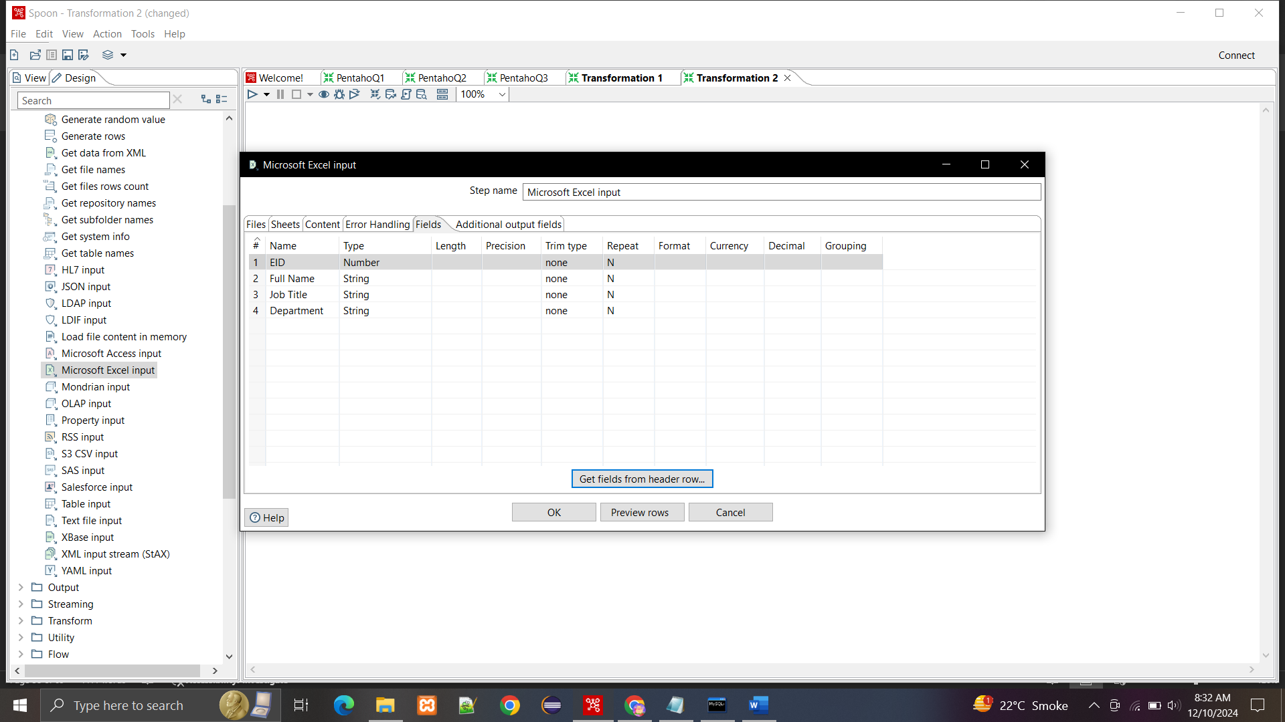

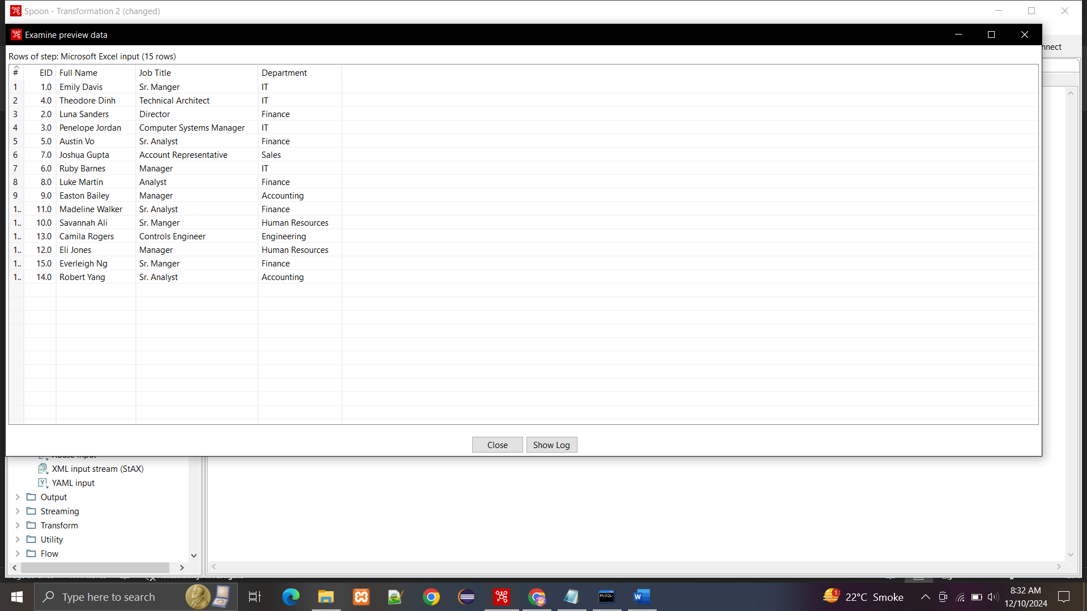

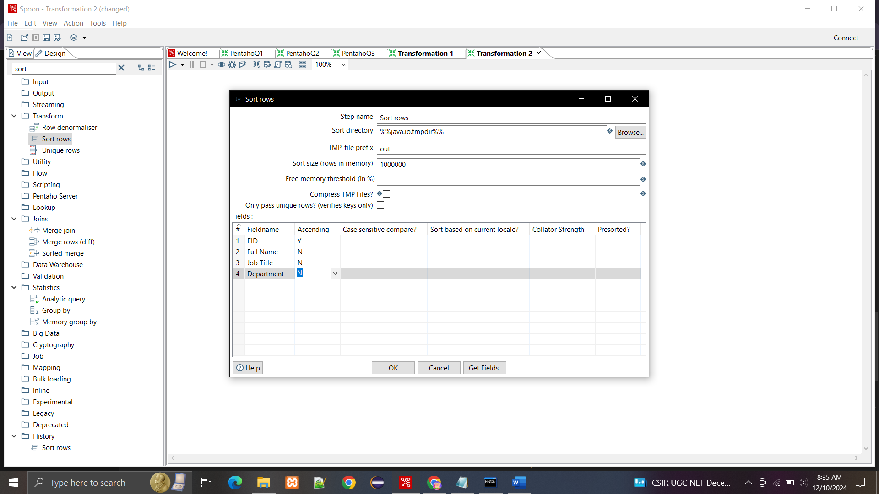

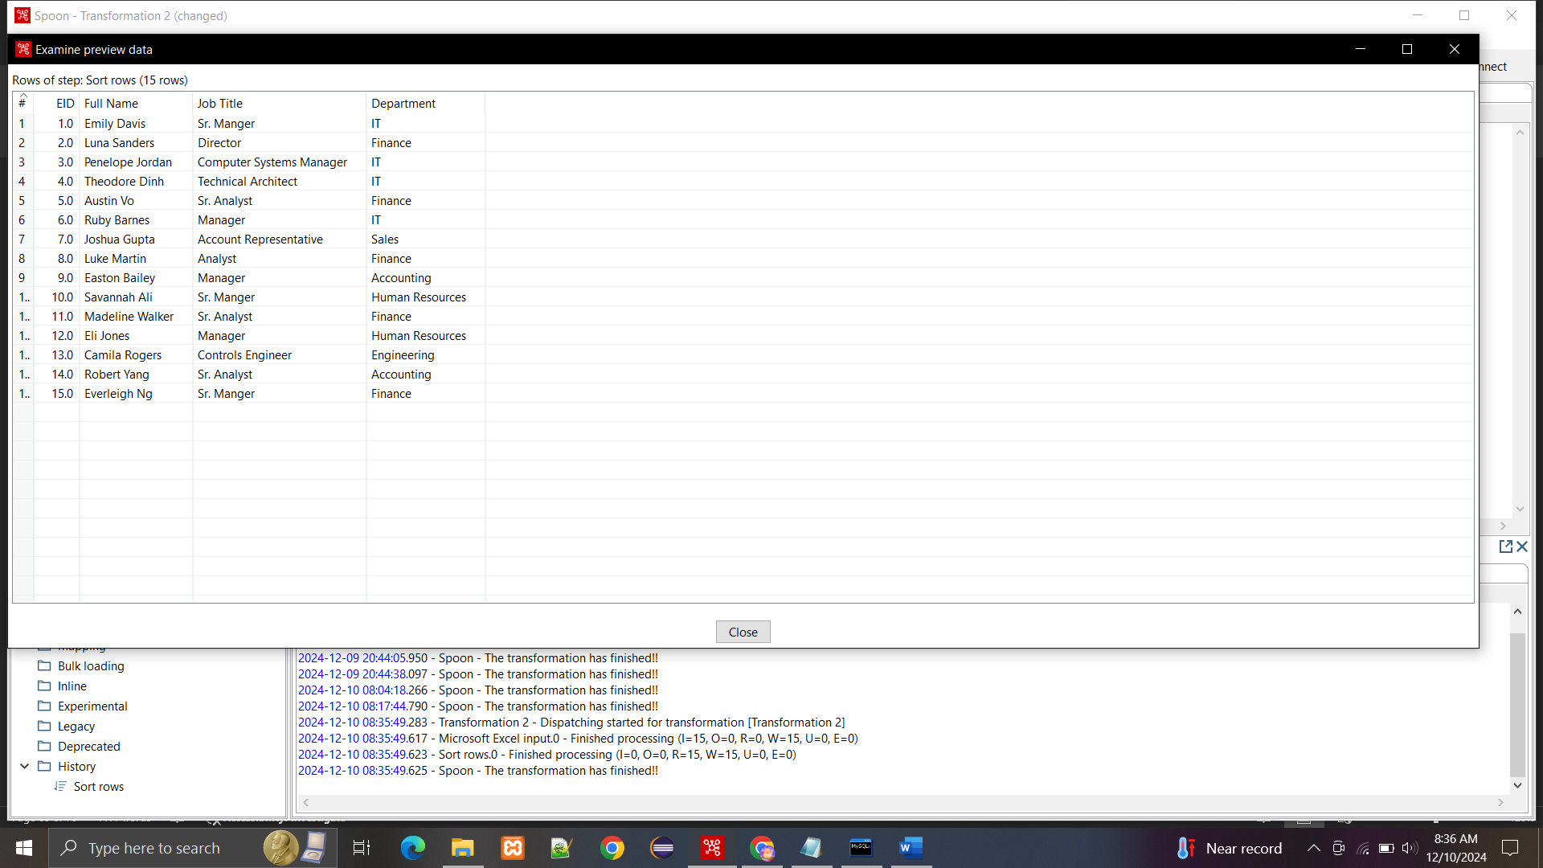

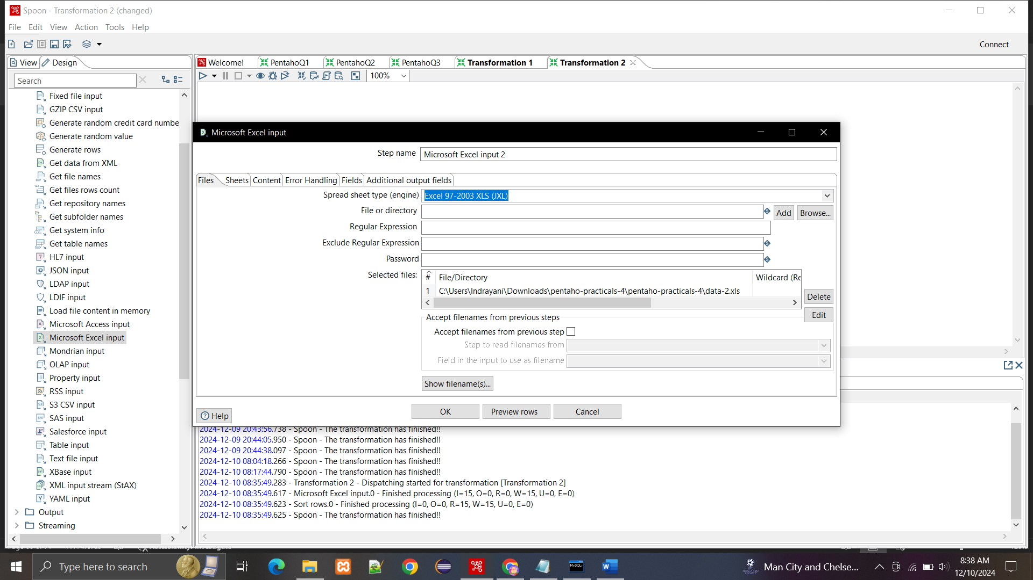

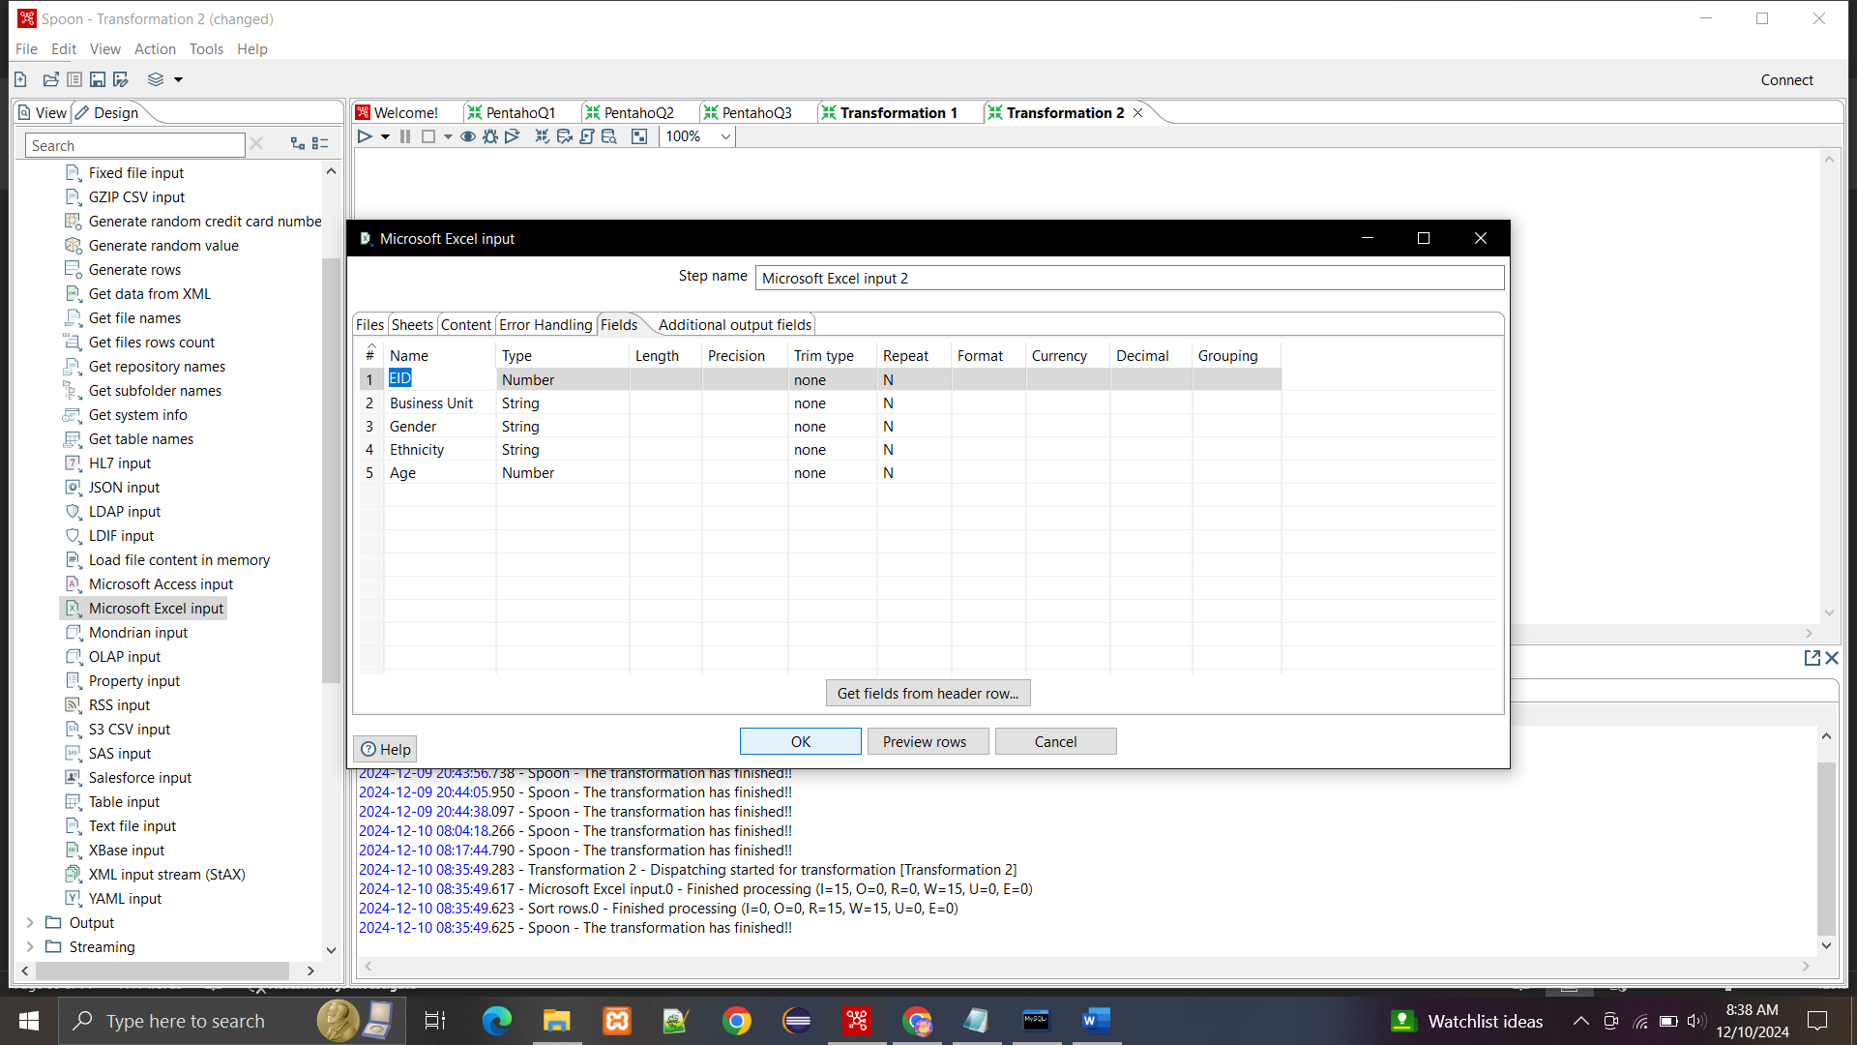

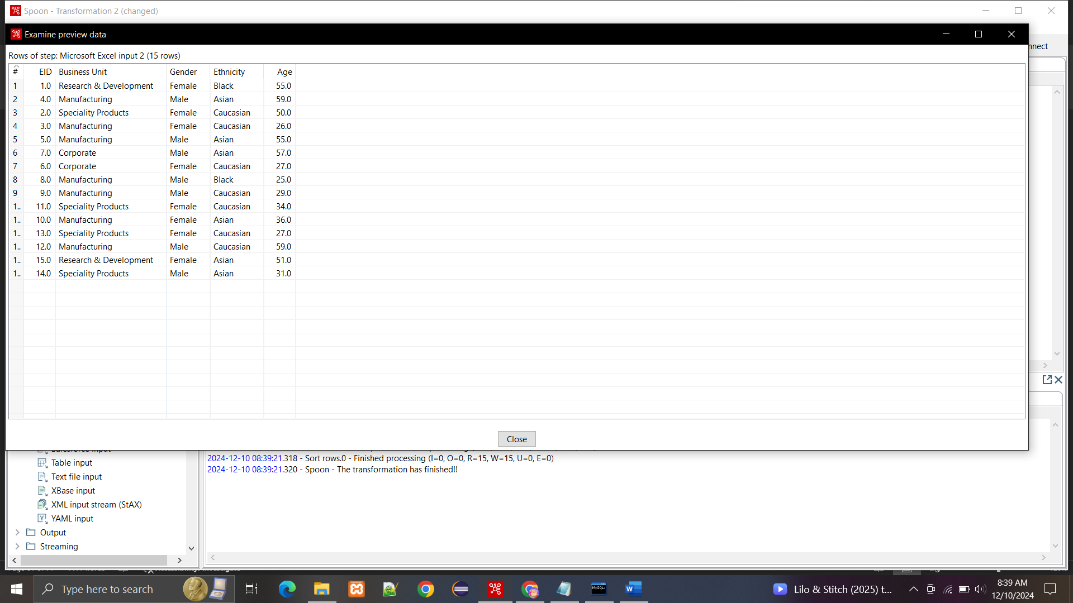

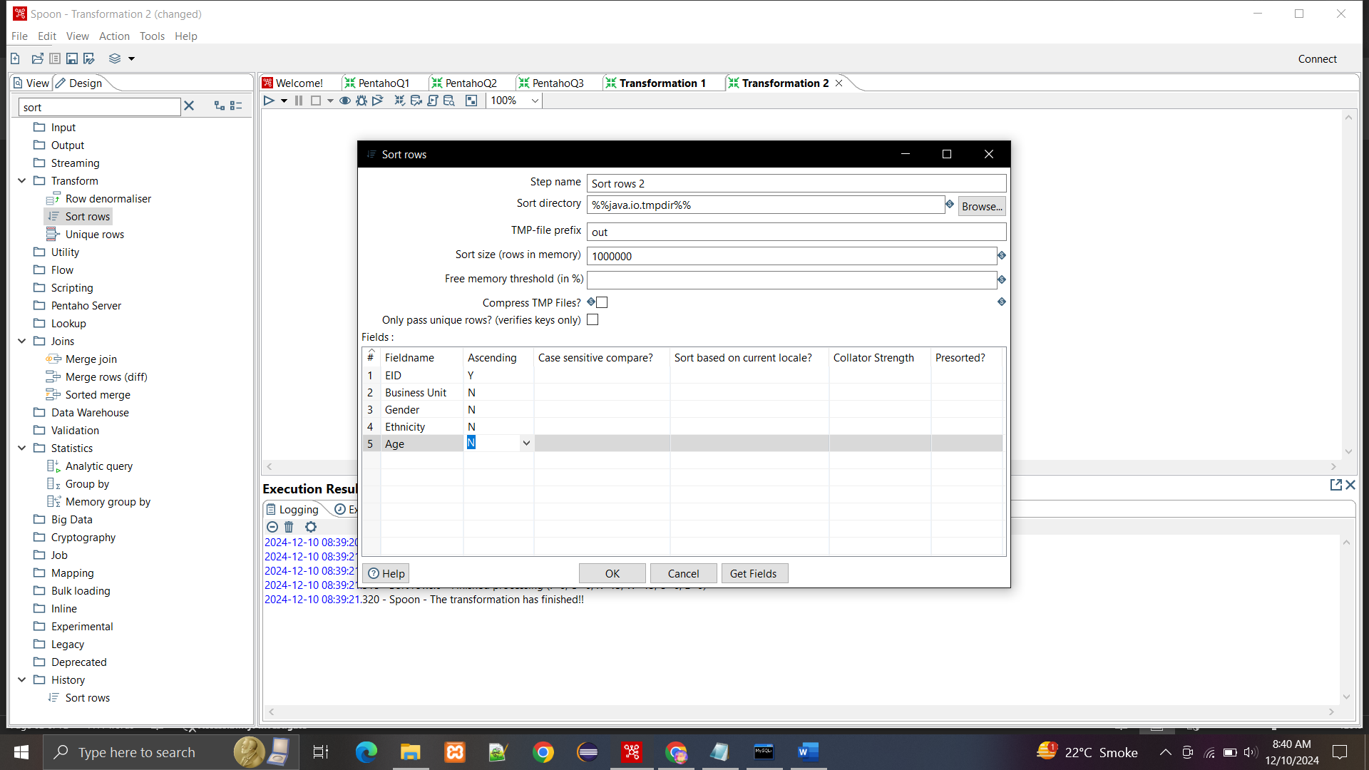

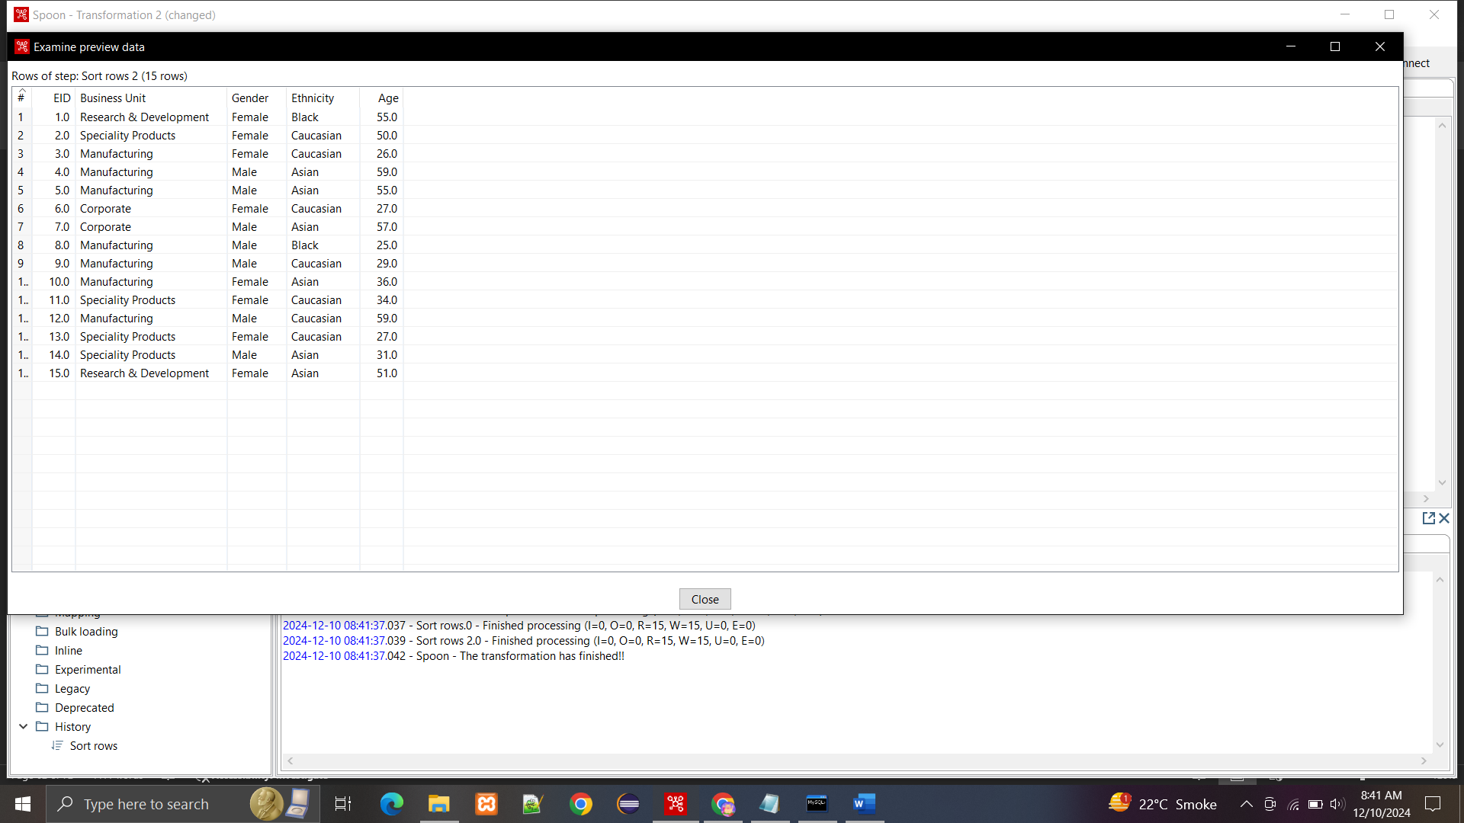

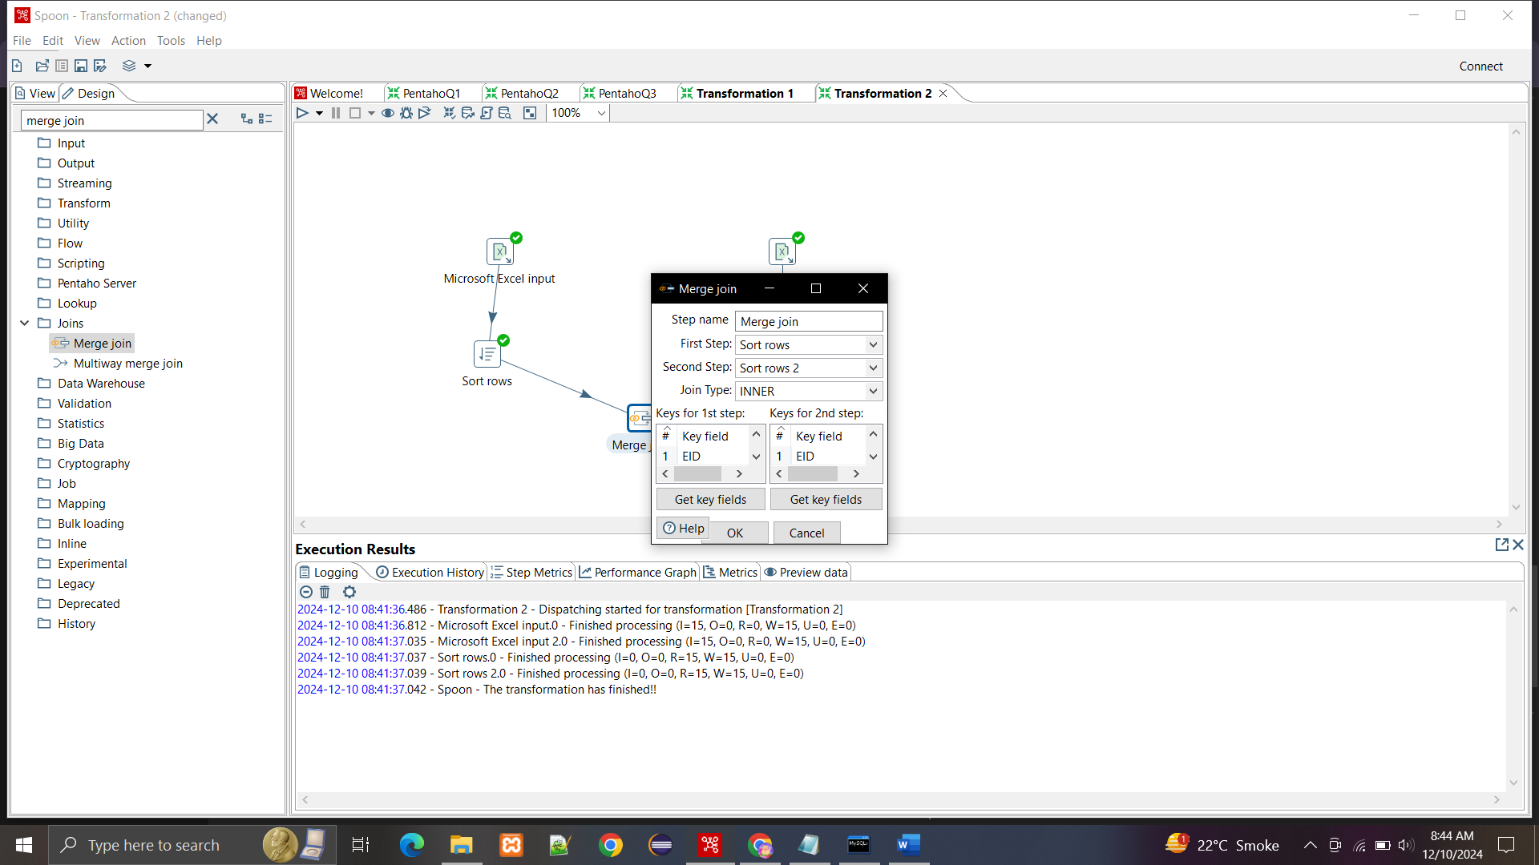

**Merge Join:**

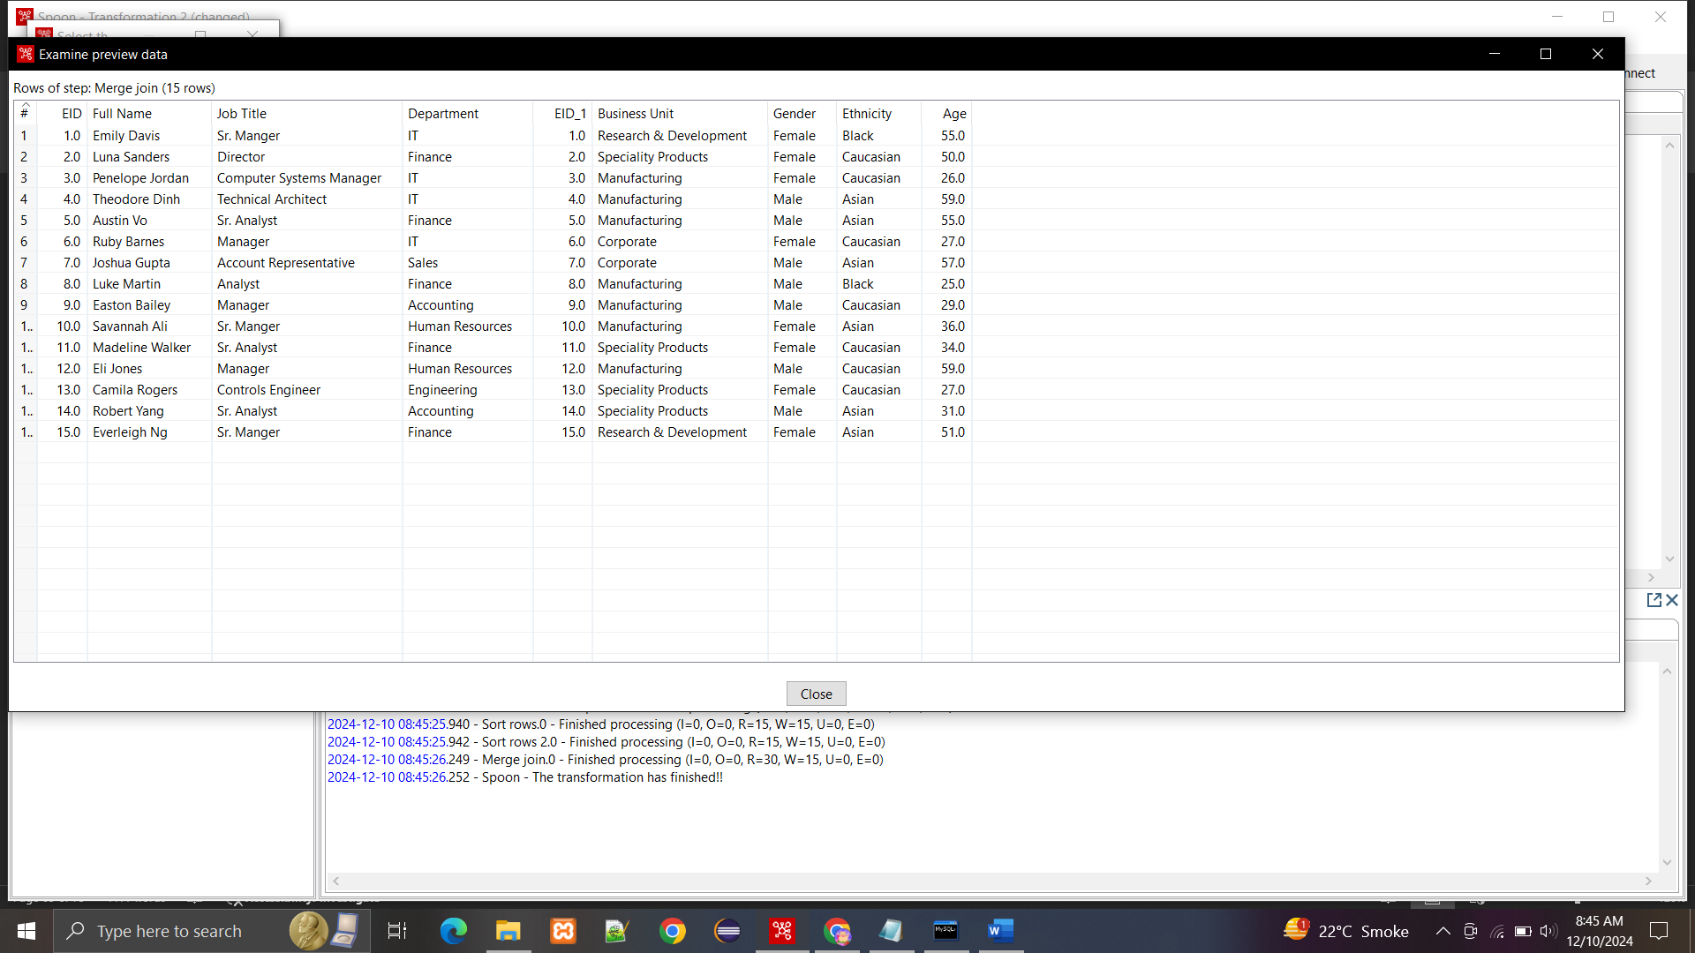

**Unique rows:** 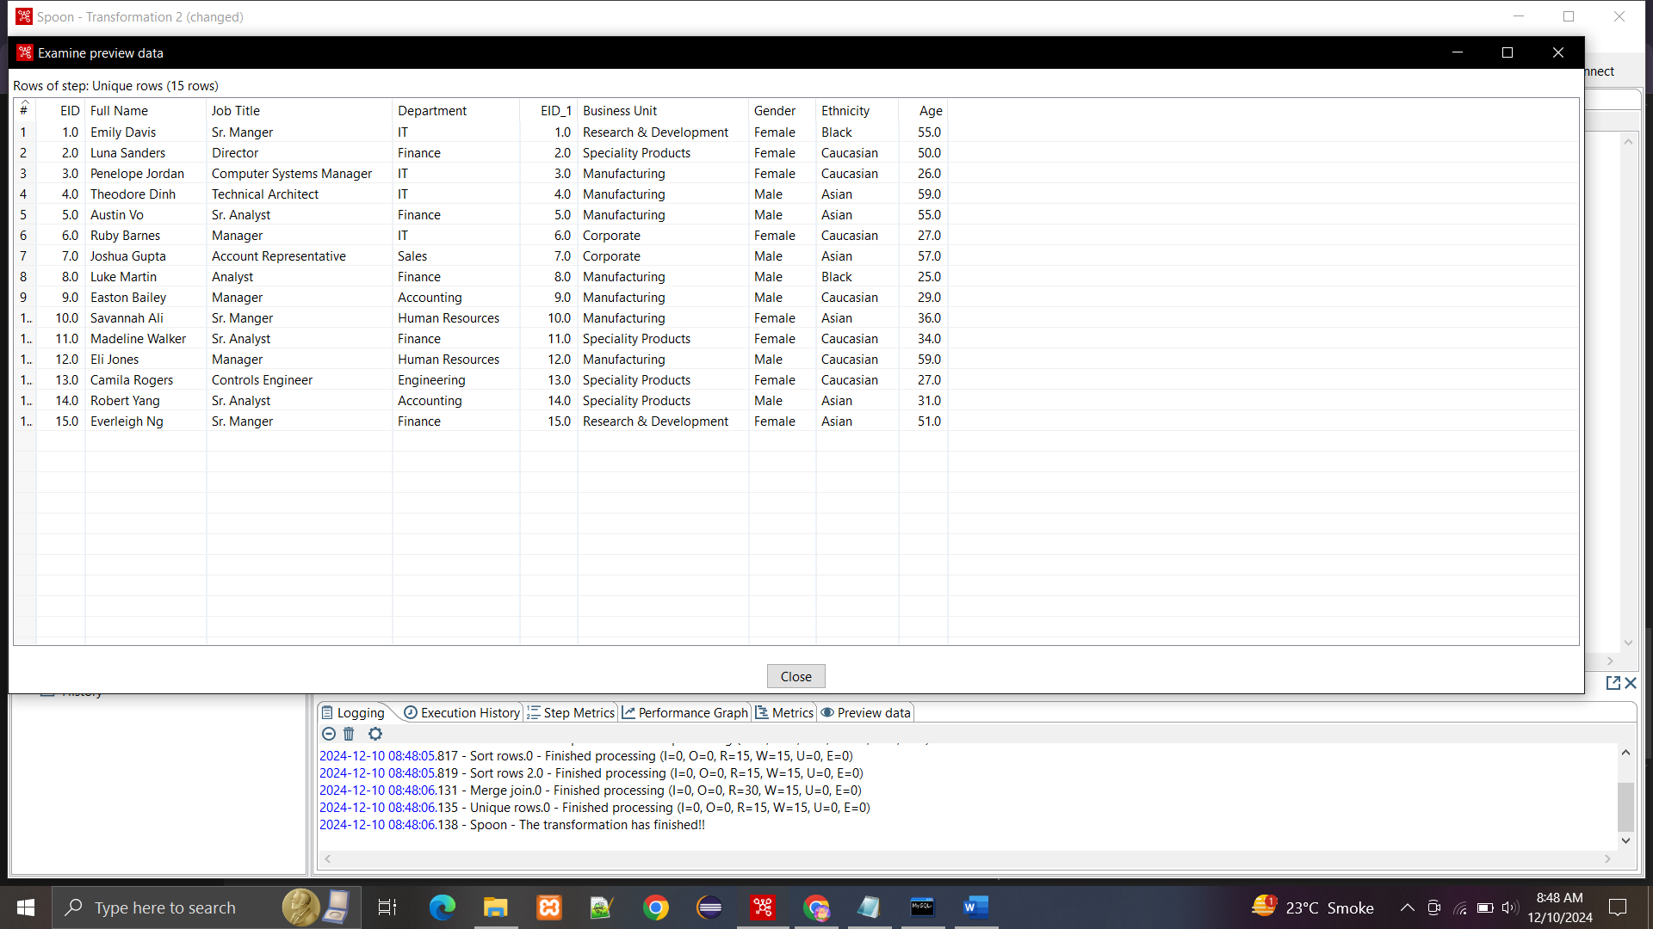

**By using select values, we removed the EID_1 which was getting repeated.**

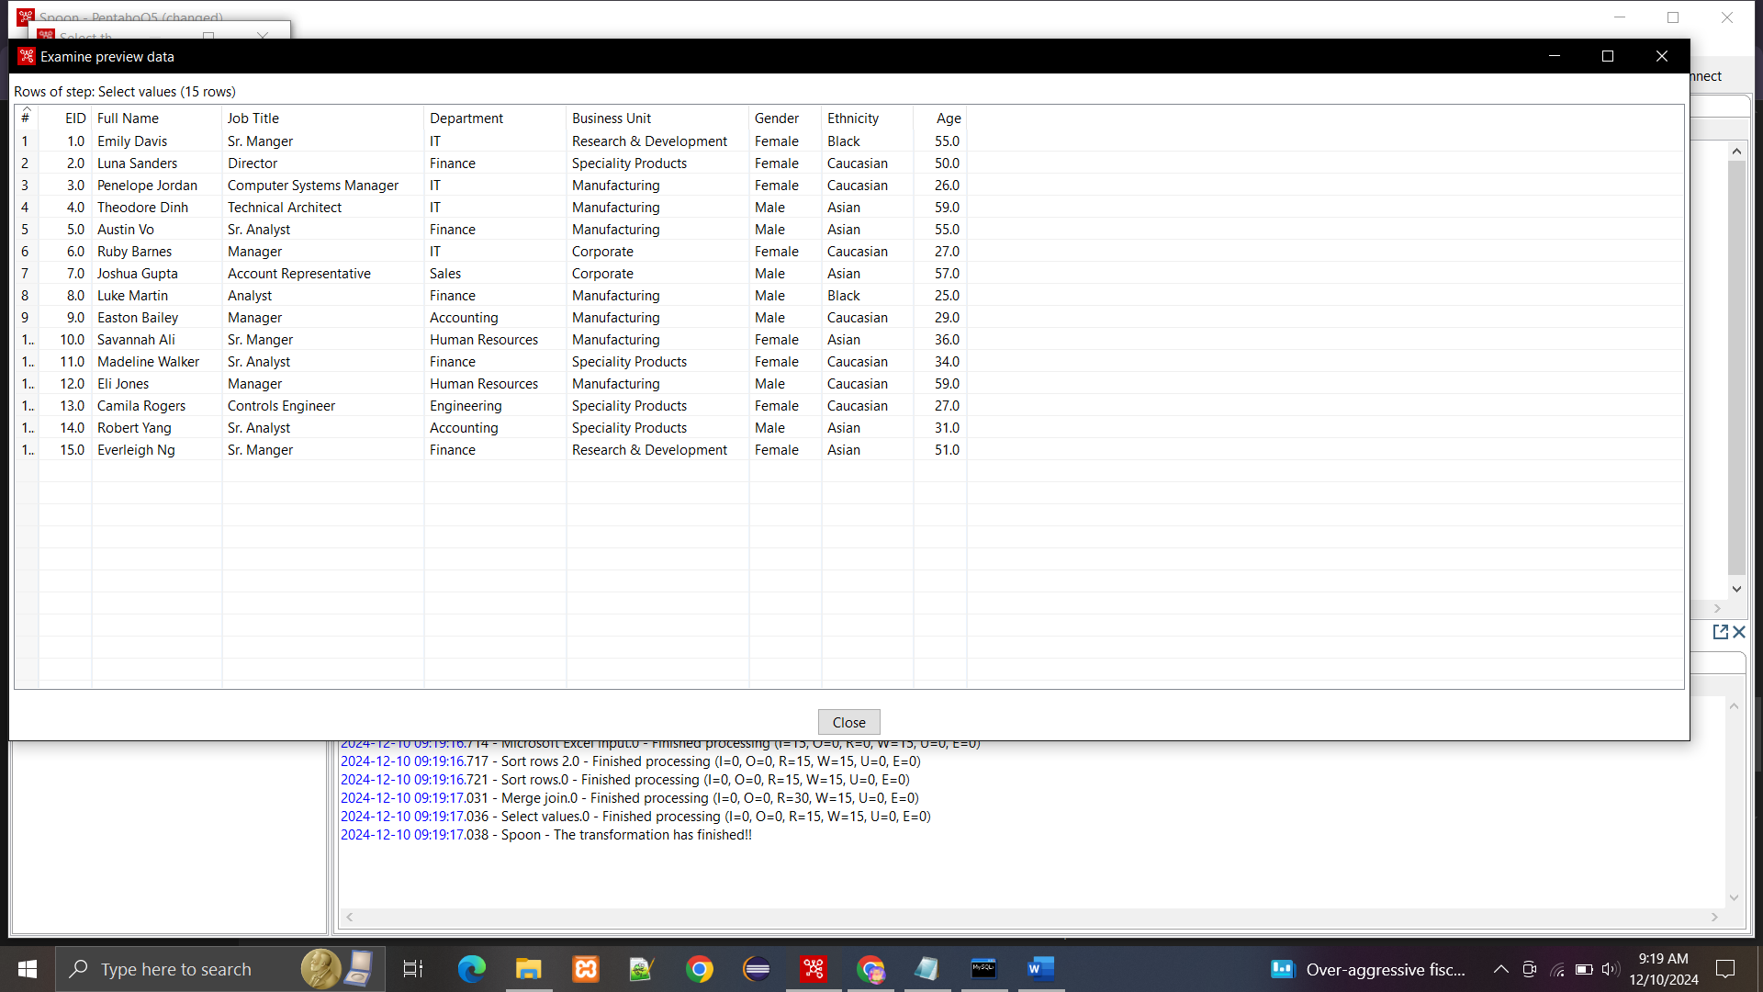

**lushing the data into the database:**

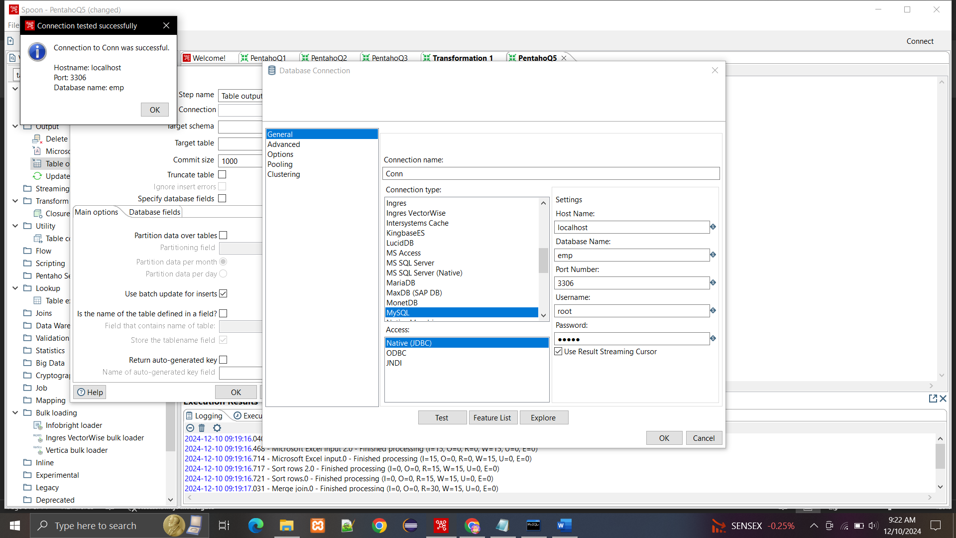

**Created table emp2 to store the data:**

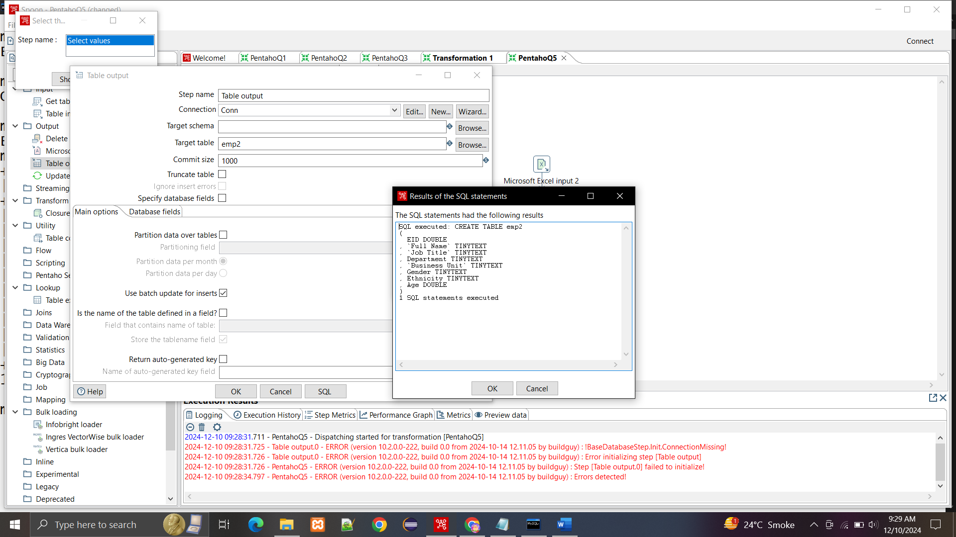

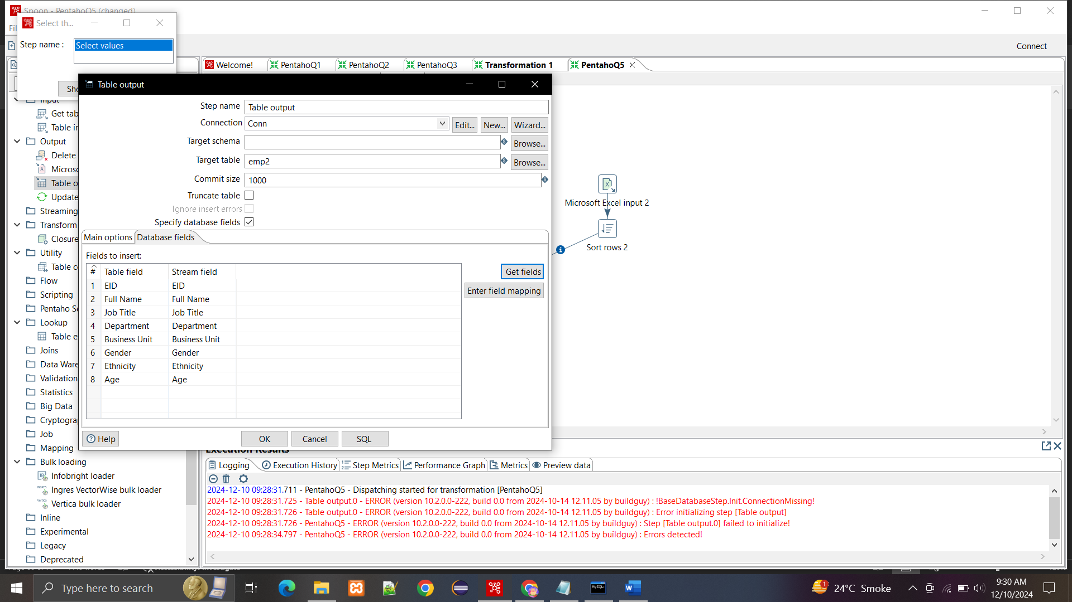

**Data flushed into the database:**

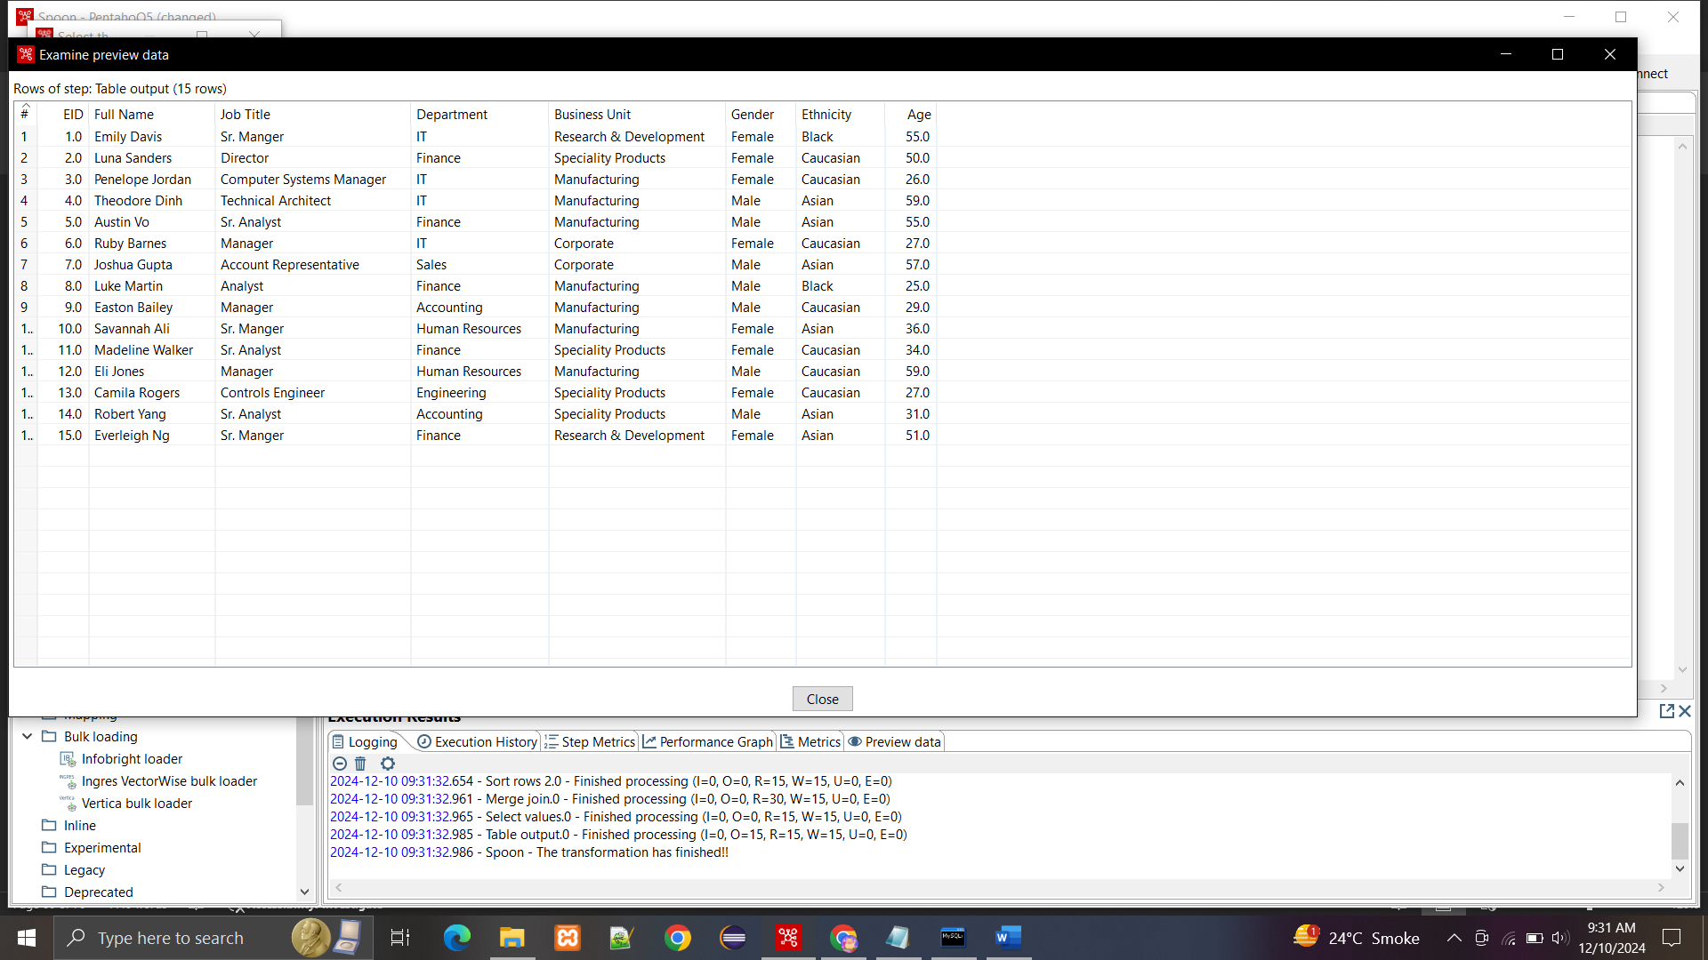

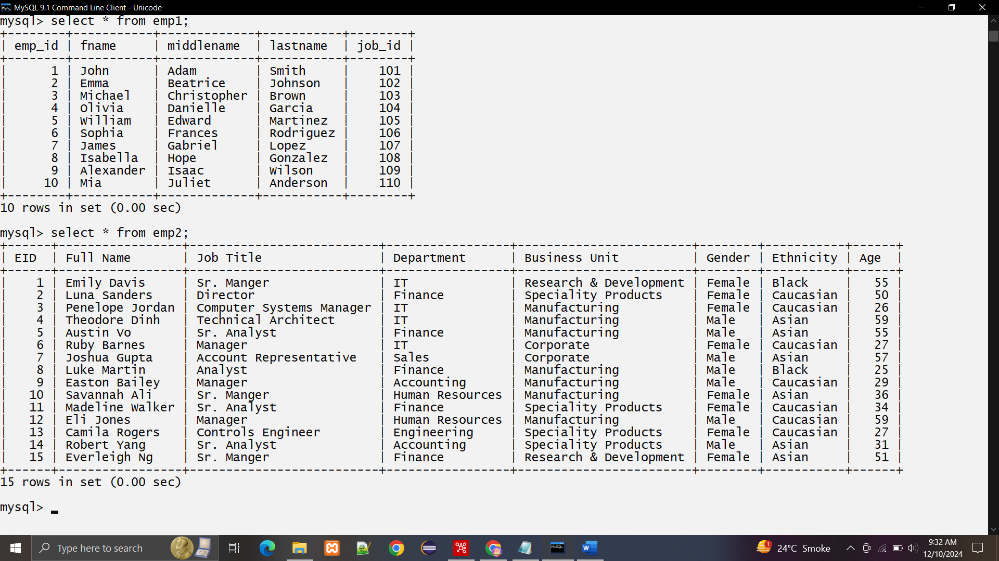

**PRACTICAL 5**

**Aim:** Introduction to basics of R programming

Writeup:

Introduction to Basics of R Programming: R is a versatile programming language widely used for statistical computing and data analysis. Below is a concise guide to its basic functionalities:

1. Installing and Loading Packages

• Installing Packages: Use install.packages("package_name") to install packages.

• Loading Packages: Use library(package_name) to load installed packages for use.

2. Data Types and Variables

• Data Types: Common types include numeric, character, logical, and complex.

• Checking Variable Type: Use class(variable) or typeof(variable).

• Printing Variables: Use print(variable) or simply type the variable name.

3. Objects in R

• Vectors: Use c() to create a vector (e.g., c(1, 2, 3)).

• Matrices: Use matrix() to create a matrix.

• Lists: Use list() to create a list.

• Factors: Use factor() to create a categorical variable.

• Data Frames: Use data.frame() to create a data frame.

• Tables: Use table() to create frequency tables.

4. Combining Data

• Column Bind: Use cbind() to combine objects column-wise.

• Row Bind: Use rbind() to combine objects row-wise.

5. File Operations

• Reading Data:

o CSV Files: Use read.csv("file.csv").

o Excel Files: Use readxl::read_excel("file.xlsx") (requires readxl package).

• Writing Data:

o Use write.csv(data, "file.csv") to save data to a CSV file.

6. Working Directory

• Set Directory: Use setwd("path/to/directory").

• Get Current Directory: Use getwd().

7. Managing Data

• Listing Data: Use data() to list available datasets.

• Removing Objects: Use rm(object_name) to remove an object.

• Attaching Data: Use attach(data_frame) to access columns directly.

• Detaching Data: Use detach(data_frame) to remove direct access.

8. Reading Data from Console

Use readline(prompt = "Enter value: ") for interactive inputs or scan() for bulk input.

9. Summary

R provides a rich set of tools for data manipulation and analysis. By understanding its basic concepts, you can easily handle and analyze data from various sources.

**Q.1 Installation and setting up R**

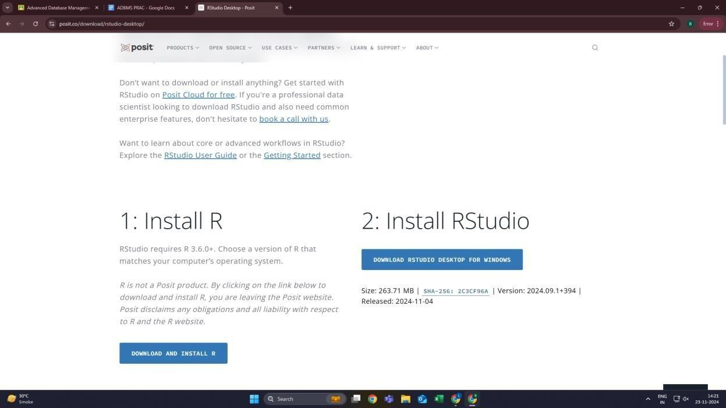

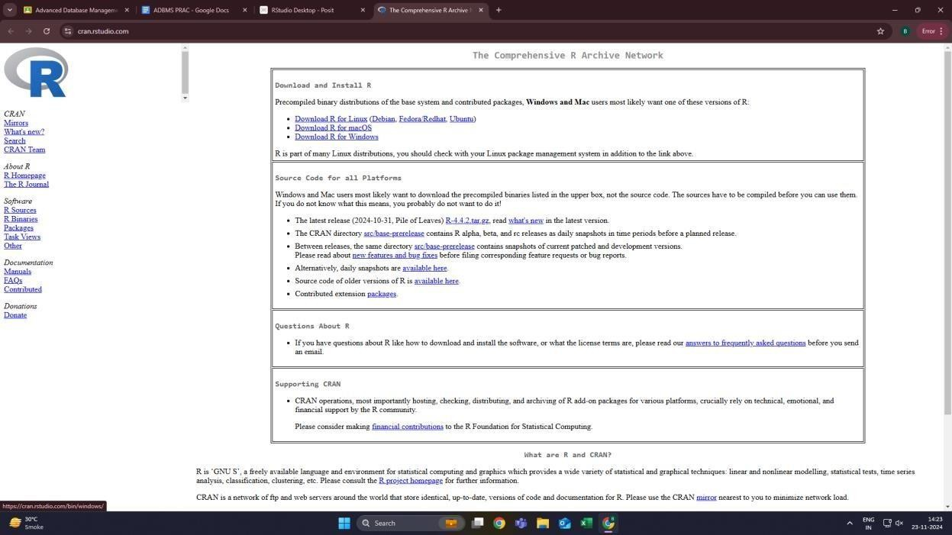

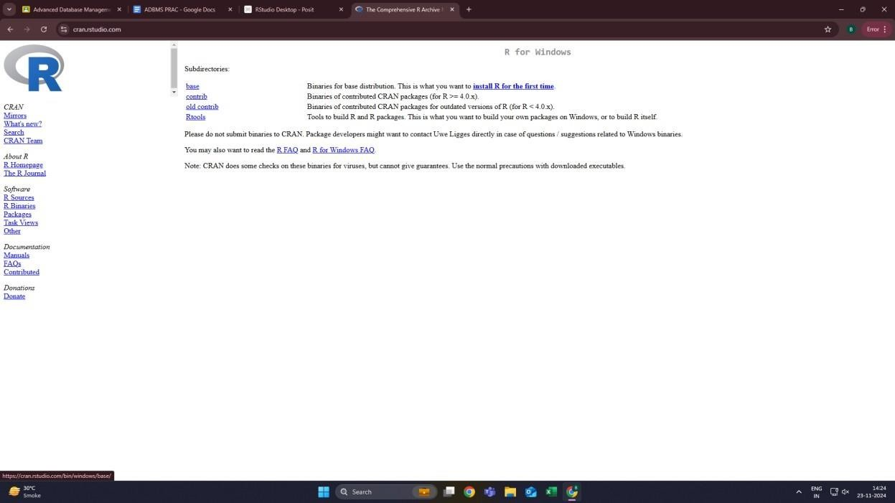

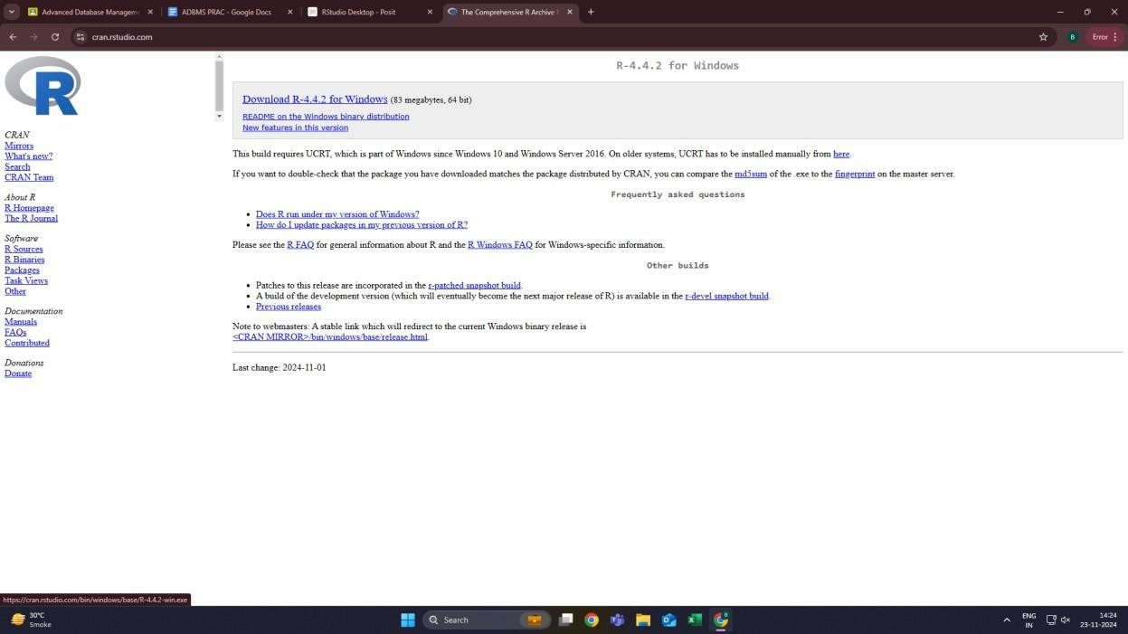

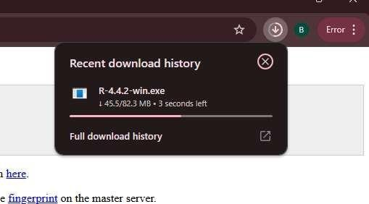

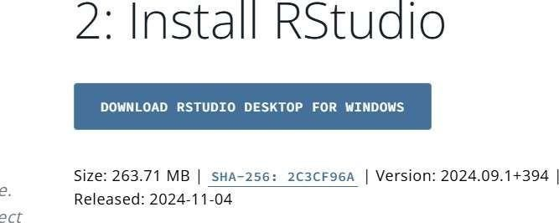

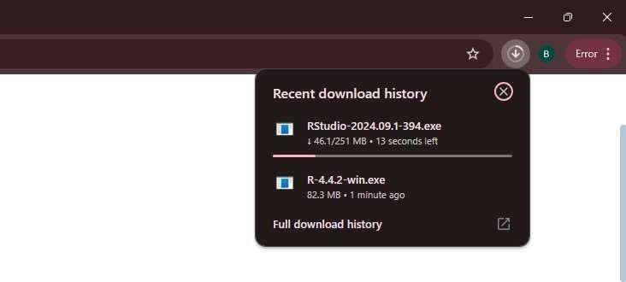

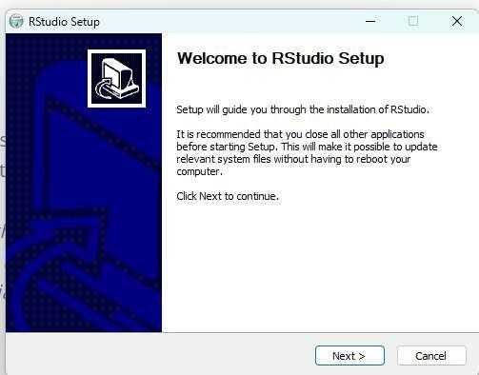

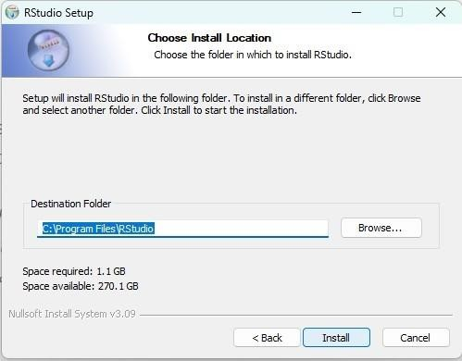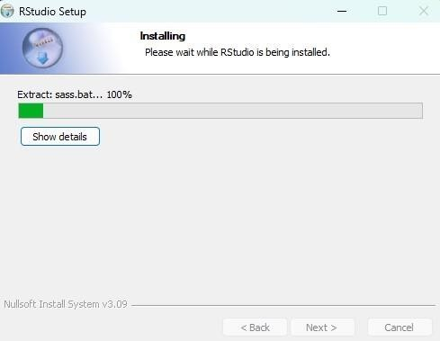

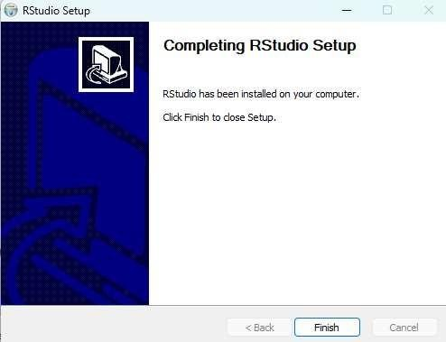

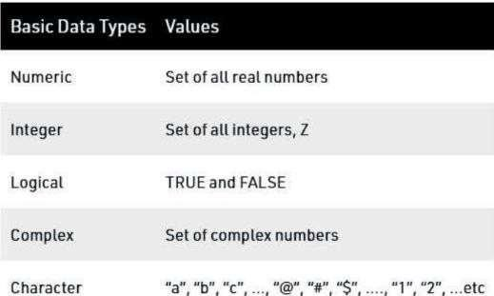**Q.2.Data types in R Programming.**

1.R Program to illustrate Numeric data type

# Assign a decimal value to variable x

x = 5.6

# print the class name of variable

x print(class(x))

# print the type of variable x

print(typeof(x))

# print the value of variable x

print (x)

Output:

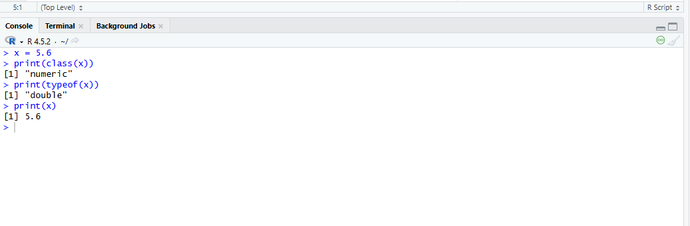

2.R program to illustrate integer data type

# Create an integer variable

x = as.integer(5)

# print the class name of variable x

print(class(x))

# print the type of variable x

print(typeof(x))

# Declare an integer by appending ‘L’ as suffix.

y = 5L

# print the class name of y

print(class(y))

# print the type of y

print(typeof(y))

OUTPUT:

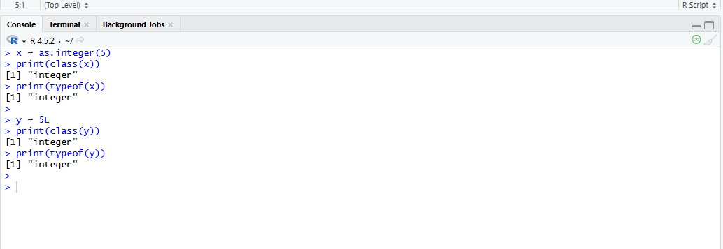

3.R program to illustrate logical data type

# Two variables

x = 4

y = 3

# Comparing two values

z = x > y

# print the logical value

print(z)

# print the class name of z

print(class(z))

# print the type of z

print(type of(z))

OUTPUT:

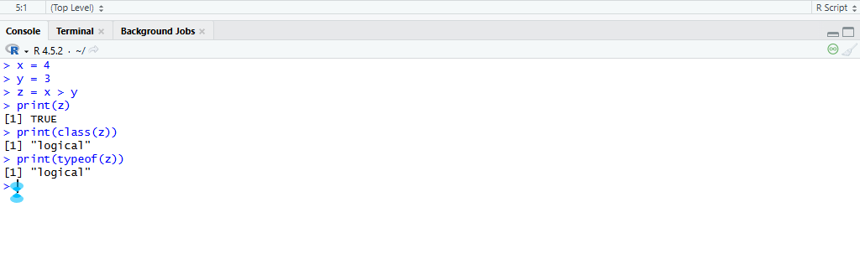

4.R program to illustrate complex data type

# Assign a complex value to variable x

x = 4 + 3i

# print the class name of variable x

print(class(x))

# print the type of variable x

print(typeof(x))

OUTPUT:

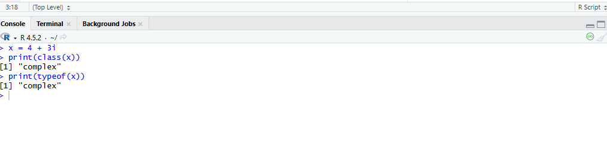

5.R program to illustrate character data type

# Assign a character value to char

char = "Mumbai University"

# print the class name of char

print(class(char))

# print the type of char

print(type of(char))

OUTPUT:

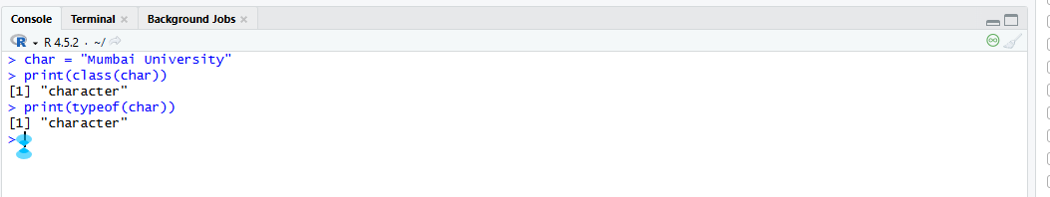

6.Reading and Writing data to and from R.

Code:

setwd("~/Adnan_FY31/Adbms/R studio practical")

setwd(“~D:/Mca_Sem1/ADBMS”)

x <- data.frame (name = c("Adnan", "Ahsan", "Suheb"), department = c("Sales", "Marketing", "Finance"))

x <- data.frame (name = c("Adnan", "Ahsan", "Suheb"), department = c("Sales", "Marketing", "Finance"))

write.table(x, file ="data.csv", sep = ",")

z <- data.frame(a = 10, b = 40, c = pi)

write.csv(z, file = "sample.csv")

Output:

Data.csv

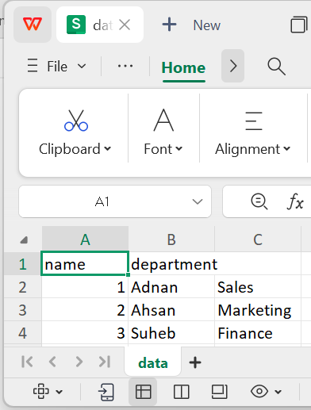

**Sample.csv**

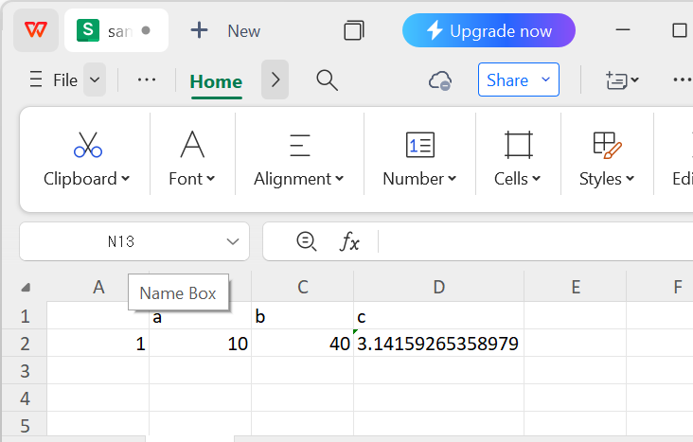

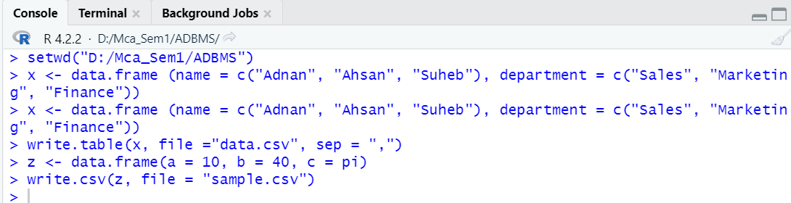

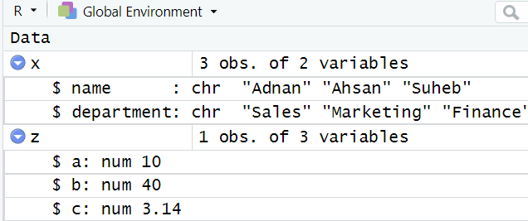

**7.Demonstrate Rstudio to insert data from a data frame into a mysql table.**

**Code:**

install.packages("RMySQL")

library(RMySQL)

con <- dbConnect(MySQL(), user='root', password='gnims', dbname='rstudiopractical',host='localhost',port=3306)

data <- data.frame( name = c("Adnan", "Suheb", "Ahsan"),age = c(22, 21, 15),city = c("Kurla", "Wadala", "Goregaon"))

insert_query <- paste0("INSERT INTO emp1 (name, age, city) VALUES ")

values <- paste0("('", data$name, "', ", data$age, ", '", data$city, "')")

insert_query <- paste0(insert_query, paste(values, collapse = ", "))

dbSendQuery(con, insert_query)

dbDisconnect(con)

**Output:**

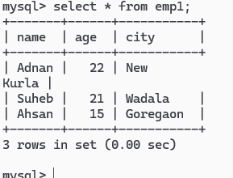

**PRACTICAL NO: 6**

AIM: Implementation of Data pre-processing techniques in RStudio like, Naming and Renaming variables, adding a new variable. Dealing with missing data. Dealing with categorical data. Data reduction using subsetting

Writeup:

Implementation of Data Pre-processing Techniques in RStudio

Data pre-processing is a critical step in data analysis to clean and prepare data for modeling. Below are some common techniques:

1. Naming and Renaming Variables

• Naming Variables: Use the names() function to assign or view variable names. Example: names(data) <- c("Var1", "Var2", "Var3").

• Renaming Variables: Modify specific names using indexing. Example: names(data)[2] <- "NewName".

2. Adding a New Variable

• Use the $ operator or indexing to add a new column. Example: data$new_var <- data$Var1 * 2

3. Dealing with Missing Data

• Identifying Missing Values: Use is.na(data) to check for missing values.

• Handling Missing Data:

* + Replace with a value: data$Var1[is.na(data$Var1)] <- mean(data$Var1, na.rm = TRUE).
  + Remove rows/columns: data <- na.omit(data) or data[complete.cases(data), ].

4. Dealing with Categorical Data

• Encoding Categories: Use factor() to convert categorical data into factor variables. Example: data$Category <- factor(data$Category, levels = c("A", "B", "C"), labels = c(1, 2, 3)).

5. Data Reduction Using Subsetting

• Selecting Rows/Columns: Use indexing to subset data. Example: subset_data <- data[1:10, c("Var1", "Var2")].

• Using Conditions: Subset rows based on conditions. Example: subset_data <- data[data$Var1 > 50, ].

These techniques help streamline the data cleaning process, making datasets more manageable and analysis-ready.

Code:

dataframe <- read.csv( "C:/Users/ADNAN/OneDrive/Documents/prac6.csv" ,sep = "\t", header = TRUE)

print(dataframe)

names(dataframe)[names(dataframe) == "Name"] <- "FirstName"

print(dataframe)

dataframe$emailaddress <- c('Adnan@gmail.com', 'Iqra@gmail.com', 'Saubiya@gmail.com',

  'Shaban@gmail.com', 'Zaid@gmail.com','Safwan@gmail.com')

print(dataframe)

dataframe <- dataframe[complete.cases(dataframe), ]

print(dataframe)

dataframe <- read.csv( "C:/Users/ADNAN/OneDrive/Documents/prac6.csv" ,sep = "\t", header = TRUE)

dataframe$Age <- ifelse(is.na(dataframe$Age), # Condition: If Age is NA (missing)

ave(dataframe$Age, FUN = function(x) mean(x, na.rm = TRUE)), # Calculate mean of non- missing values in Age

dataframe$Age # Else, keep the original Age value

)

print(dataframe)

dataframe$Salary <- ifelse(

  is.na(dataframe$Salary), # Condition: If Salary is NA (missing)

  ave(dataframe$Salary, FUN = function(x) mean(x, na.rm = TRUE)), # Calculate mean of non-missing values in Salary

  dataframe$Salary # Else, keep the original Salary value

)

print(dataframe)

dataframe$Gender <- as.numeric(factor(dataframe$Gender))

print(dataframe)

subset_data <- dataframe[dataframe$Age > 30, ]

print(subset_data)

dataframe <- read.csv("C:/Users/ADNAN/OneDrive/Documents/prac6.csv",sep = "\t", header = TRUE)

print(dataframe)

sample_size <- 5 # Adjust the sample size as needed

sample_data <- dataframe[sample(nrow(dataframe), sample_size, replace = FALSE), ]

print(sample_data)

**1.Load Data from CSV (make sure to make the CSV files)**

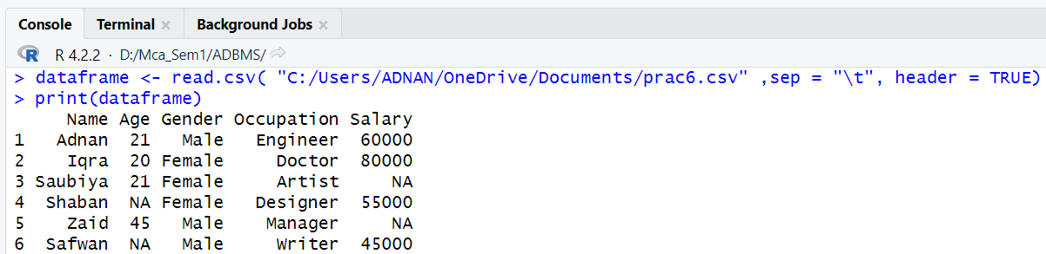

**2.Naming and Renaming Variables**

**1. To Rename Variables**

**2. To Add a New Variable**

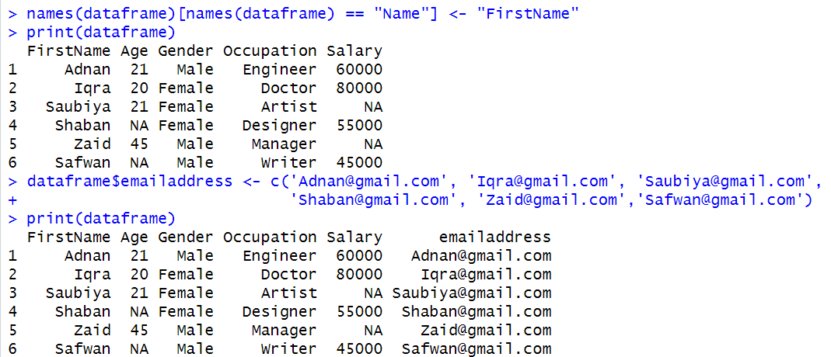

**3.Dealing with Missing Data**

1. **Remove Rows with Missing Values**

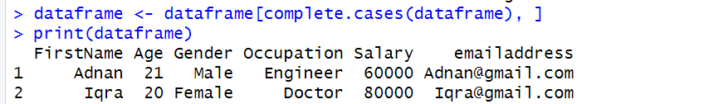

**2. Fill Missing Values with Mean**

**a. To calculate the missing Age**

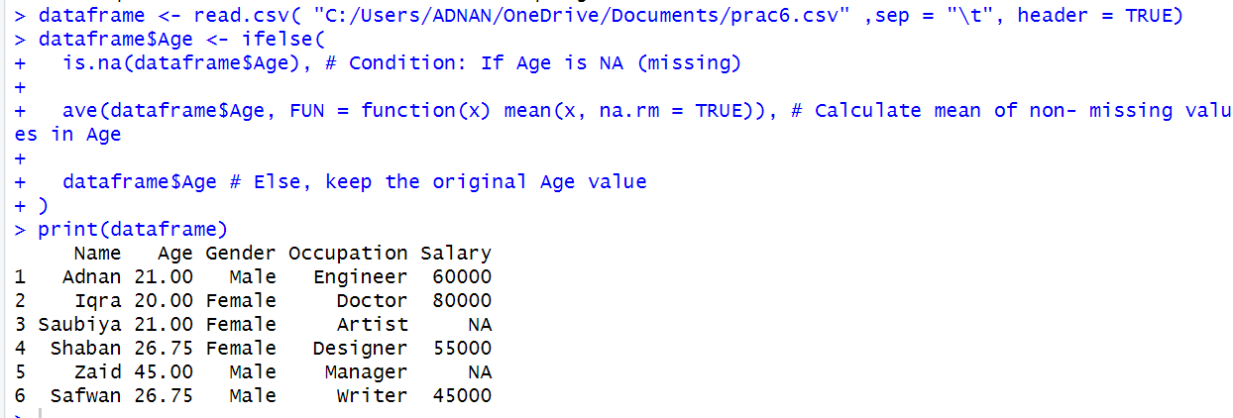

**b. To calculate the missing salary**

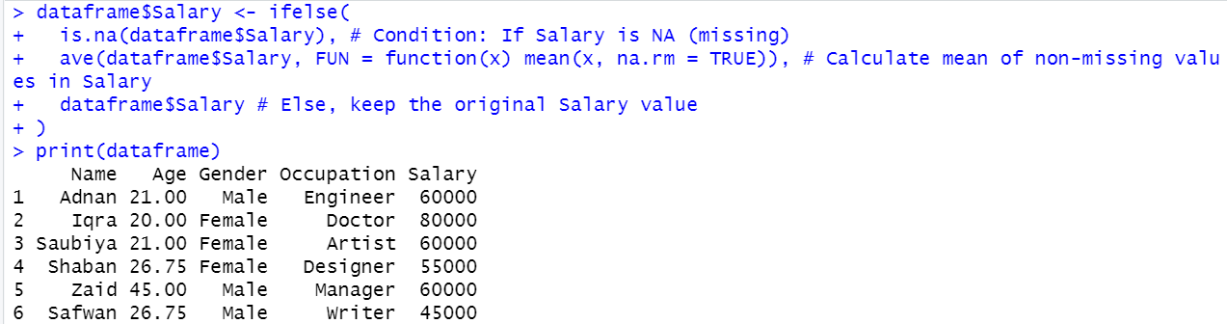

**4.Dealing with Categorical Data**

1. **Convert Categorical to Numerical (using factorization)**

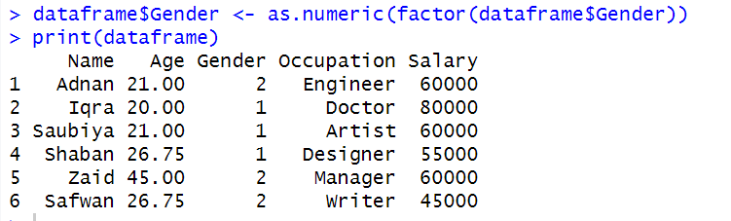

**5.Data Reduction using Subsetting**

1. **Subset Based on Condition**

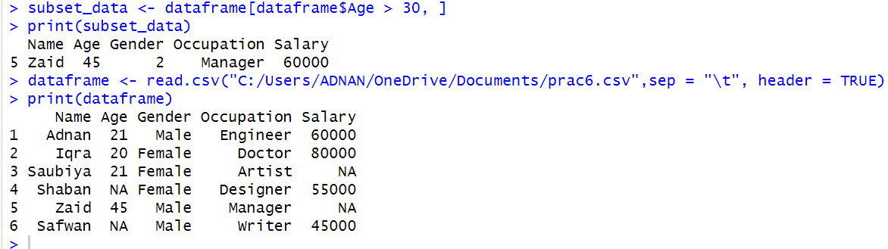

1. **Random Sampling (to reduce data size for analysis)**

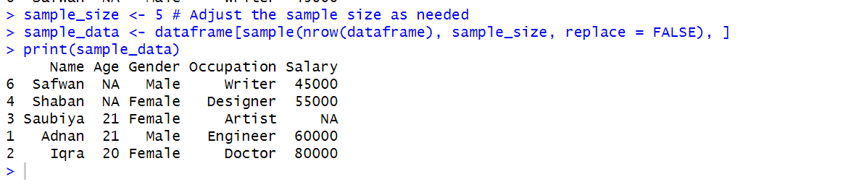

**Practical No:-7**

**Aim:**Implementation and analysis of Linear Regression and Classification algorithms – Naïve Bayesian and K-Nearest Neighbor.

**Write-up**

**1. Implementation and Analysis of Linear Regression in R Console**

Linear regression is a statistical and machine learning technique used to model the relationship between a dependent variable and one or more independent variables. It assumes a linear relationship between variables and is widely used for prediction and trend analysis.

**1.1 Loading Data**

A dataset is loaded or created for regression analysis.

data <- data.frame(

x = c(1, 2, 3, 4, 5),

y = c(2, 4, 5, 4, 5)

)

**1.2 Fitting a Linear Regression Model**

The lm() function is used to fit a linear regression model.

model <- lm(y ~ x, data = data)

**1.3 Summarizing the Model**

The summary() function provides information such as coefficients, R-squared value, and p-values.

summary(model)

**1.4 Plotting the Results**

The regression line is visualized using a scatter plot and fitted line.

plot(data$x, data$y, main="Linear Regression", xlab="X", ylab="Y")

abline(model, col="blue")

**1.5 Making Predictions**

The predict() function is used to predict values for new input data.

new_data <- data.frame(x = c(6, 7))

predictions <- predict(model, newdata = new_data)

**1.6 Interpreting Results**

Coefficients indicate the relationship between variables

R-squared shows how well the model fits the data

p-values indicate the statistical significance of predictors

**2. Implementation and Analysis of Naïve Bayes Classification**

Naïve Bayes is a probabilistic classification algorithm based on Bayes’ Theorem. It assumes that features are independent, making it simple and efficient for classification tasks such as text classification and spam detection.

**2.1 Loading Dataset**

data <- data.frame(

Outlook = c("Sunny","Sunny","Overcast","Rain"),

Play = c("No","No","Yes","Yes")

)

**2.2 Training the Model**

library(e1071)

model <- naiveBayes(Play ~ ., data = data)

**2.3 Making Predictions**

predict(model, data)

**2.4 Analysis**

Fast and efficient classifier

Performs well with large datasets

Works best when feature independence assumption holds

**3. Implementation and Analysis of K-Nearest Neighbor (KNN)**

K-Nearest Neighbor is an instance-based classification algorithm that classifies a data point based on the majority class of its nearest neighbors.

**3.1 Loading Dataset**

data <- data.frame(

x = c(1,2,3,6,7,8),

y = c(1,2,3,6,7,8),

class = c("A","A","A","B","B","B")

)

**3.2 Applying KNN**

library(class)

train <- data[,1:2]

test <- data[,1:2]

cl <- data$class

result <- knn(train, test, cl, k = 3)

**3.3 Analysis**

Simple and easy to understand

No training phase required

Performance depends on choice of K and distance measure

**Conclusion**

Linear Regression is effective for predicting continuous values, while Naïve Bayes and K-Nearest Neighbor are widely used classification algorithms. Naïve Bayes is fast and suitable for probabilistic classification, whereas KNN is a distance-based method that provides accurate results for small datasets. Together, these algorithms demonstrate both regression and classification techniques in machine learning.

**7.1**

**Code:**

x <- c(1, 2, 3, 4, 5)

y <- c(2, 4, 5, 4, 5)

data <- data.frame(x, y)

model <- lm(y ~ x, data = data)

summary(model)

predicted <- predict(model)

print(predicted)

plot(x, y, main = "Linear Regression", col = "blue", pch = 16)

abline(model, col = "red", lwd = 2)

**Output:**

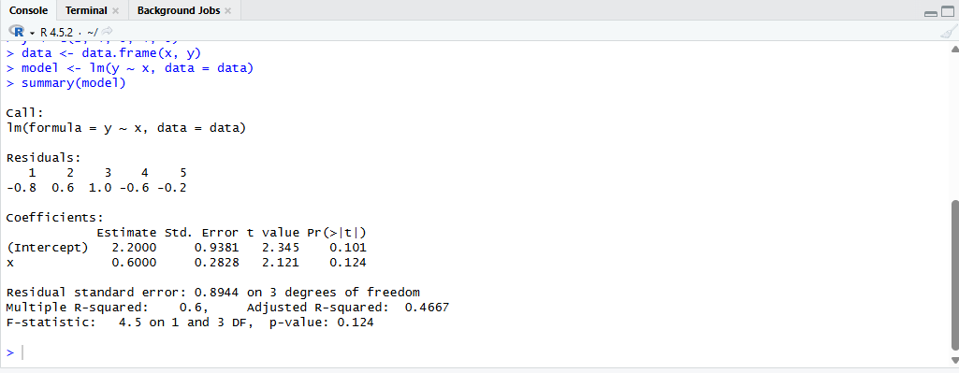



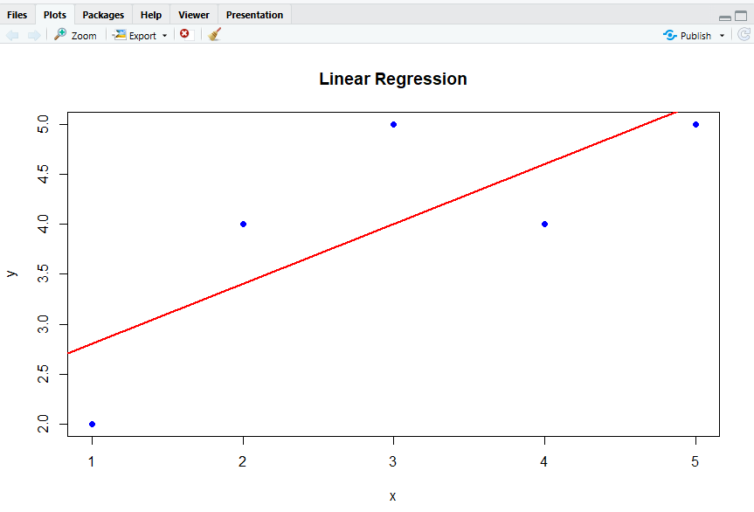

**7.2**

**Code:**

install.packages("e1071")

library(e1071)

data <- data.frame(

Weather = c("Sunny", "Rainy", "Sunny", "Overcast", "Rainy", "Sunny"),

Play = c("No", "Yes", "Yes", "Yes", "No", "Yes")

)

data$Weather <- as.factor(data$Weather)

data$Play <- as.factor(data$Play)

model <- naiveBayes(Play ~ Weather, data = data)

print(model)

test <- data.frame(Weather = c("Sunny", "Rainy", "Overcast"))

prediction <- predict(model, test)

print(prediction)

**Output:**

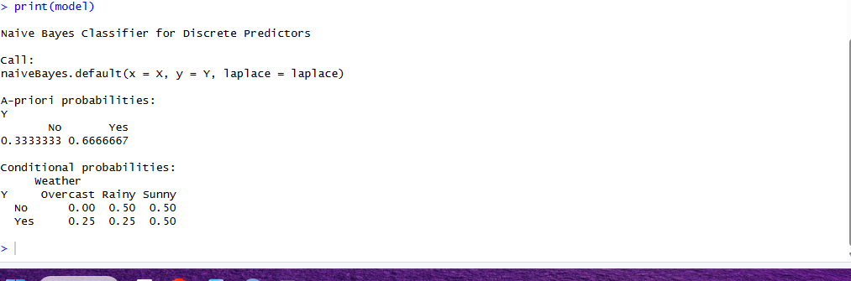

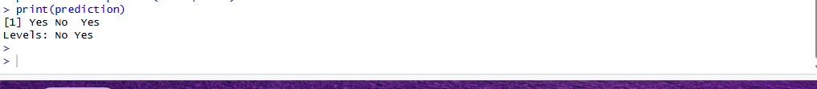

**7.3**

**Code:**

install.packages("class")

library(class)

data <- data.frame(

Height = c(150, 160, 170, 180, 190),

Weight = c(50, 60, 70, 80, 90),

Category = c("Thin", "Normal", "Normal", "Overweight", "Overweight")

)

train <- data[, 1:2]

labels <- data$Category

test <- data.frame(Height = 175, Weight = 75)

result <- knn(train, test, labels, k = 3)

print(result)

**Output:**

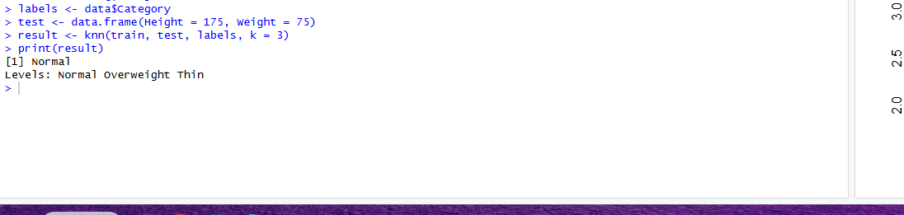

**Practical no.8**

**Aim:** **Implementation and analysis of Classification algorithms - ID3**

**Introduction**

Classification is a supervised learning technique used to predict class labels based on input data. ID3 (Iterative Dichotomiser 3) is a decision tree–based classification algorithm that constructs a tree using information gain. It is widely used for understanding the fundamentals of decision tree learning due to its simplicity and interpretability.

Major Points

ID3 builds a decision tree using a top-down greedy approach.

It uses entropy to measure impurity in the dataset.

Information Gain is used to select the best attribute for splitting.

Works only with categorical attributes.

Produces easy-to-understand and interpretable classification rules.

**Conclusion**

ID3 is a simple and efficient classification algorithm suitable for small and structured datasets. Although it has limitations such as sensitivity to noise and inability to handle continuous data directly, it remains an important algorithm for understanding decision tree-based classification methods.

**Code:**

**ID3 Algorithm Implementation in R**

install.packages("rpart")

install.packages("rpart.plot")

library(rpart)

library(rpart.plot)

data <- data.frame(

Outlook = c("Sunny","Sunny","Overcast","Rain","Rain","Rain",

"Overcast","Sunny","Sunny","Rain","Sunny",

"Overcast","Overcast","Rain"),

Temperature = c("Hot","Hot","Hot","Mild","Cool","Cool",

"Mild","Cool","Mild","Mild","Mild",

"Hot","Mild","Hot"),

Humidity = c("High","High","High","High","Normal","Normal",

"High","High","Normal","Normal","Normal",

"High","Normal","High"),

Wind = c("Weak","Strong","Weak","Weak","Weak","Strong",

"Strong","Weak","Weak","Weak","Strong",

"Strong","Weak","Strong"),

PlayTennis = c("No","No","Yes","Yes","Yes","No",

"Yes","No","Yes","Yes","Yes",

"Yes","Yes","No")

)

print("Dataset Loaded Successfully")

print(data)

entropy <- function(target){

freq <- table(target) / length(target)

return(-sum(freq * log2(freq)))

}

base_entropy <- entropy(data$PlayTennis)

print(paste("Base Entropy:", round(base_entropy, 4)))

model <- rpart(PlayTennis ~ ., data = data, method = "class",

parms = list(split = "information"))

print("Decision Tree Model:")

print(model)

rpart.plot(model, type = 4, extra = 104,

fallen.leaves = TRUE,

main = "ID3 Decision Tree (Play Tennis Dataset)")

test <- data.frame(Outlook="Sunny", Temperature="Cool",

Humidity="Normal", Wind="Strong")

prediction <- predict(model, test, type="class")

print("Test Input:")

print(test)

print(paste("Predicted Output:", prediction))

predicted <- predict(model, data, type="class")

accuracy <- sum(predicted == data$PlayTennis) / nrow(data)

print(paste("Model Accuracy:", round(accuracy * 100, 2), "%"))

**Output:**

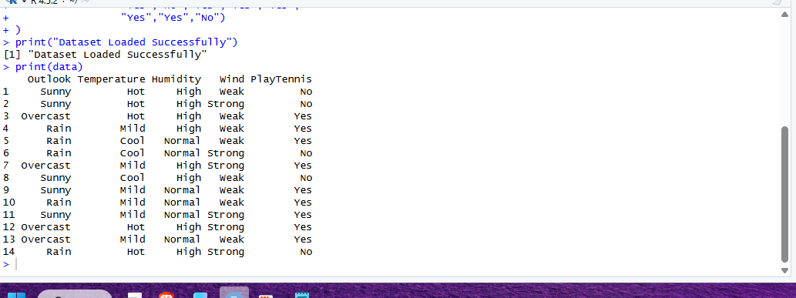

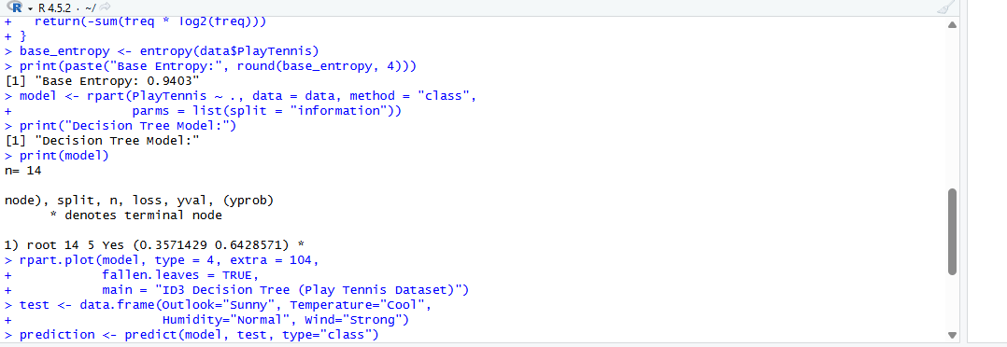

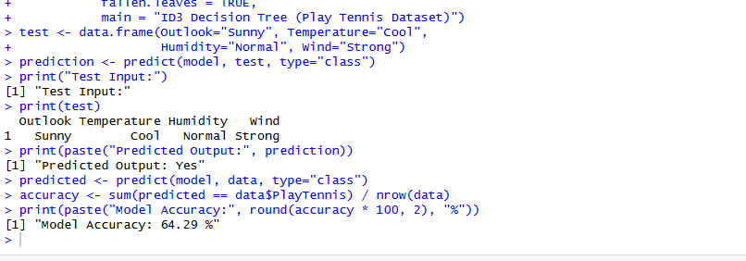

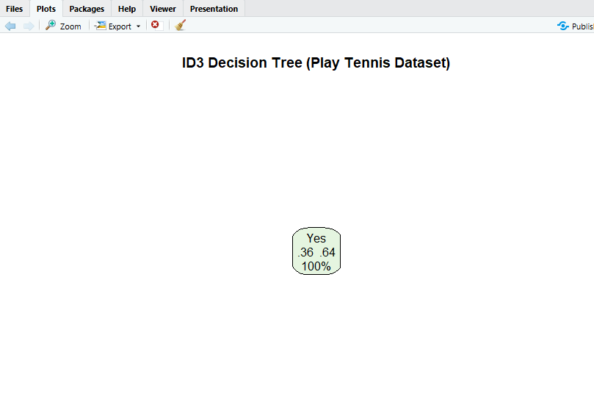

**PRACTICAL 9**

**AIM: Implementation and analysis of . C4.5 and Apriori Algorithm using Market Basket Analysis**

**1. Introduction**

Data mining is the process of discovering meaningful patterns, correlations, and knowledge from large datasets using statistical, machine learning, and database techniques. Among various data mining tasks, classification and association rule mining play a crucial role in decision-making systems.

This study focuses on the implementation and analysis of two widely used algorithms:

**C4.5 Algorithm** for classification

**Apriori Algorithm** for association rule mining using Market Basket Analysis

Both algorithms are foundational techniques used in domains such as retail analytics, healthcare, finance, and customer behavior analysis.

**2. Classification and the C4.5 Algorithm**

**2.1 Classification in Data Mining**

Classification is a **supervised learning technique** that assigns predefined class labels to data instances based on their attributes. A classification model is trained using labeled data and then used to predict the class of unseen data.  
Decision tree-based classifiers are popular due to their simplicity, interpretability, and efficiency.

**2.2 C4.5 Algorithm**

The **C4.5 algorithm**, developed by **Ross Quinlan**, is an extension of the ID3 algorithm and is used to generate a **decision tree** for classification purposes.

C4.5 constructs a decision tree by recursively splitting the dataset based on attribute values that provide the highest discriminatory power. The algorithm handles both **categorical and continuous attributes**, manages missing values, and performs **pruning** to avoid overfitting.

**2.3 Working Principle of C4.5**

1. Select the attribute that best splits the dataset using **Gain Ratio**.
2. Create a decision node based on the selected attribute.
3. Split the dataset into subsets.
4. Repeat the process recursively for each subset.
5. Stop when all instances belong to the same class or no attributes remain.

**2.4 Information Gain and Gain Ratio**

* **Entropy** measures the impurity or randomness in the dataset:
$$Entropy(S)=-∑p_{i}{log⁡}_{2}(p_{i})$$

* **Information Gain** measures the reduction in entropy after splitting:
$$Gain(S,A)=Entropy(S)-∑\frac{∣S_{v}∣}{∣S∣}Entropy(S_{v})$$

* **Gain Ratio** adjusts Information Gain to avoid bias toward attributes with many values:

$$GainRatio(A)=\frac{Gain(S,A)}{SplitInfo(A)}$$

C4.5 selects the attribute with the **highest Gain Ratio**.

**2.5 Advantages of C4.5**

* Handles continuous and discrete data
* Deals with missing values
* Performs tree pruning
* Produces easily interpretable rules

**3. Association Rule Mining and Market Basket Analysis**

**3.1 Association Rule Mining**

Association rule mining aims to discover interesting relationships, patterns, or associations among items in large transactional databases. It is widely used in **Market Basket Analysis**, where customer purchasing behavior is analyzed.

An association rule is represented as:

$$X→Y$$

where $X$ and $Y$ are itemsets.

**3.2 Market Basket Analysis**

Market Basket Analysis identifies patterns in customer purchases to understand which products are frequently bought together.  
It helps businesses in:

* Product placement
* Cross-selling strategies
* Recommendation systems
* Inventory management

**4. Apriori Algorithm**

**4.1 Overview**

The **Apriori algorithm** is a classical algorithm for mining frequent itemsets and generating association rules. It is based on the **Apriori Principle**, which states:

“If an itemset is frequent, all of its subsets must also be frequent.”

**4.2 Working of Apriori Algorithm**

1. Generate frequent 1-itemsets by scanning the database.
2. Use frequent $k$-itemsets to generate candidate $\left(k + 1\right)$-itemsets.
3. Prune candidate itemsets whose subsets are not frequent.
4. Repeat until no further frequent itemsets are found.
5. Generate association rules from frequent itemsets.

**4.3 Measures of Association Rules**

* **Support**  
  Indicates how frequently an itemset appears in the dataset.
$$Support(X)=\frac{\text{Number of transactions containing }X}{\text{Total transactions}}$$

* **Confidence**  
  Measures the reliability of the rule.
$$Confidence(X→Y)=\frac{Support(X∪Y)}{Support(X)}$$

* **Lift**  
  Measures the strength of association.

$$Lift(X→Y)=\frac{Confidence(X→Y)}{Support(Y)}$$

**4.4 Advantages of Apriori Algorithm**

* Simple and easy to understand
* Effective for small and medium datasets
* Generates interpretable association rules

**6. Conclusion**

The C4.5 and Apriori algorithms represent two important paradigms in data mining: **classification** and **association analysis**.  
C4.5 is effective for predictive modeling and decision-making, while Apriori provides valuable insights into customer behavior through Market Basket Analysis.  
Together, these algorithms enable comprehensive data-driven analysis for various real-world applications.

**Code:**

**1. C4.5 Algorithm Implementation in R**

install.packages("RWeka")

library(RWeka)

data <- data.frame(

Weather = c("Sunny", "Rainy", "Sunny", "Overcast", "Rainy", "Sunny"),

Temperature = c("Hot", "Mild", "Mild", "Cool", "Cool", "Hot"),

Play = c("No", "Yes", "Yes", "Yes", "No", "Yes")

)

data <- data.frame(lapply(data, factor))

model_c45 <- J48(Play ~ Weather + Temperature, data = data)

print(model_c45)

test <- data.frame(

Weather = factor("Sunny", levels = levels(data$Weather)),

Temperature = factor("Cool", levels = levels(data$Temperature))

)

predict_c45 <- predict(model_c45, test)

print(predict_c45)

predicted <- predict(model_c45, data)

accuracy <- sum(predicted == data$Play) / nrow(data)

print(paste("Model Accuracy:", round(accuracy * 100, 2), "%"))

**Output:**

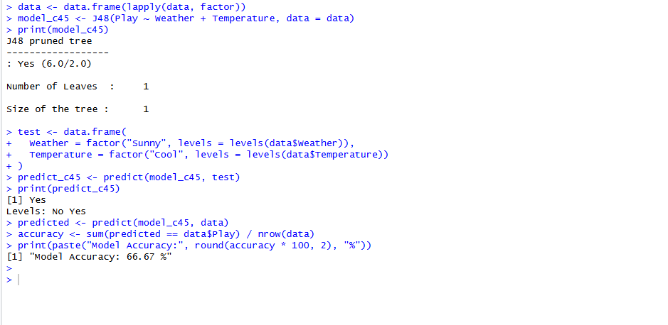

**PRACTICAL NO.9.2**

**Code:**

install.packages("arules" , dependencies = TRUE)

install.packages("arulesViz" , dependencies = TRUE)

library(arules)

library(arulesViz)

transactions <- list(

c("Milk", "Bread", "Eggs"),

c("Bread", "Butter"),

c("Milk", "Bread", "Butter", "Eggs"),

c("Milk", "Eggs"),

c("Bread", "Eggs"),

c("Milk", "Bread", "Butter")

)

trans <- as(transactions, "transactions")

summary(trans)

inspect(trans)

rules <- apriori(trans, parameter = list(supp = 0.5, conf = 0.60))

inspect(rules)

inspect(sort(rules, by = "lift"))

plot(rules, method = "graph")

**Output:**

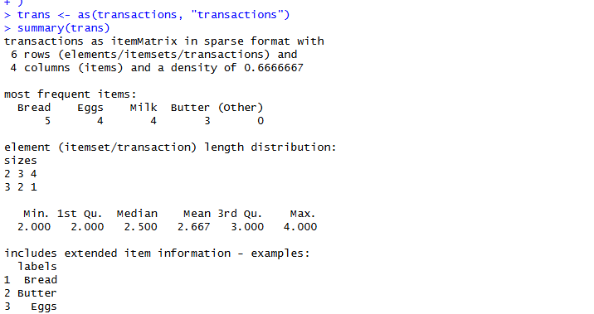

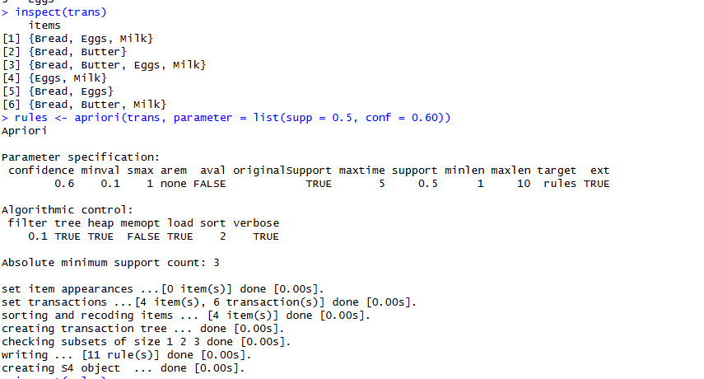

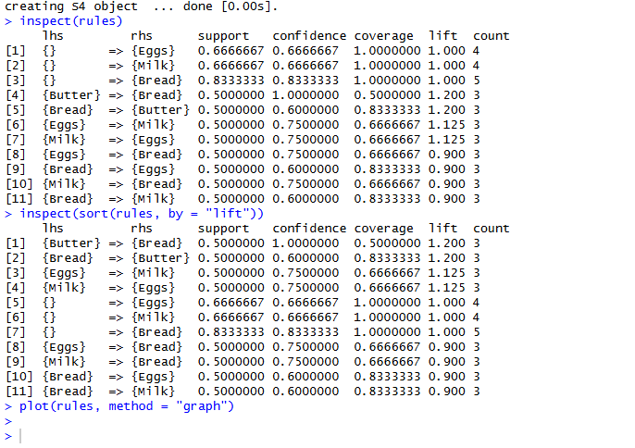

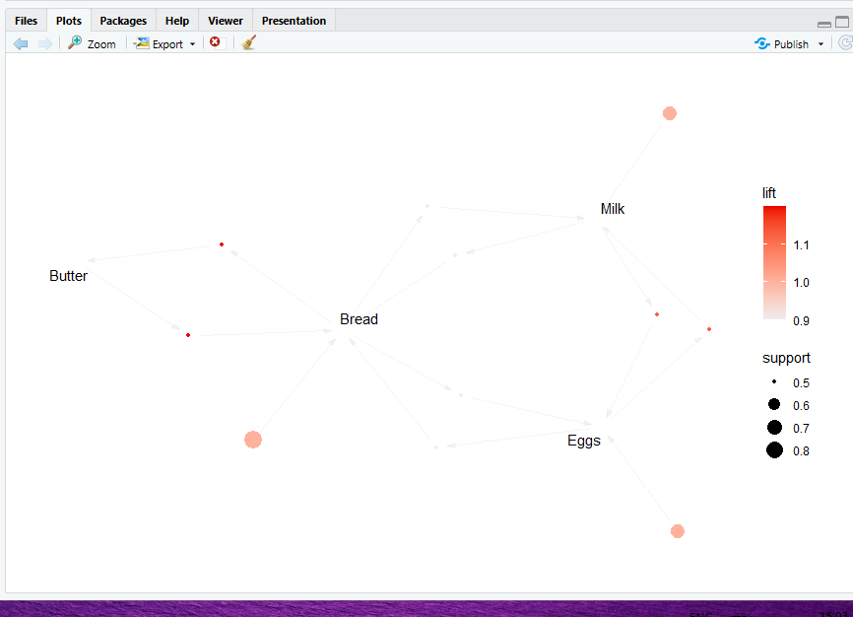

**PRACTICAL 10**

**A.** **K-MEANS CLUSTERING**

**B. AGGLOMERATIVE HIERARCHICAL CLUSTERING**

**1. Introduction**

Clustering is an unsupervised machine learning technique used to group data points such that objects within the same group are more similar to each other than to those in other groups. Unlike supervised learning, clustering does not require labeled data. It is widely used in data analysis, pattern recognition, customer segmentation, image processing, and bioinformatics.

This journal focuses on the implementation and analysis of two popular clustering algorithms:

1. **K-Means Clustering**
2. **Agglomerative (Hierarchical) Clustering**

**2. K-Means Clustering**

**2.1 Definition**

K-Means is a partition-based clustering algorithm that divides a dataset into K distinct non-overlapping clusters, where each data point belongs to the cluster with the nearest mean (centroid).

**2.2 Objective of K-Means**

The main objective of K-Means is to minimize intra-cluster variance, also known as Within Cluster Sum of Squares (WCSS).

$$WCSS=\sum_{i=1}^{k}{\sum_{x∈C_{i}}{∣∣x-}}μ_{i}∣∣^{2}$$

**Where:**

* $k$**= number of clusters**
* $C_{i}$**= i-th cluster**
* $μ_{i}$**= centroid of cluster $C_{i}$**

**2.3 Working of K-Means Algorithm**

Step 1: Choose the number of clusters $K$.  
Step 2: Initialize $K$ centroids randomly.  
Step 3: Assign each data point to the nearest centroid using distance measures such as Euclidean distance.  
Step 4: Recalculate centroids as the mean of all points in a cluster.  
Step 5: Repeat steps 3 and 4 until centroids no longer change or maximum iterations are reached.

**2.4 Advantages of K-Means**

* Simple and easy to implement
* Fast and computationally efficient
* Works well for large datasets

**2.5 Limitations of K-Means**

* Requires predefined value of $K$
* Sensitive to initial centroid selection
* Performs poorly with non-spherical clusters
* Sensitive to outliers

**2.6 Applications of K-Means**

* Customer segmentation
* Market basket analysis
* Image compression
* Document clustering

**3. Agglomerative (Hierarchical) Clustering**

**3.1 Definition**

Agglomerative clustering is a **hierarchical clustering technique** that follows a **bottom-up approach**. Initially, each data point is treated as a separate cluster, and clusters are **merged step by step** based on similarity until a single cluster is formed.

**3.2 Types of Linkage Methods**

Agglomerative clustering uses linkage criteria to decide which clusters to merge:

1. **Single Linkage** – Minimum distance between points
2. **Complete Linkage** – Maximum distance between points
3. **Average Linkage** – Average distance between all points
4. **Ward’s Method** – Minimizes variance within clusters

**3.3 Working of Agglomerative Clustering**

**Step 1:** Treat each data point as an individual cluster.  
**Step 2:** Compute the distance matrix between clusters.  
**Step 3:** Merge the two closest clusters based on linkage criteria.  
**Step 4:** Update the distance matrix.  
**Step 5:** Repeat steps 3 and 4 until one cluster remains or desired clusters are obtained.

**3.4 Dendrogram**

A **dendrogram** is a tree-like diagram used to visualize the hierarchical clustering process. It helps in deciding the optimal number of clusters by cutting the tree at a certain height.

**3.5 Advantages of Agglomerative Clustering**

* No need to specify number of clusters initially
* Produces a clear hierarchical structure
* Works well for small datasets

**3.6 Limitations of Agglomerative Clustering**

* Computationally expensive
* Not suitable for large datasets
* Once clusters are merged, they cannot be split

**4. Conclusion**

K-Means and Agglomerative clustering are powerful unsupervised learning algorithms with different strengths. K-Means is efficient and suitable for large datasets, whereas Agglomerative clustering provides better interpretability through hierarchical relationships. The choice of algorithm depends on dataset size, structure, and application requirements.

**10.1**

**Aim: K Means clustering**

**Code:**

install.packages("factoextra")

library(factoextra)

data(iris)

df <- iris[, 1:4]

df_scaled <- scale(df)

set.seed(123)

kmeans_model <- kmeans(df_scaled, centers = 3, nstart = 25)

cat("Cluster Centers:\n")

print(kmeans_model$centers)

cat("\nCluster Sizes:\n")

print(kmeans_model$size)

cat("\nCluster Assignments (first 20 rows):\n")

print(kmeans_model$cluster[1:20])

library(ggplot2)

library(cluster)

fviz_cluster(

list(data = df_scaled, cluster = kmeans_model$cluster),

geom = "point",

ellipse = TRUE,

main = "K-Means Clustering of Iris Data"

)

data(iris)

df <- iris[, 1:4]

df_scaled <- scale(df)

dist_matrix <- dist(df_scaled, method = "euclidean")

hclust_model <- hclust(dist_matrix, method = "ward.D2")

plot(

hclust_model,

main = "Hierarchical Clustering Dendrogram (Agglomerative)",

xlab = "Samples",

ylab = "Height"

)

clusters <- cutree(hclust_model, k = 3)

cat("Cluster Assignments (first 20 rows):\n")

print(clusters[1:20])

df_clustered <- data.frame(df_scaled, Cluster = as.factor(clusters))

ggplot(df_clustered, aes(x = Sepal.Length, y = Petal.Length, color = Cluster)) +

geom_point() +

labs(title = "Agglomerative Clustering Results")

**Output:**

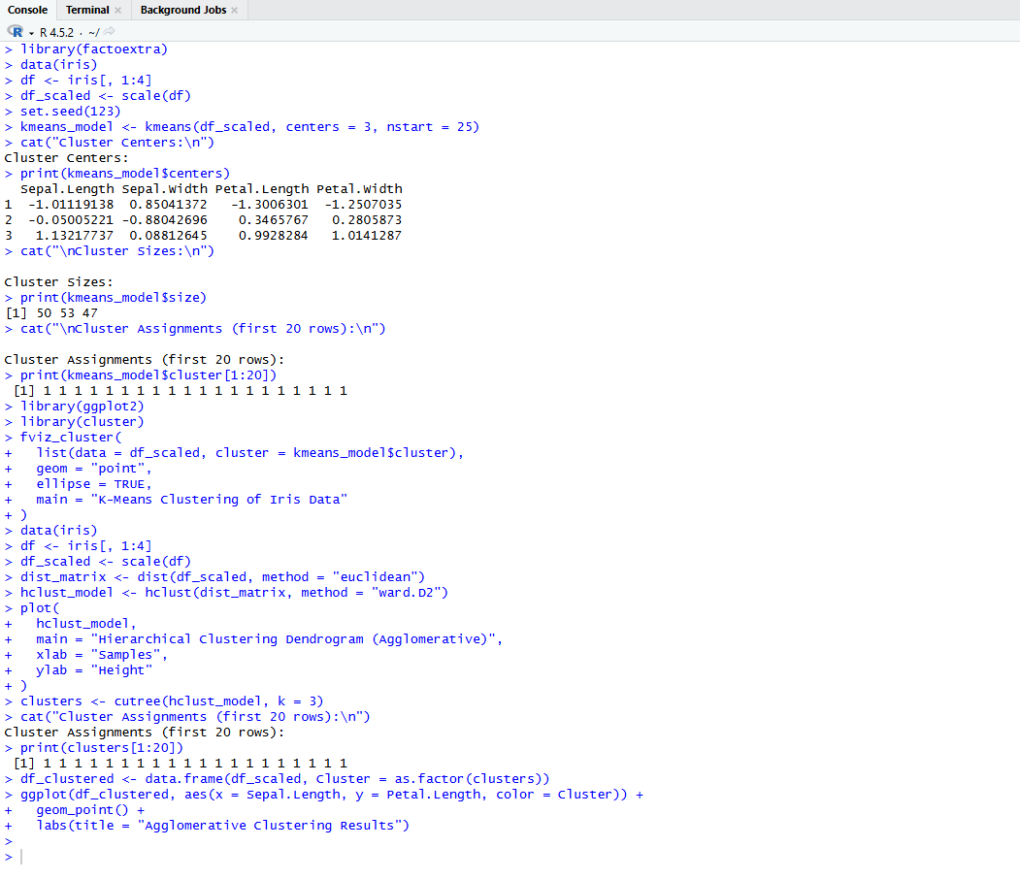

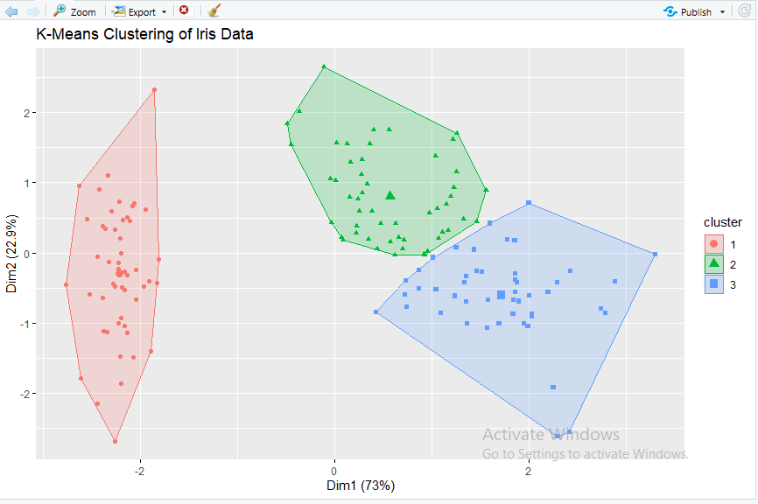

**Agglomerative (Hierarchical) Clustering**

**Output:**

